Unit 6 Lesson 7: Distances and Parabolas

1 Notice and Wonder: Distances (Warm up)

Student Task Statement
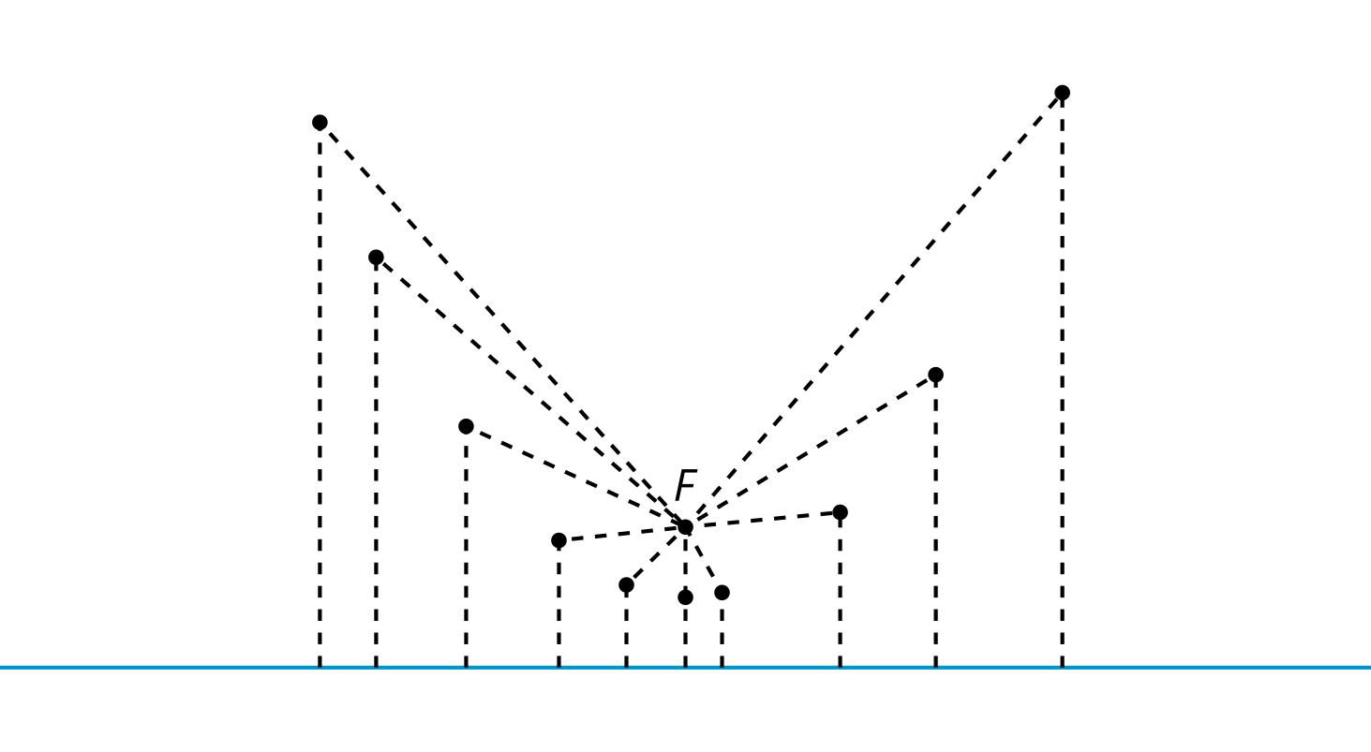
What do you notice? What do you wonder?

Activity Synthesis
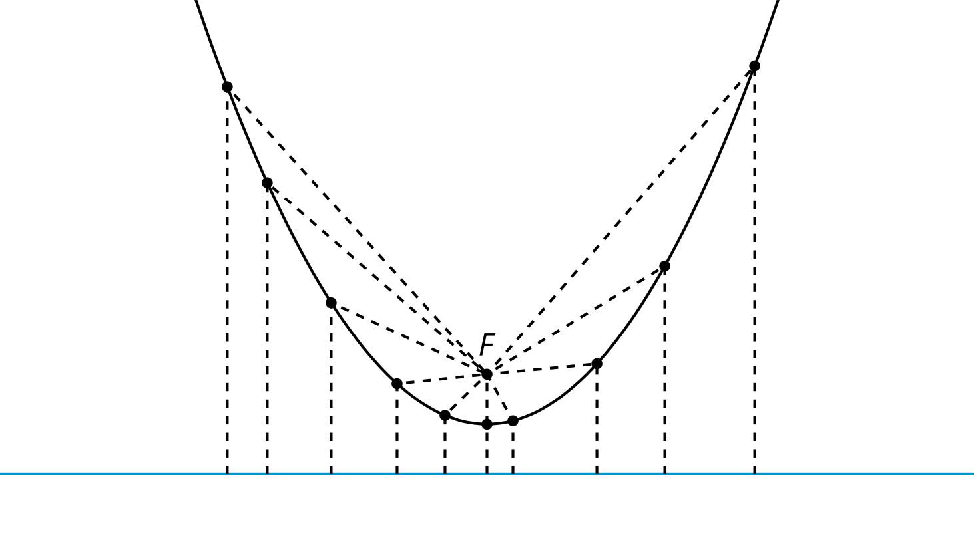
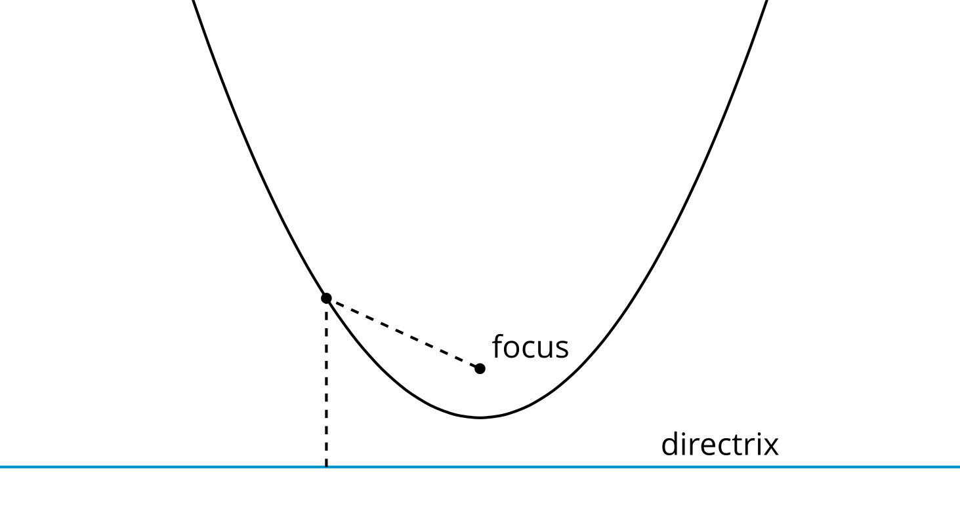

2 Into Focus

Student Task Statement
Here are several images of parabolas.
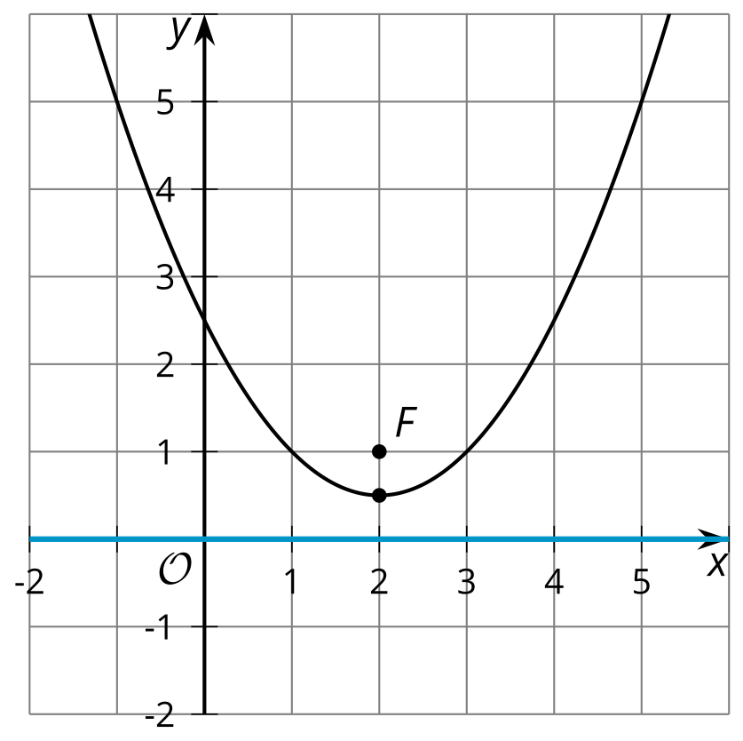
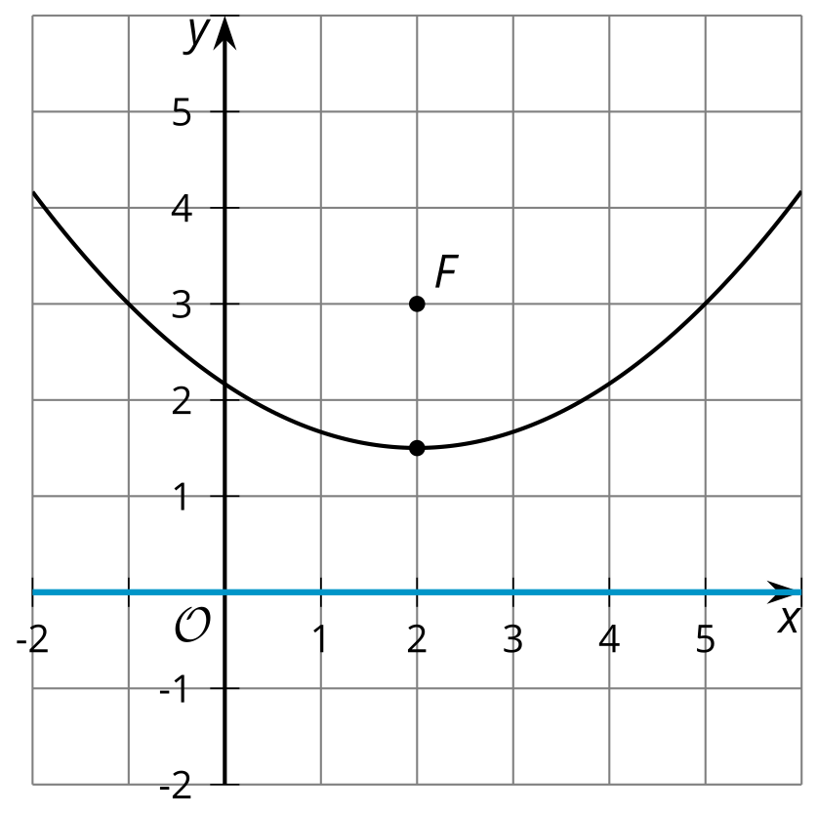
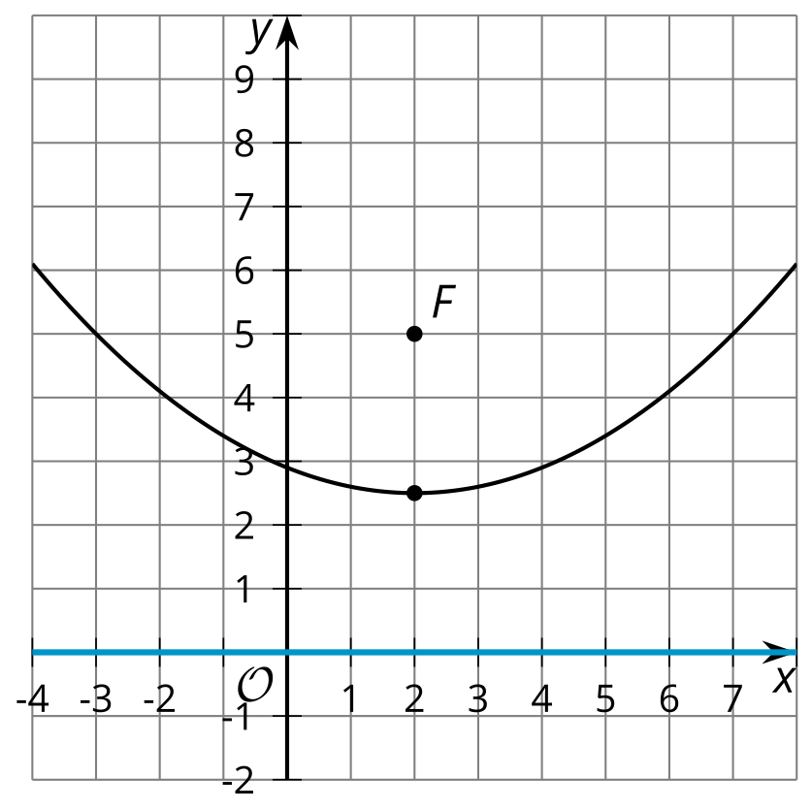
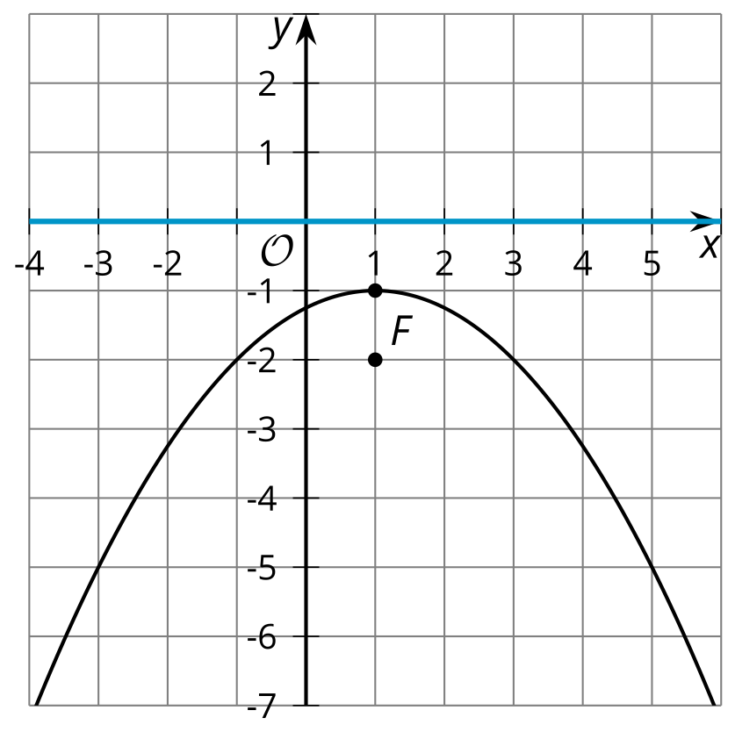
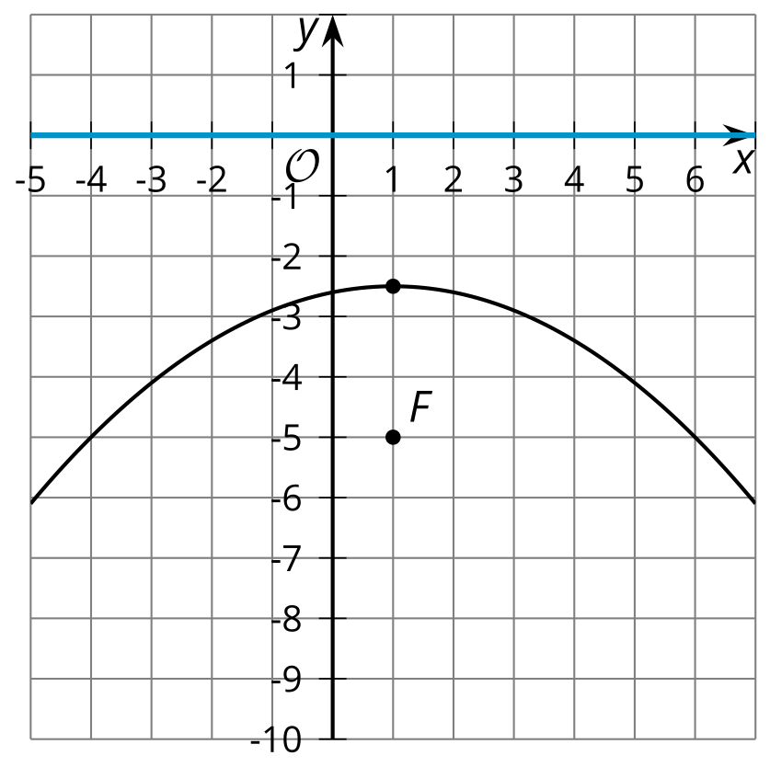
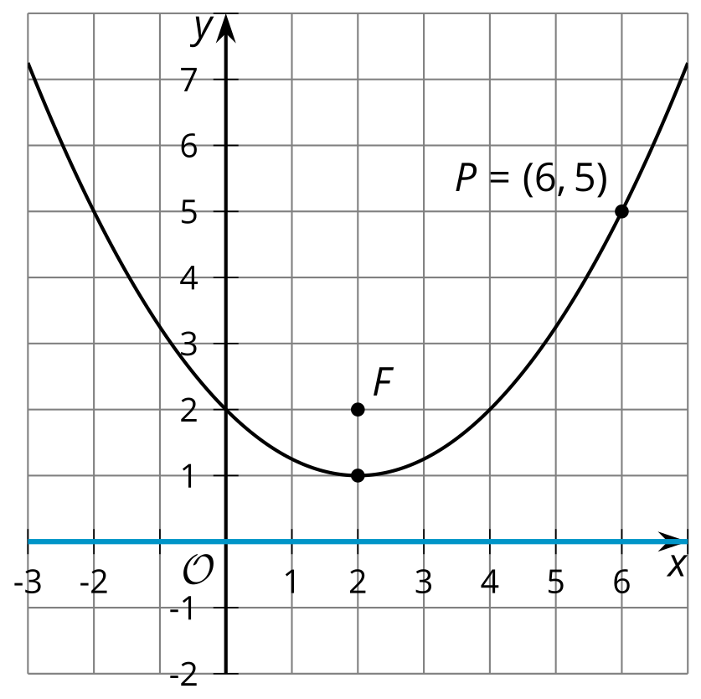
Look at the focus and directrix of each parabola. In each case, the directrix is the $x$-axis.
- How does the distance between the focus and the directrix affect the shape of the parabola?
- What seems to need to be true in order for the parabola to open downward (that is, to be shaped like a hill instead of a valley)?
- The vertex of the parabola is the lowest point on the curve if it opens upward, or the highest if it opens downward. Where is the vertex located in relationship to the focus and the directrix?
- In the final image, the directrix is on the $x$-axis and the focus is the point $\left(2,2\right)$. Point $P$ on the parabola is plotted.
  - What is the distance between point $P$ and the directrix?
  - What does this tell you about the distance between $P$ and $F$?

Activity Synthesis
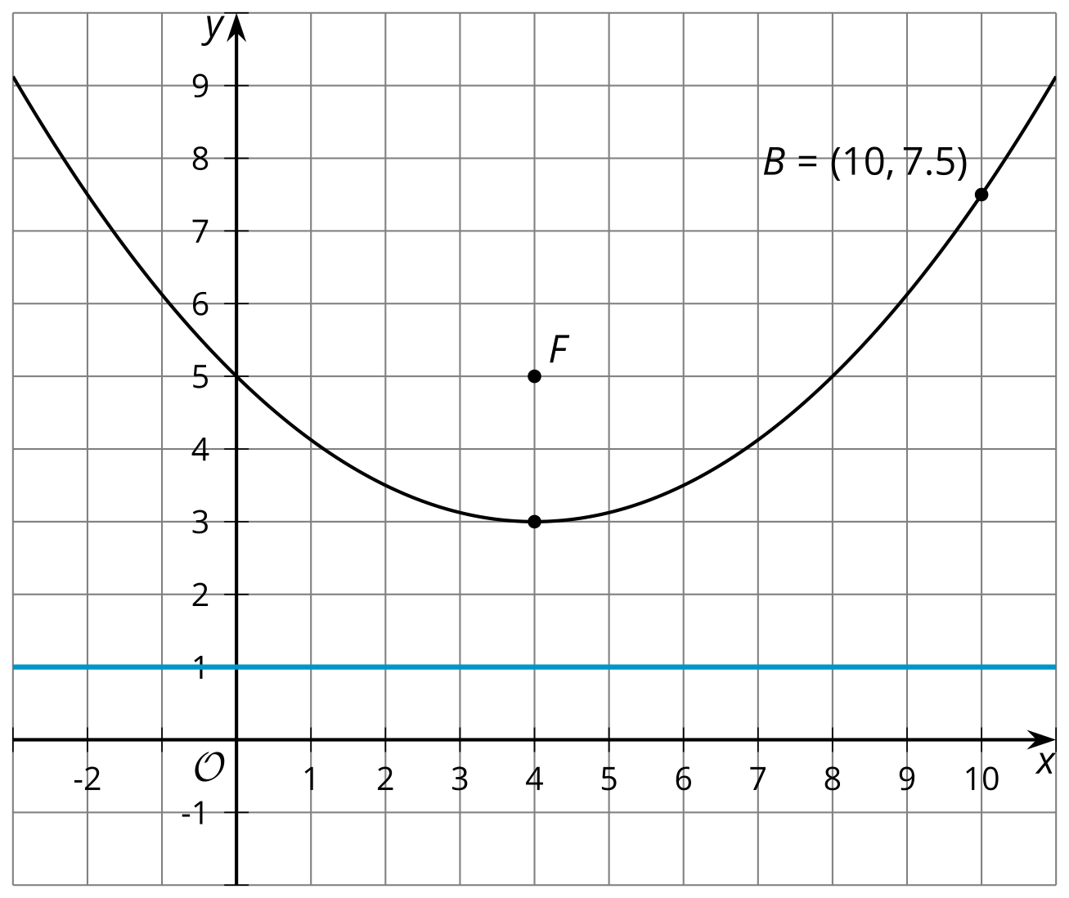

3 On Point

Student Task Statement
The image shows a parabola with focus $\left(6,4\right)$ and directrix $y=0$ (the $x$-axis).
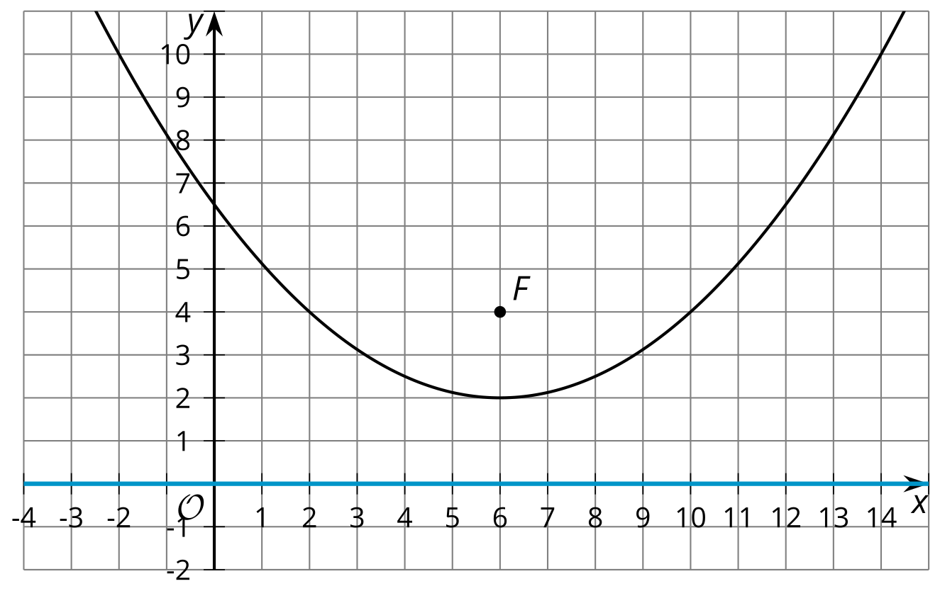
- The point $\left(11,5\right)$ looks like it might be on the parabola. Determine if it really is on the parabola. Explain or show your reasoning.
- The point $\left(14,10\right)$ looks like it might be on the parabola. Determine if it really is on the parabola. Explain or show your reasoning.
- In general, how can you determine if a particular point $\left(x,y\right)$ is on the parabola?

Images for Activity Synthesis
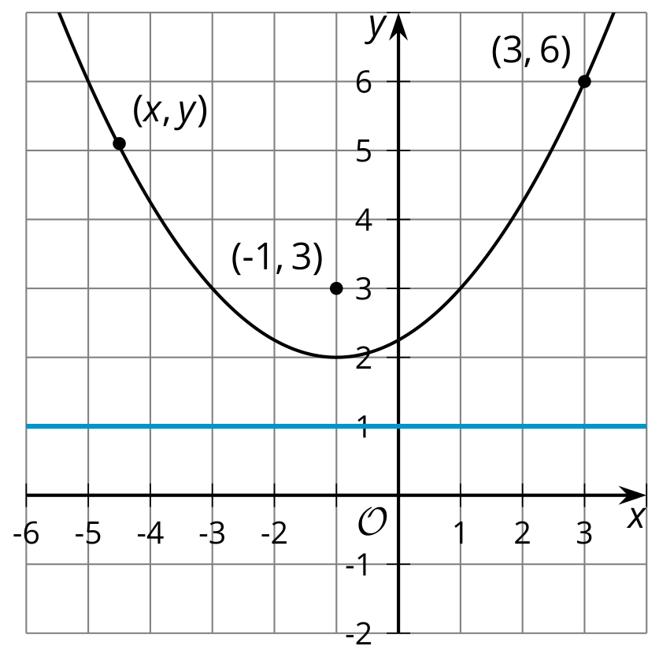
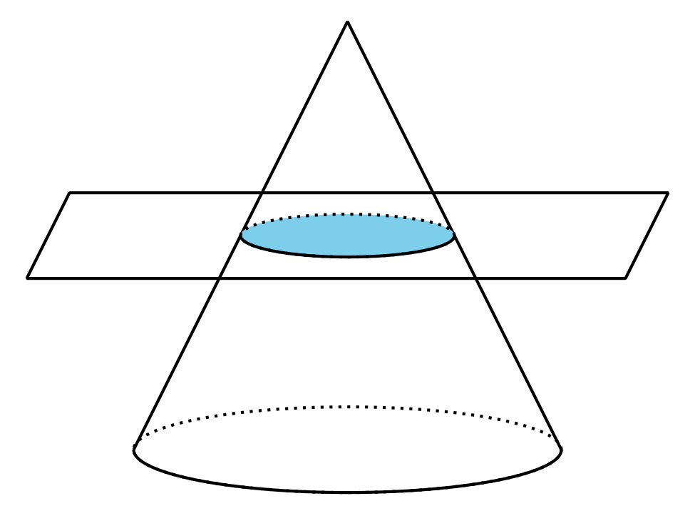
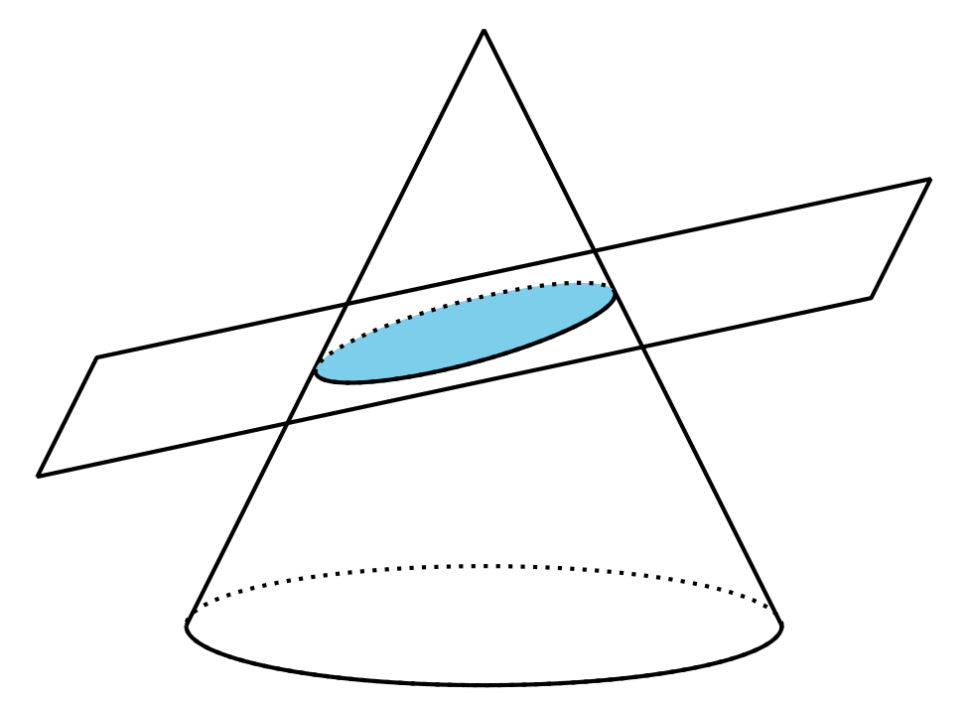
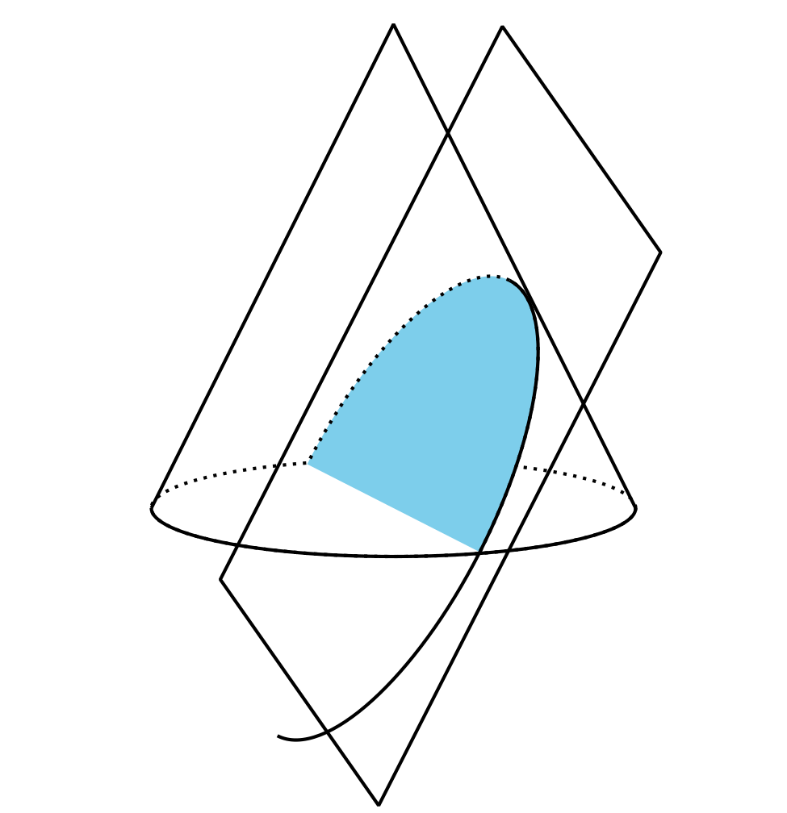
© CC BY 2019 by Illustrative Mathematics®

