Lesson 2: Keeping the Equation Balanced

2.1: Notice and Wonder: Hanging Socks
What do you notice? What do you wonder?
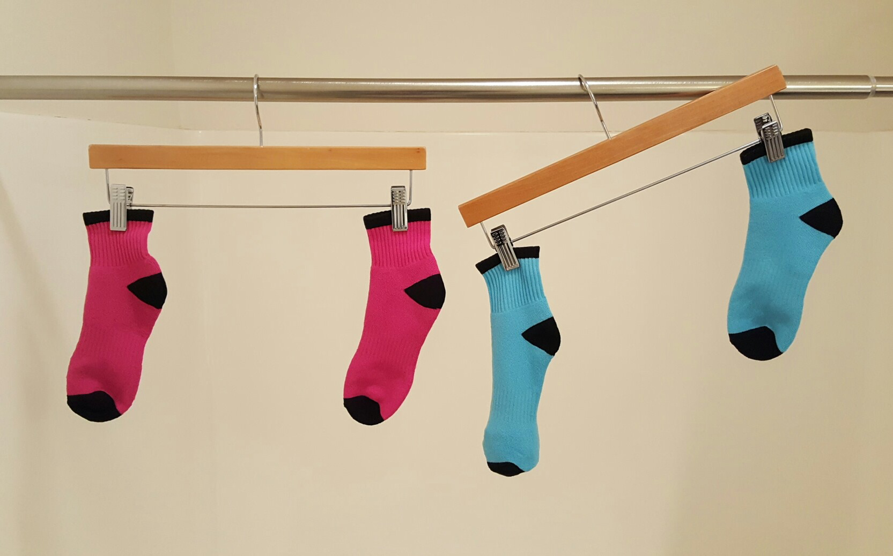

2.2: Hanging Blocks
This picture represents a hanger that is balanced because the weight on each side is the same.
- Elena takes two triangles off of the left side and three triangles off of the right side. Will the hanger still be in balance, or will it tip to one side? Which side? Explain how you know.
- If a triangle weighs 1 gram, how much does a square weigh?
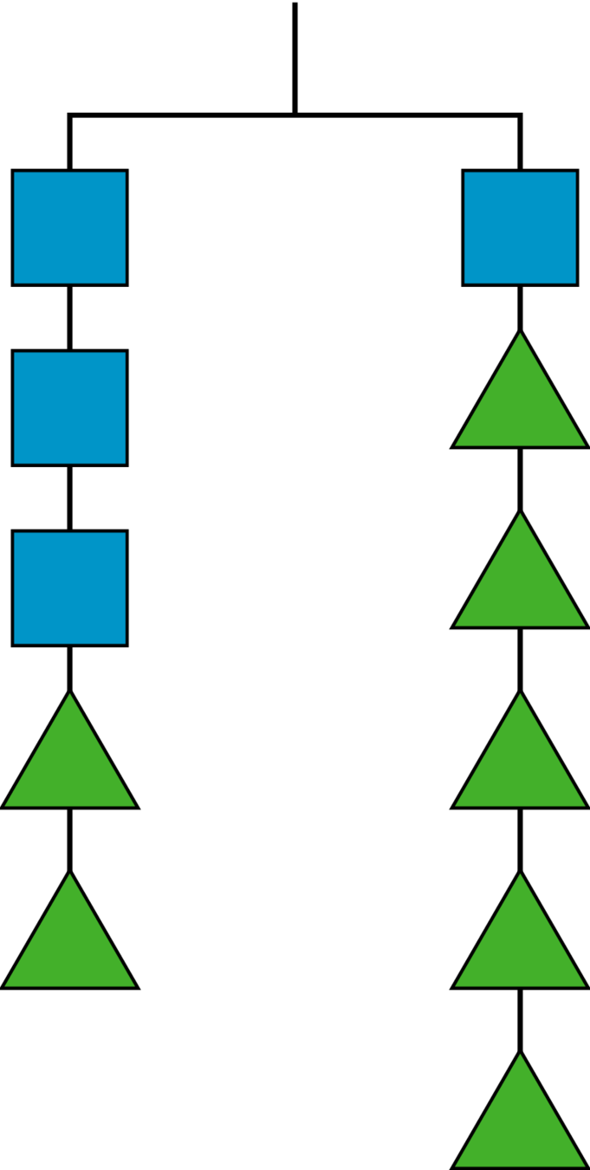

2.3: More Hanging Blocks
A triangle weighs 3 grams and a circle weighs 6 grams.
- Find the weight of a square in Hanger A and the weight of a pentagon in
Hanger B.
- Write an equation to represent
each hanger.
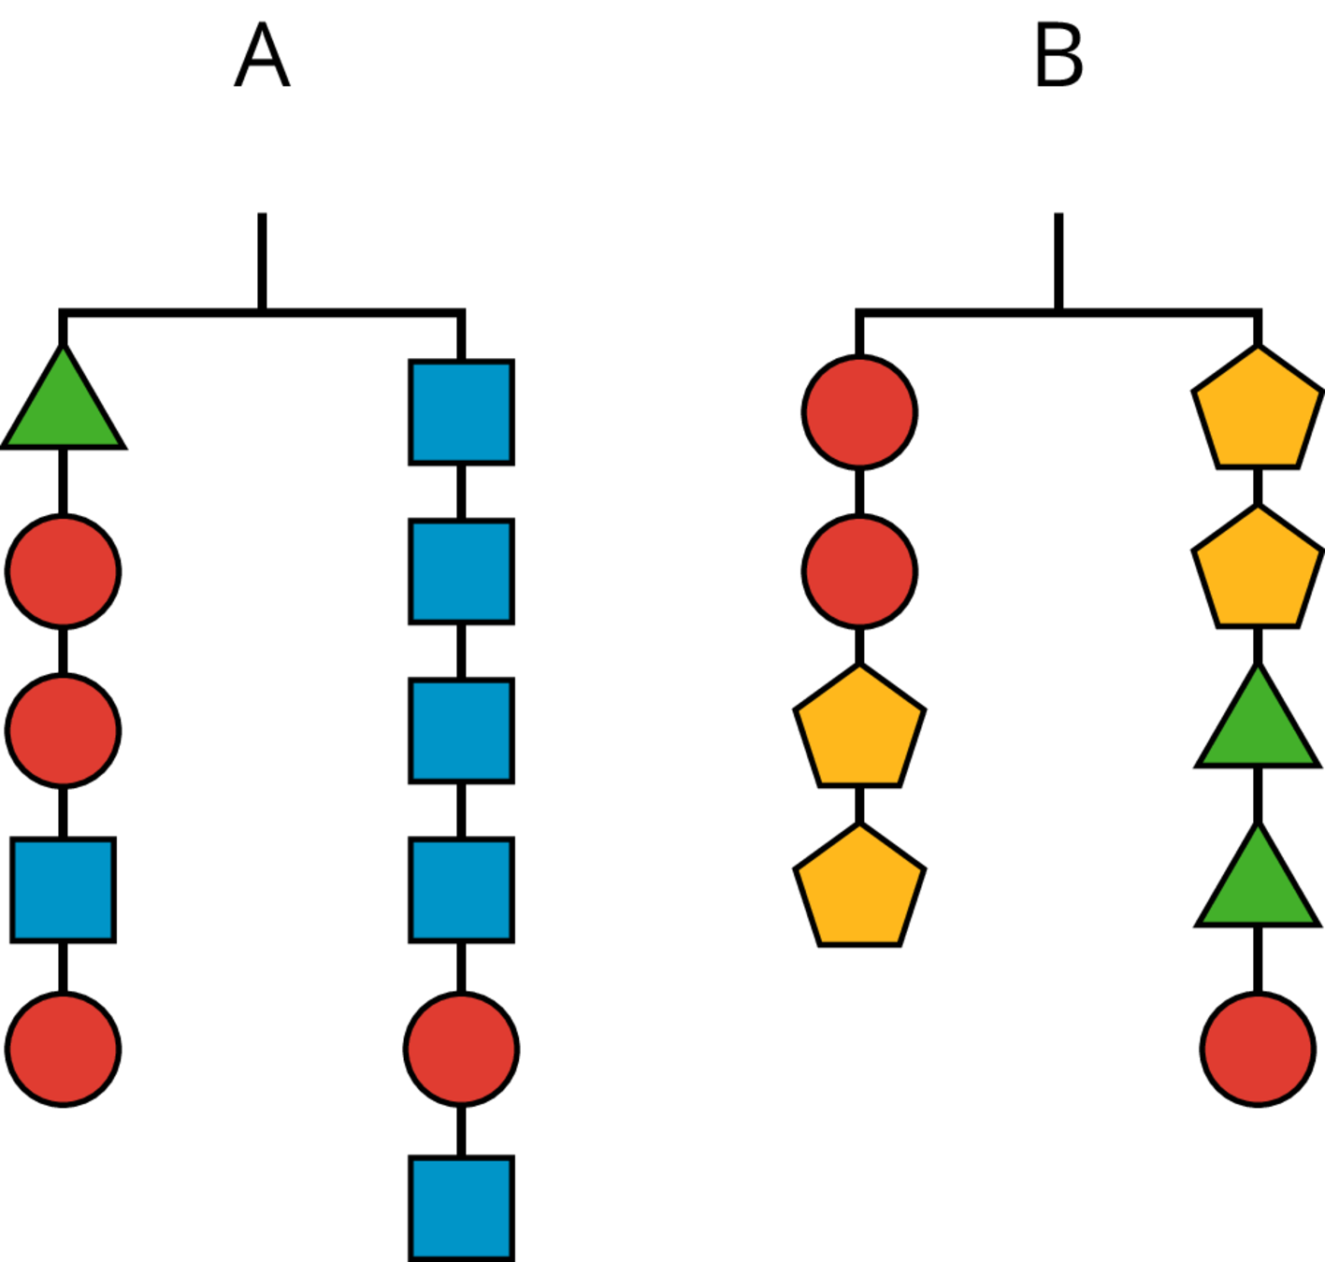

Are you ready for more?
What is the weight of a square on this hanger if a triangle weighs 3 grams?
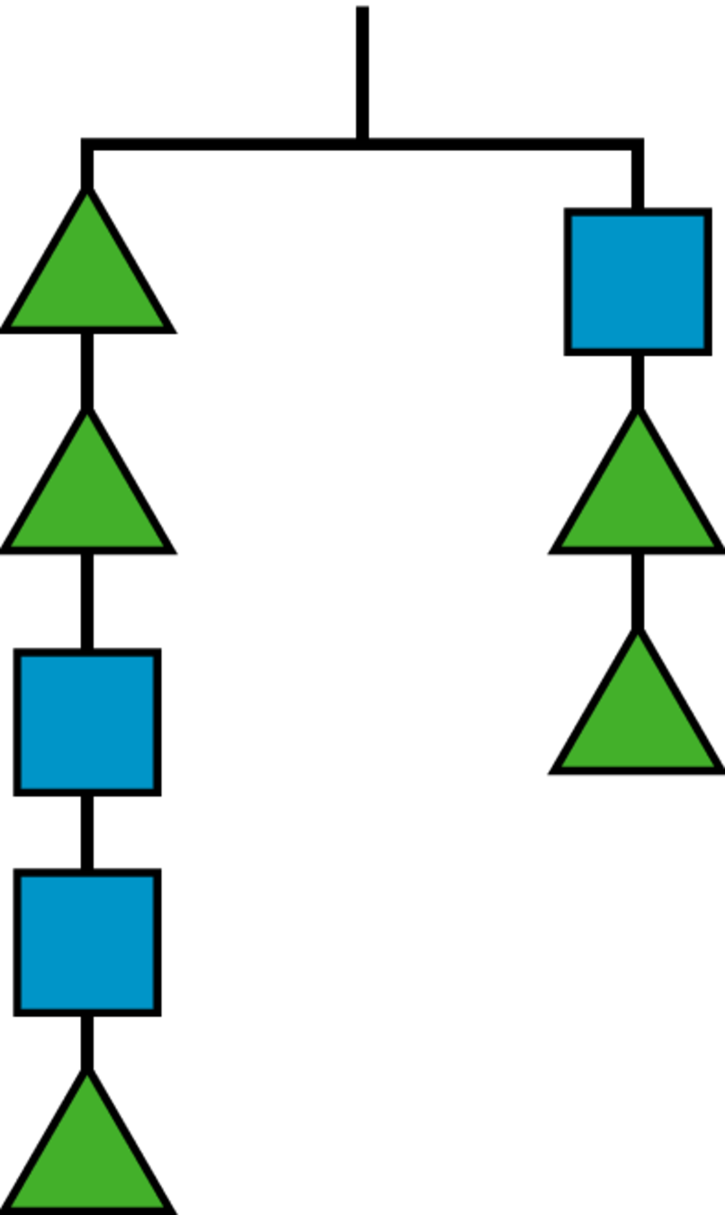

Lesson 2 Summary
If we have equal weights on the ends of a hanger, then the hanger will be in balance. If there is more weight on one side than the other, the hanger will tilt to the heavier side.
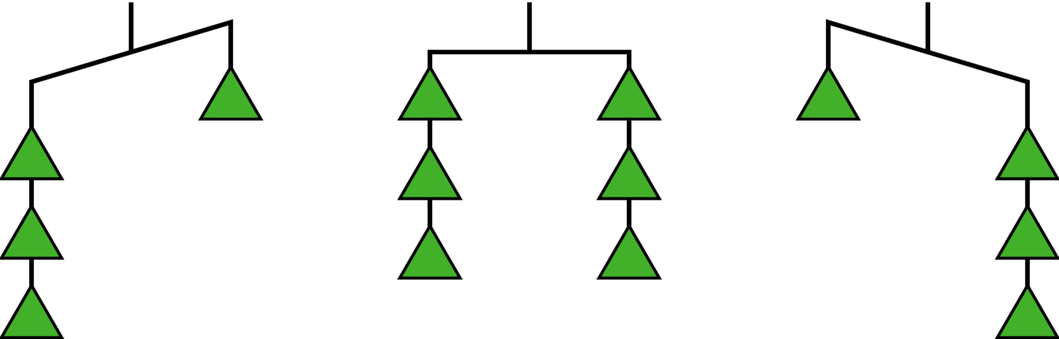
We can think of a balanced hanger as a metaphor for an equation. An equation says that the expressions on each side have equal value, just like a balanced hanger has equal weights on each side.
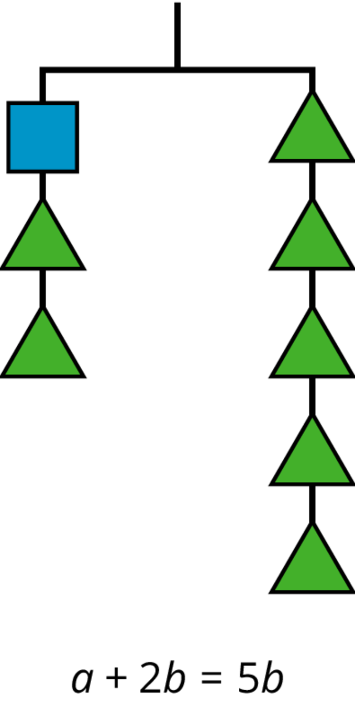
If we have a balanced hanger and add or remove the same amount of weight from each side, the result will still be in balance.
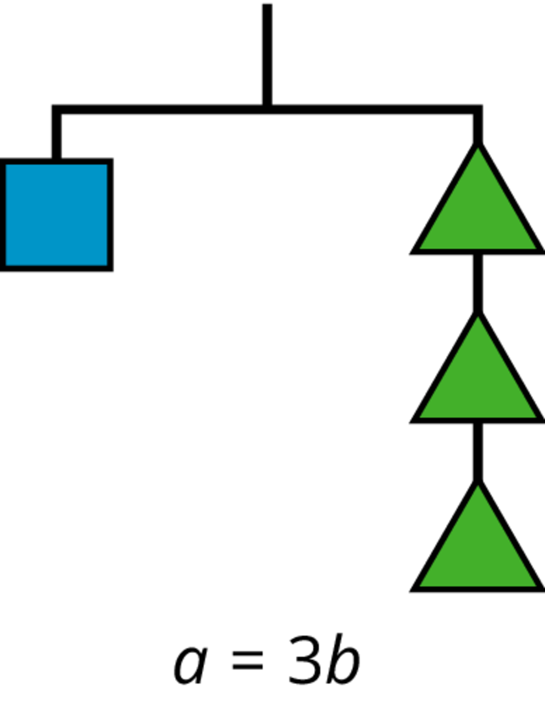
We can do these moves with equations as well: adding or subtracting the same amount from each side of an equation maintains the equality.
© CC BY Open Up Resources. Adaptations CC BY IM.

