Unit 5 Lesson 7: Does it Make a New Ten?

WU Which One Doesn’t Belong: Expressions (Warm up)

Student Task Statement
Which one doesn’t belong?
A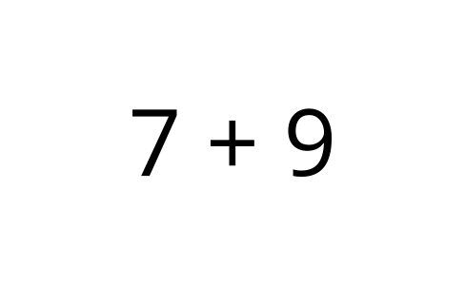
B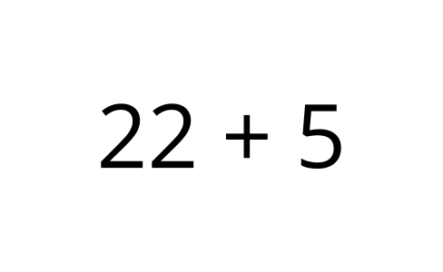
C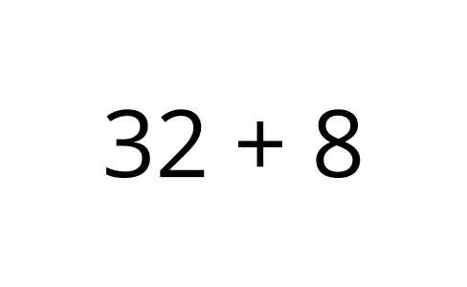
D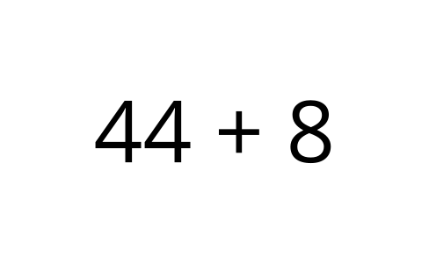

1 A Ten or Not a Ten?

Student Task Statement
Jada likes to look for ways to make a new ten when she adds. Would she be able to a make a new ten when she adds to find the value of these sums?
If Jada could make a new ten, circle “Yes.”
If Jada could not make a new ten, circle “No.”
- Does the expression make a new ten?
- $45+5$
- Yes
- No
- Explain how you know.
- Find the value.
- Write equations to show how you found the value of the sum.
- Does the expression make a new ten?
- $9+63$
- Yes
- No
- Explain how you know.
- Find the value.
- Write equations to show how you found the value of the sum.
- Does the expression make a new ten?
- $26+3$
- Yes
- No
- Explain how you know.
- Find the value.
- Write equations to show how you found the value of the sum.
- Does the expression make a new ten?
- $8+47$
- Yes
- No
- Explain how you know.
- Find the value.
- Write equations to show how you found the value of the sum.

2 Missing Numbers

Images for Launch
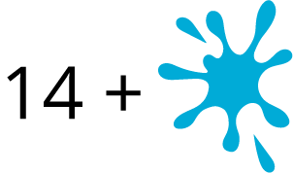

Student Task Statement
Lin’s brother spilled water on her math work!
Figure out what number Lin wrote before it got smudged.
- Lin wrote a one-digit number with which you can make a new ten when you find the value of the sum.
- 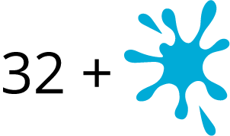
- What could Lin’s number be?
Write equations to show your thinking.
- Lin wrote a one-digit number with which you can not make a new ten when you find the value of the sum.
- 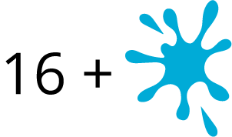
- What could Lin’s number be?
Write equations to show your thinking.
- Lin wrote a two-digit number with which you can make a new ten when you find the value of the sum.
- What could Lin’s number be?
Write equations to show your thinking.
- Lin wrote a two-digit number with which you can not make a new ten when you find the value of the sum.
- What could Lin’s number be?
Write equations to show your thinking.
- How do you know whether or not you can make a new ten when you are finding the value of a sum?

Activity Synthesis
© CC BY 2021 Illustrative Mathematics®

