Lesson 14: Half of the Clock
- Let’s learn more about time to the half hour.

Warm-up: Number Talk: Work with 30
Find the value of each expression mentally.
- $30+10$
- $30+15$
- $30+30$
- $30+35$

14.1: Put Times in Order
What do you notice?
What do you wonder?
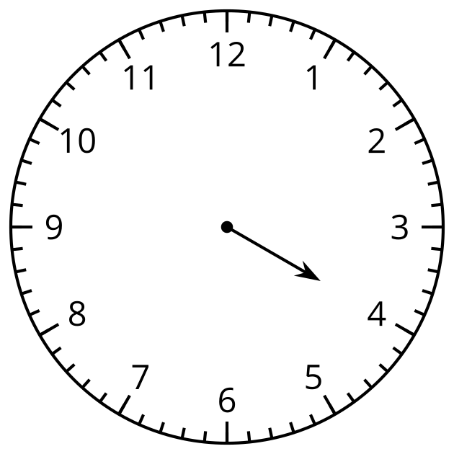
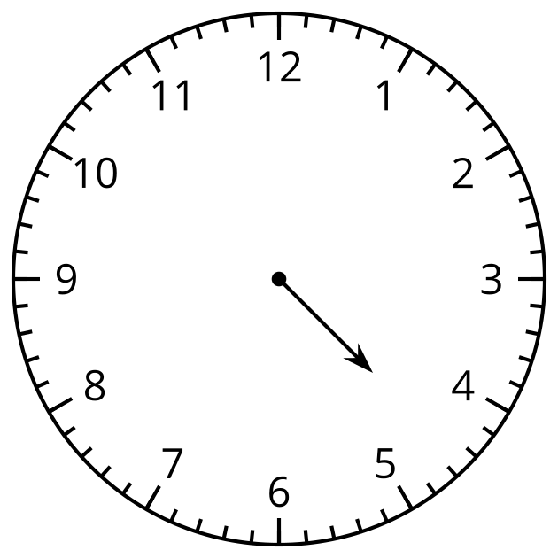

14.2: Half Past What?
What time is shown on each clock?
If the time is half past, color the clock red.
If the time is o’clock, color the clock blue.
Write the time in words using half past or o’clock.

- 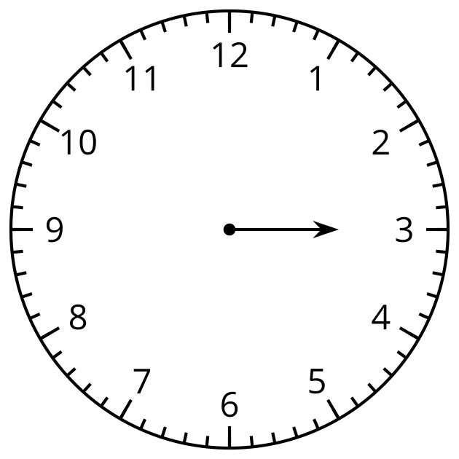

- 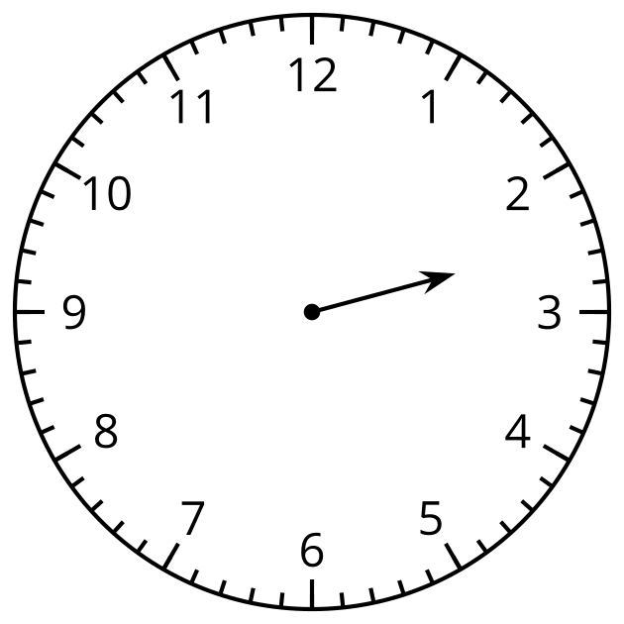

- 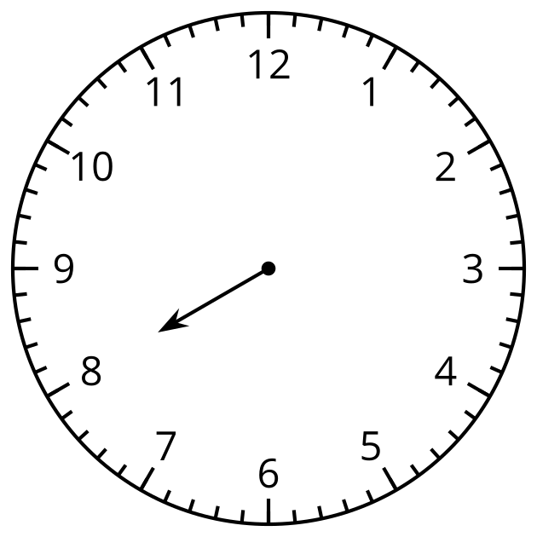

- 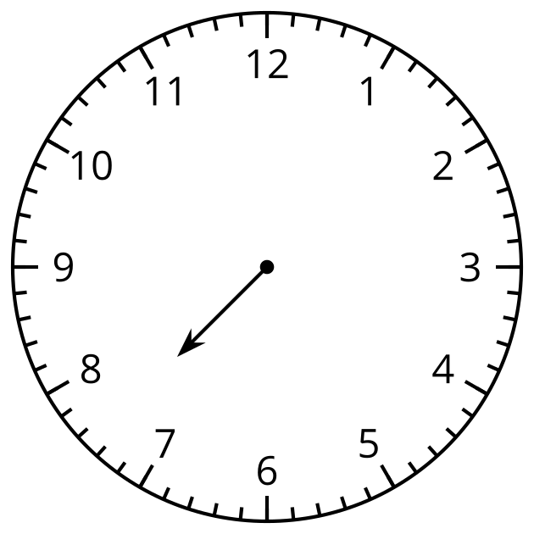

- 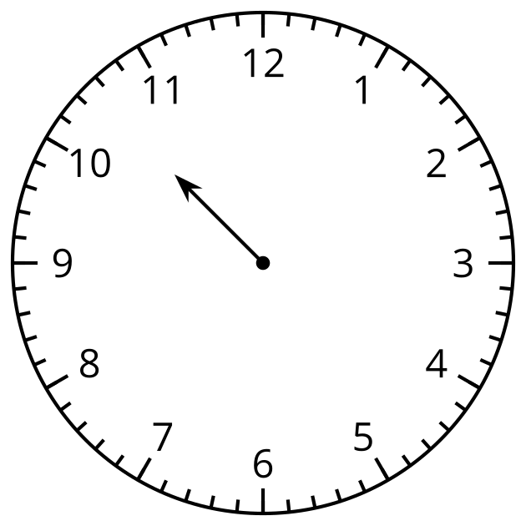

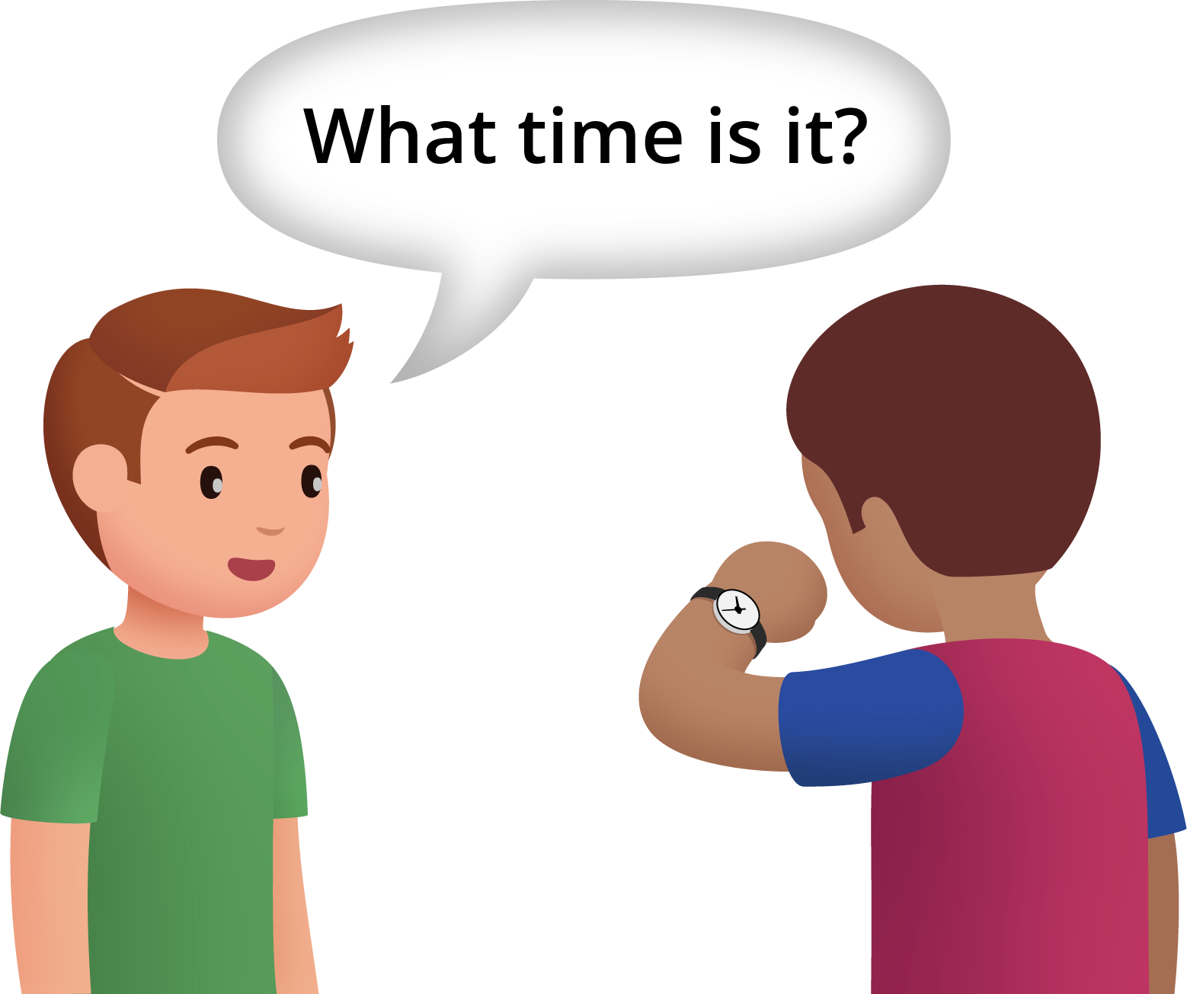

14.3: Notice and Wonder: The Hands on the Clock Go Round and Round
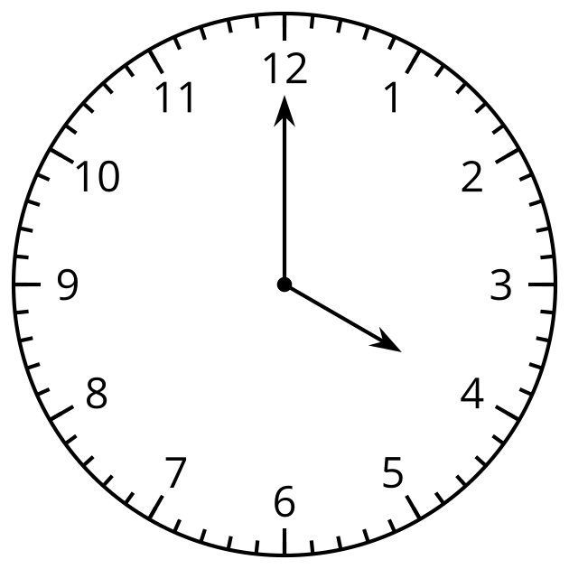
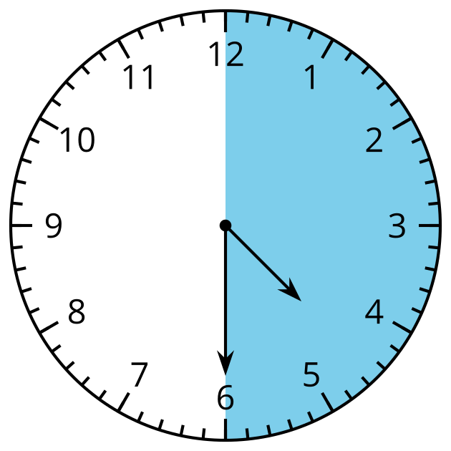
© CC BY 2021 Illustrative Mathematics®

