Lesson 10: Solve Problems with Decimals
- Let's round and order decimals to solve problems.

Warm-up: Notice and Wonder: The Luge
What do you notice? What do you wonder?
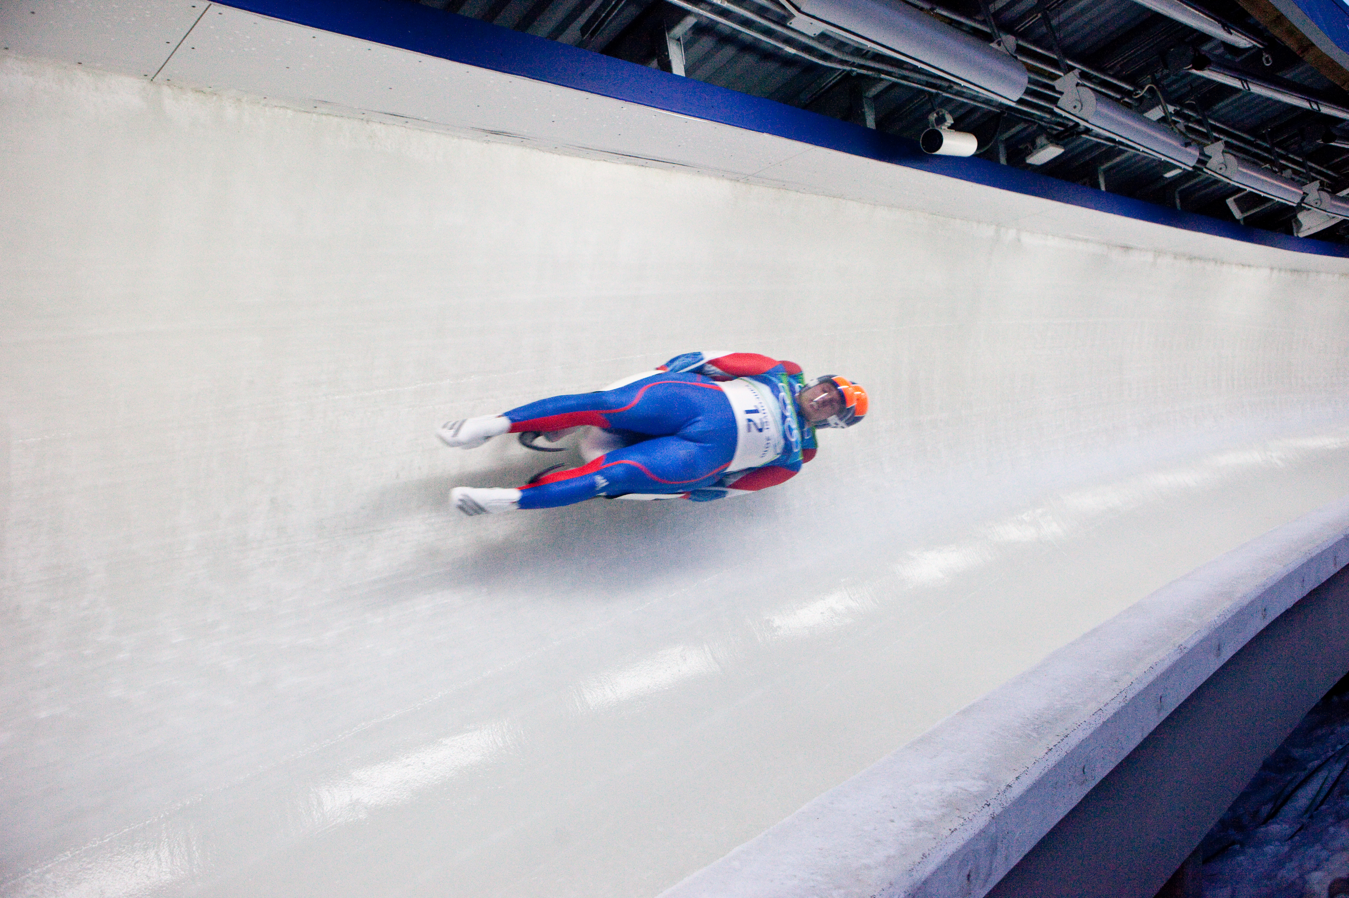
A | B
48.532 | 82.13
48.561 | 82.75
48.626 | 82.81
48.634 | 83.07
48.708 | 82.80

10.1: How Accurate Is It?
athlete | time (seconds) | speed (mph)
Athlete 1 | 48.532 | 82.13
Athlete 2 | 48.561 | 82.75
Athlete 3 | 48.626 | 82.81
Athlete 4 | 48.634 | 83.07
Athlete 5 | 48.708 | 82.80
- How would the results of the race change if the times were recorded to the nearest second?
- How would the results of the race change if the times were recorded to the nearest tenth of a second?
- How would the results of the race change if the times were recorded to the nearest hundredth of a second?
- An athlete recorded a time of 48.85 seconds to the nearest hundredth of a second. What are the possible times of this athlete recorded to the thousandth of a second?
- An athlete recorded a time of 48.615 seconds to the nearest thousandth of a second. What are the possible times that this athlete recorded to the nearest hundredth of a second?

10.2: Compare Speeds
The table shows the top speeds, in miles per hour, of 5 luge athletes:
athlete | speed (miles per hour)
Athlete 1 | 82.13
Athlete 2 | 82.75
Athlete 3 | 82.81
Athlete 4 | 83.07
Athlete 5 | 82.80
- List the top speeds of the athletes in decreasing order.
- Do any of the athletes have the same top speed rounded to the nearest tenth of a mile per hour? What about rounded to the nearest mile per hour?
- There was a sixth athlete who was faster than the rider at 82.80 mph, but slower than the rider at 82.81 mph. What could the speeds of the 3 athletes be if all measured to the nearest thousandth of a mile per hour?

Section Summary
Section Summary
In this section, we represented decimals to the thousandths place.
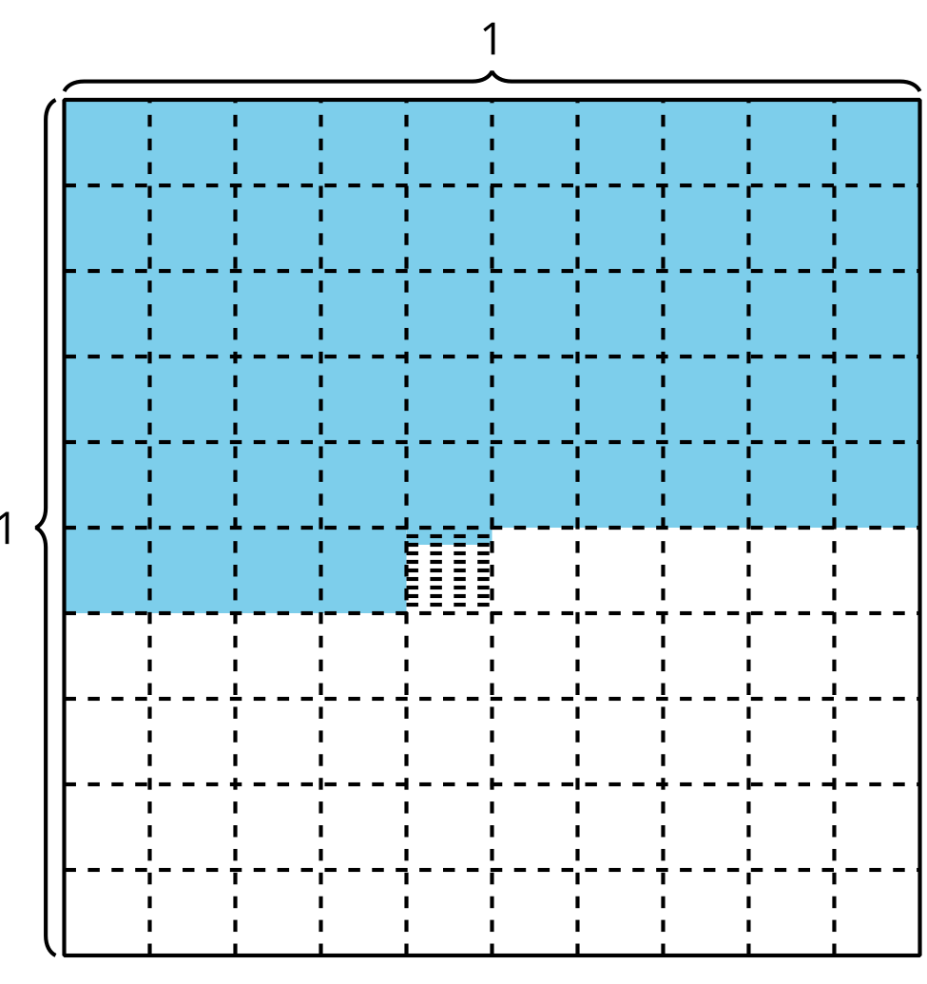
The shaded region of the diagram represents 0.542. The 5 shaded rows are each a tenth or 0.1, the 4 shaded small squares are each a hundredth or 0.01, and the 2 shaded tiny rectangles are each a thousandth or 0.001. The decimal 0.542 can be represented in other ways
- $\frac{542}{1,000}$
- five hundred forty-two thousandths
- $\left(5×0.1\right)+\left(4×0.01\right)+\left(2×0.001\right)$
We can also locate 0.542 on a number line.
The number line shows that 0.542 is closer to 0.54 than to 0.55 so 0.542 rounded to the nearest hundredth is 0.54.
© CC BY 2021 Illustrative Mathematics®

