Lesson 19: Compare to 1
- Let’s explain what happens when we multiply a fraction by a fraction greater than, less than, or equal to 1.

Warm-up: What Do You Know About $\frac{15}{14}×\frac{23}{30}$?
What do you know about $\frac{15}{14}×\frac{23}{30}$?

19.1: Compare Fraction Products on the Number Line
- Match the expressions and number lines that show the same value.
  - $\frac{2}{5}×\frac{4}{3}$
  - $\frac{3}{4}×\frac{5}{2}$
  - $\frac{4}{3}×\frac{5}{2}$
  - $\left(1+\frac{1}{3}\right)×\frac{5}{2}$
  - $\left(1−\frac{3}{5}\right)×\frac{4}{3}$
  - $\left(1−\frac{1}{4}\right)×\frac{5}{2}$
- A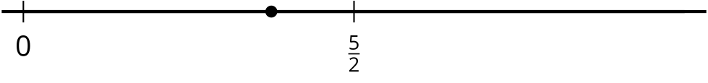
- B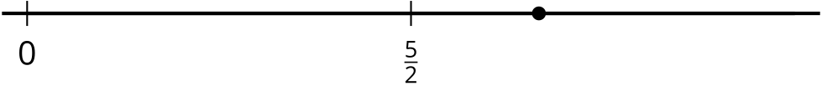
- C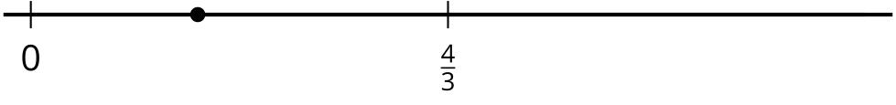
- Choose one of the expressions from each set and explain whether the value is greater than or less than the second factor.

19.2: True Statement
- Rewrite each expression as a sum or difference of 2 products.
  - $\left(1−\frac{2}{5}\right)×\frac{4}{7}$
  - $\left(1+\frac{1}{5}\right)×\frac{4}{7}$
  - $\left(1−\frac{3}{8}\right)×\frac{4}{7}$
  - $\left(1+\frac{1}{8}\right)×\frac{4}{7}$
- Fill in each blank with $<$ or $>$ to make the inequality true.
  - $\left(1−\frac{2}{5}\right)×\frac{4}{7} \underset{_}{} \frac{4}{7}$
  - $\left(1+\frac{1}{5}\right)×\frac{4}{7} \underset{_}{} \frac{4}{7}$
  - $\left(1−\frac{3}{8}\right)×\frac{4}{7} \underset{_}{} \frac{4}{7}$
  - $\left(1+\frac{1}{8}\right)×\frac{4}{7} \underset{_}{} \frac{4}{7}$
- Describe the value of the product when $\frac{4}{7}$ is multiplied by a fraction greater than 1. Explain your reasoning.
- Describe the value of the product when $\frac{4}{7}$ is multiplied by a fraction less than 1. Explain your reasoning.

Section Summary
Section Summary
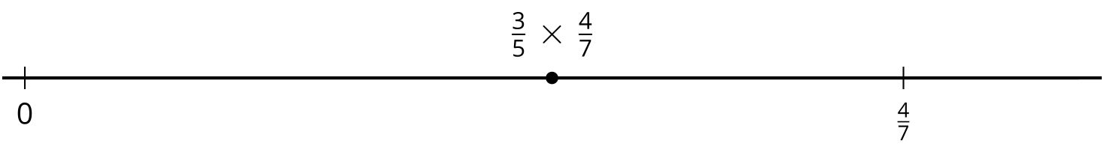
In this section, we learned how to compare the size of a product to the size of the factors. To compare $\frac{3}{5}×\frac{4}{7}$ with $\frac{4}{7}$, for example, we can put them on a number line.
Since $\frac{3}{5}$ is 3 equal parts with 5 parts in the whole, it is to the left of $\frac{4}{7}$, only part of the way there. We can also see this by writing $\frac{3}{5}$ as $1−\frac{2}{5}$.
$\left(1−\frac{2}{5}\right)×\frac{4}{7}=\frac{4}{7}−\left(\frac{2}{5}×\frac{4}{7}\right)$
The product is less than $\frac{4}{7}$ because it is $\frac{4}{7}$ minus a fraction.
© CC BY 2021 Illustrative Mathematics®

