Lesson 5: Subtract with Objects
- Let’s use counters to subtract.

Warm-up: How Many Do You See: Subtraction
How many do you see?
How do you see them?
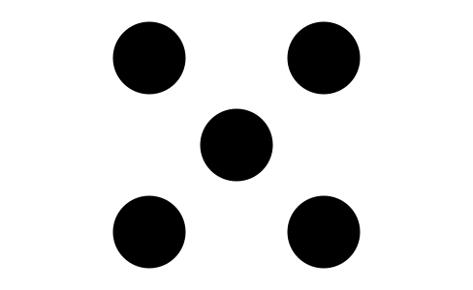
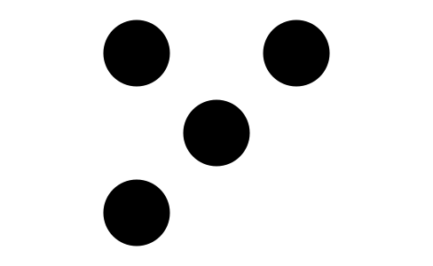
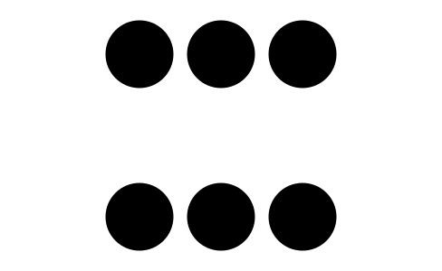
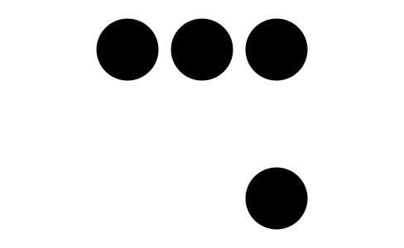

5.1: Subtract Counters
- Count out 8 counters.
Take away 3 counters.
- There are
- counters left.
- Count out 10 counters.
Take away 6 counters.
- There are
- counters left.
- Count out 7 counters.
Take away 1 counter.
- There are
- counters left.
- Count out 9 counters.
Take away 3 counters.
- There are
- counters left.

5.2: Introduce 5-Frames, Subtract

5.3: Centers: Choice Time
Choose a center.
5-frames
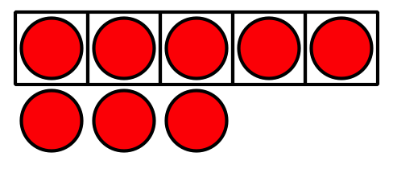
Roll and Add
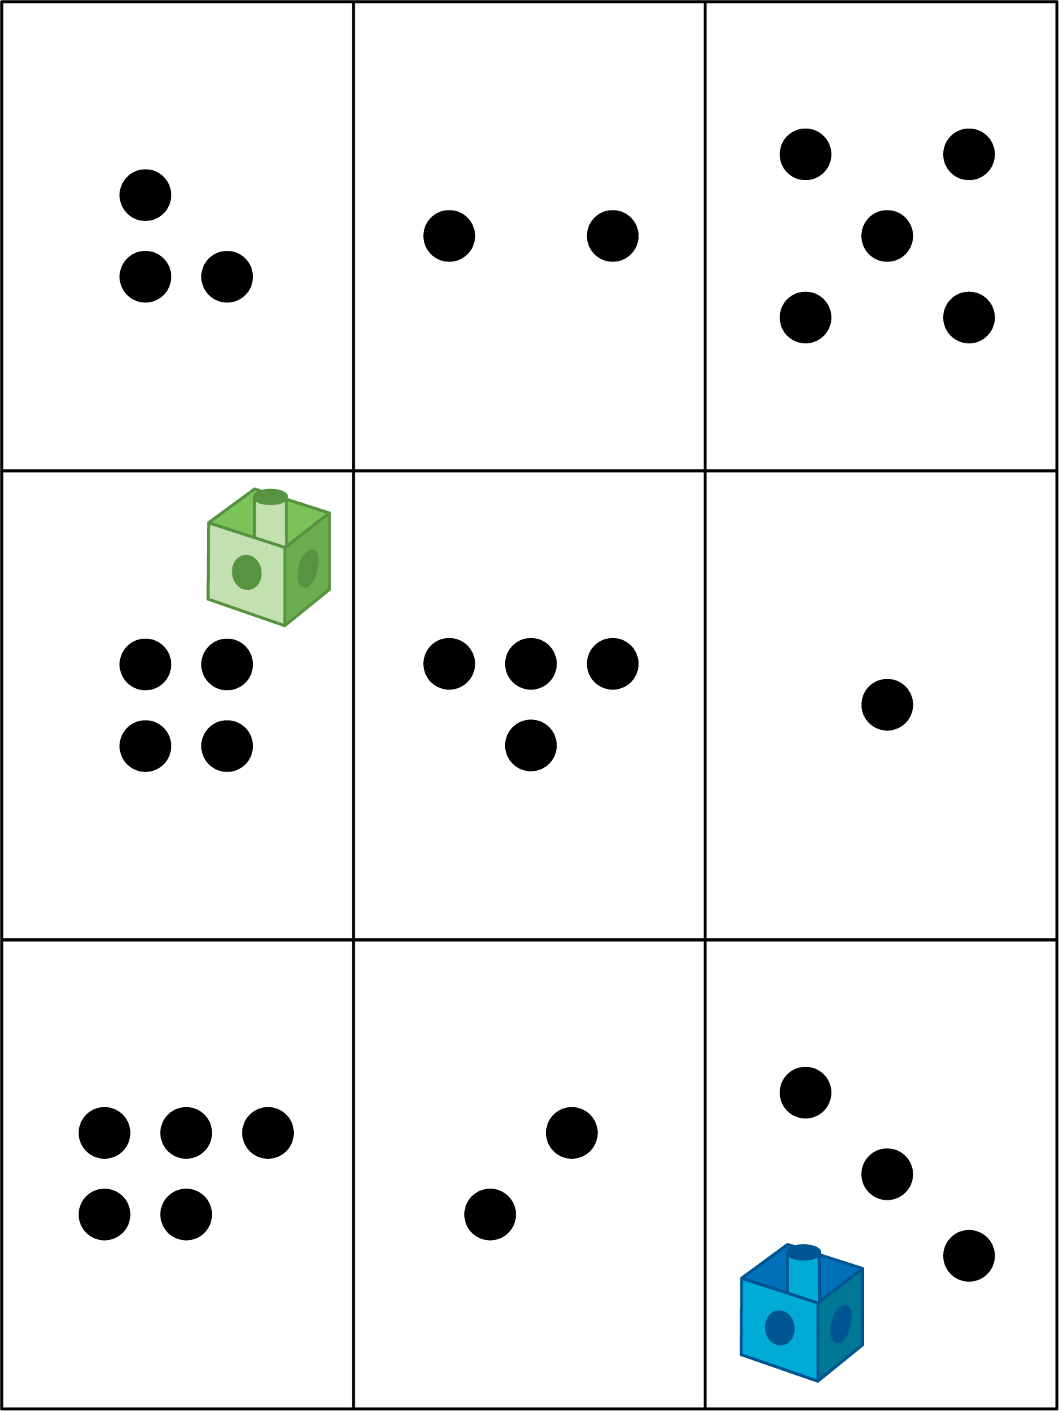
Math Libs
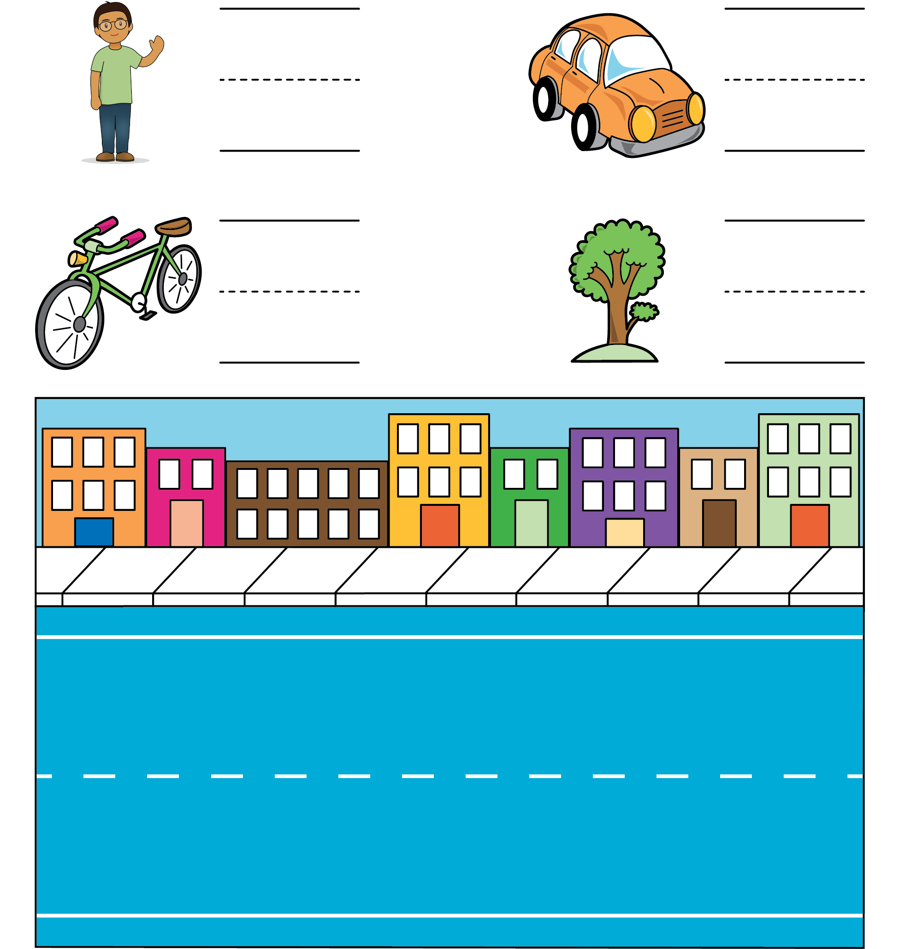
Match Mine
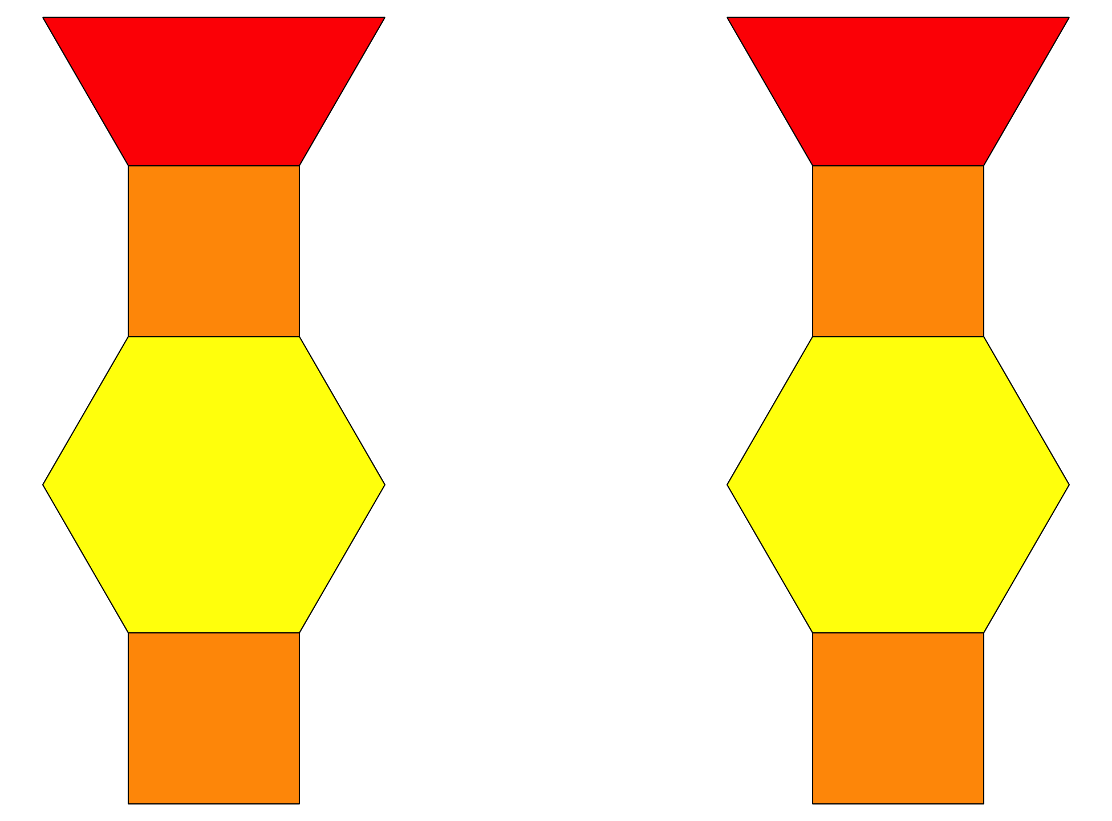

Section Summary
Section Summary In this section, we counted two groups of things to figure out how many there are altogether.
3 yellow counters and 4 red counters is 7 counters.
3 and 4 is 7.
We added more things and found out how many there were altogether.
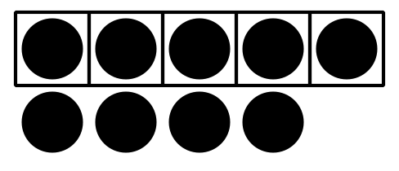
There were 5 counters on the 5-frame and we added 4 more counters.
5 and 4 is 9.
We subtracted, or took away, some things and figured out how many were left.
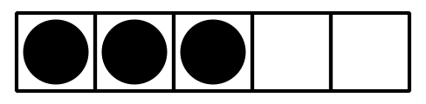
There were 5 counters on the 5-frame and we took away 2 of them.
5 take away 2 is 3.
© CC BY 2021 Illustrative Mathematics®

