Unit 4 Lesson 5: Center Day 1

WU Which One Doesn’t Belong: Tens (Warm up)

Student Task Statement
Which one doesn’t belong?
A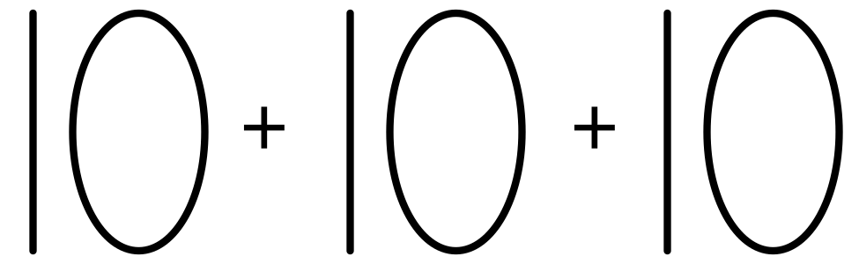
B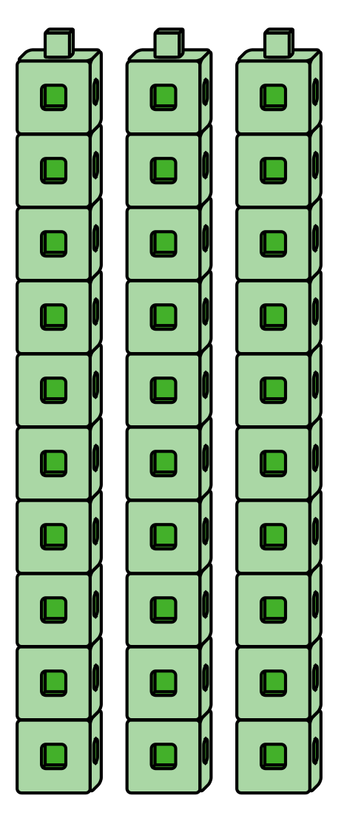
C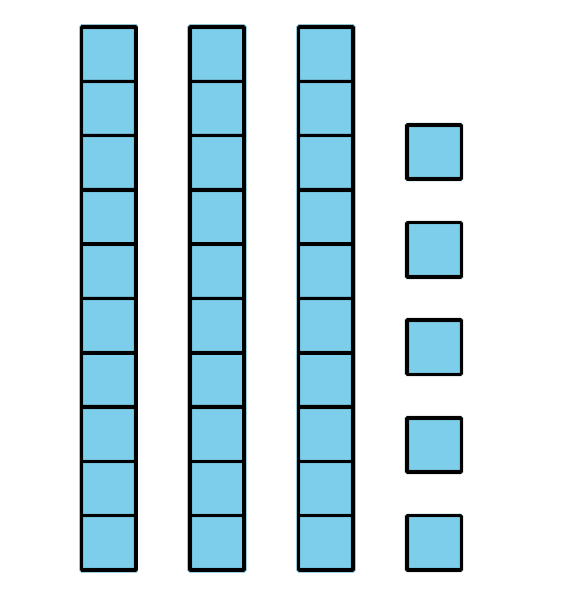
D

1 Introduce Check It Off, Add or Subtract Tens

Student Task Statement

2 Centers: Choice Time

Student Task Statement
Choose a center.
Five in a Row
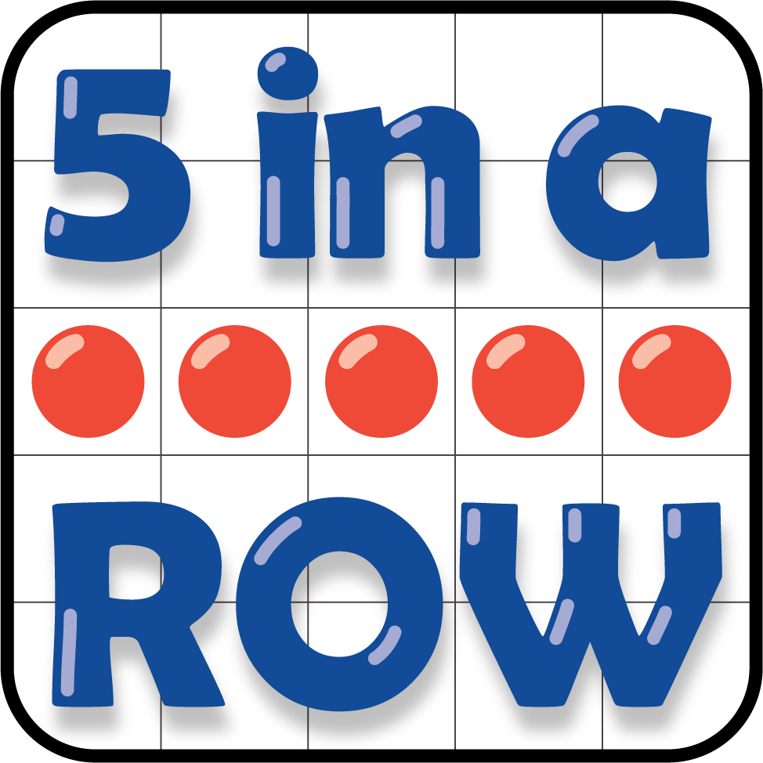
How Close?
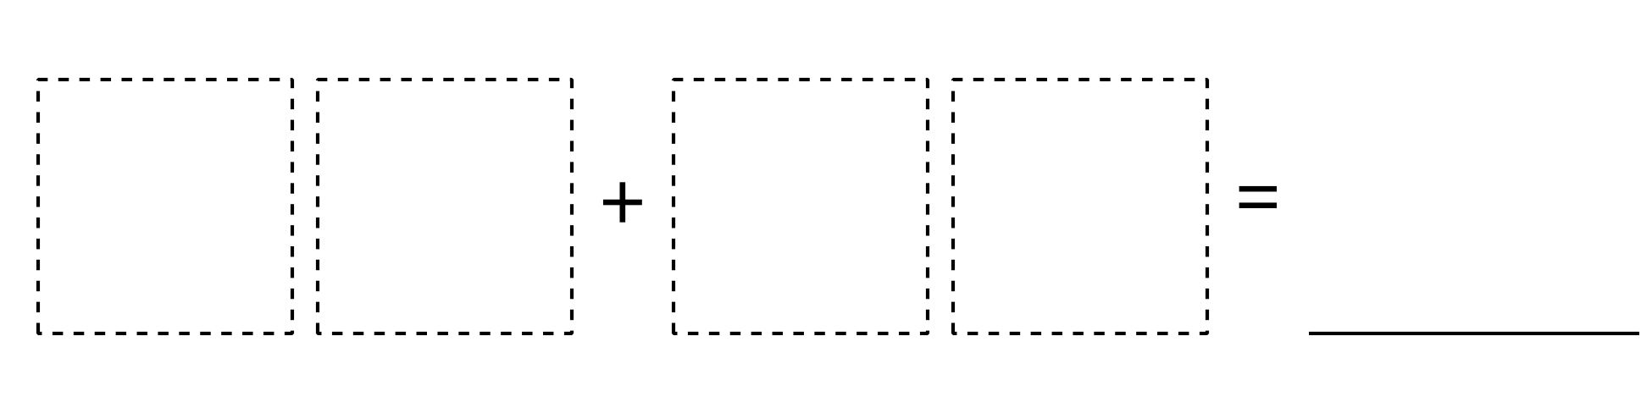
Number Puzzles
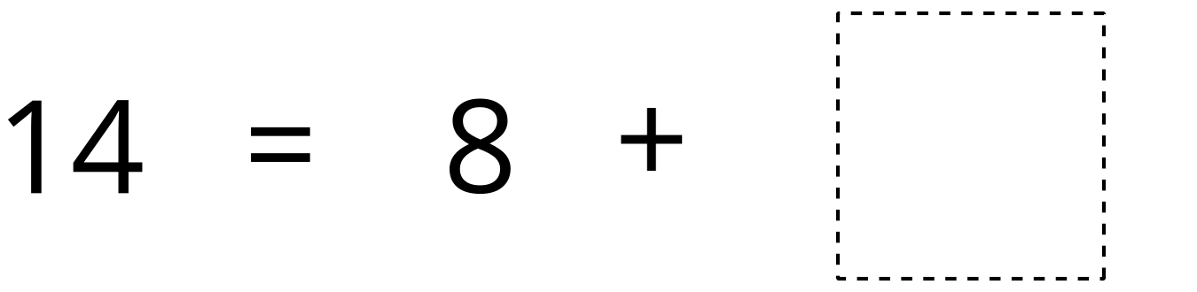
© CC BY 2021 Illustrative Mathematics®

