Lesson 8: More Questions about Scaled Bar Graphs
- Let’s solve problems using data shown on bar graphs.

Warm-up: Number Talk: Repeated Addition
Find the value of each expression mentally.
- $2+2+2+2+2$
- $2+2+2+2+2+2$
- $5+5+5+5+5+5$
- $5+5+5+5+5+5+5$

8.1: New School Year
A group of students were asked, “How are you feeling about the new school year?” Their responses are shown in this bar graph:
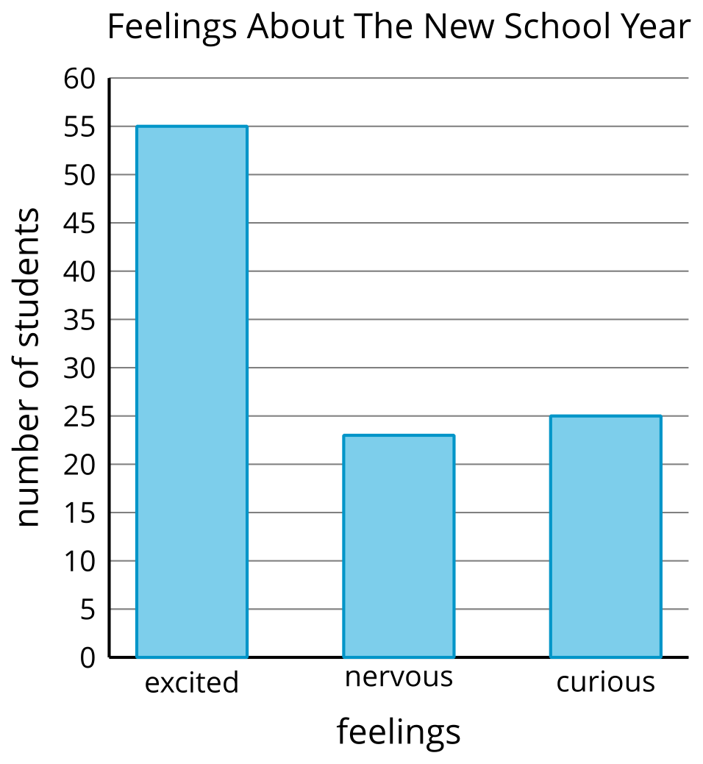
How many more students are excited about the new school year than are nervous or curious?

8.2: Use Bar Graphs to Solve Problems
The bar graph shows how many of each type of tree Clare saw on the way home. Use the graph to answer the questions. Show your thinking using expressions or equations.
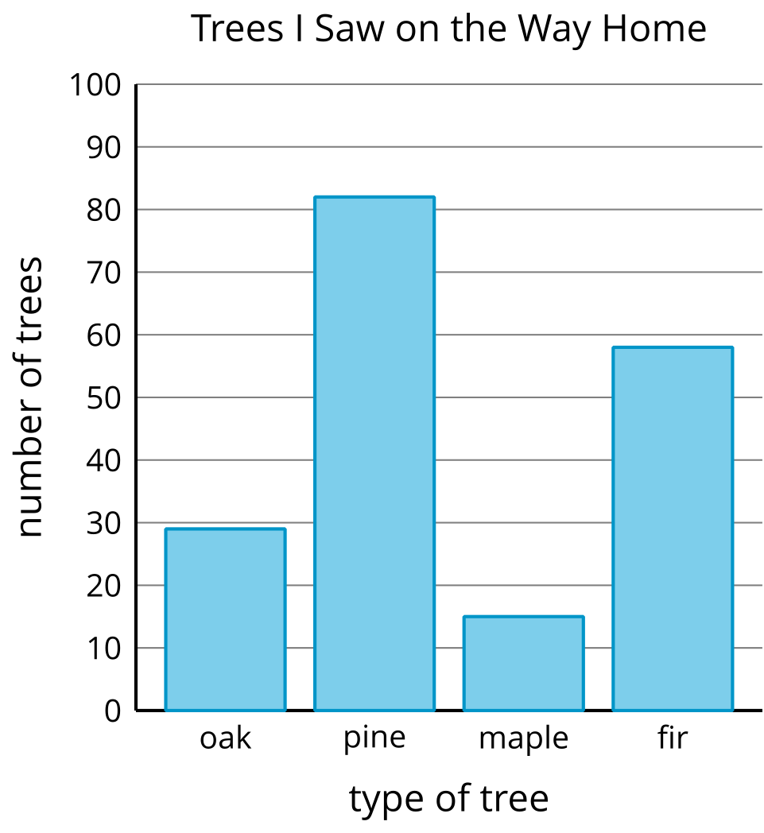
- How many more pine trees did Clare see than fir trees?
- How many more pine trees did Clare see than oak or maple trees?
- How many fewer oak trees did Clare see than pine trees?
- How many fewer maple or oak trees did Clare see than fir trees?

Section Summary
Section Summary
In this section, we created scaled picture graphs and scaled bar graphs.
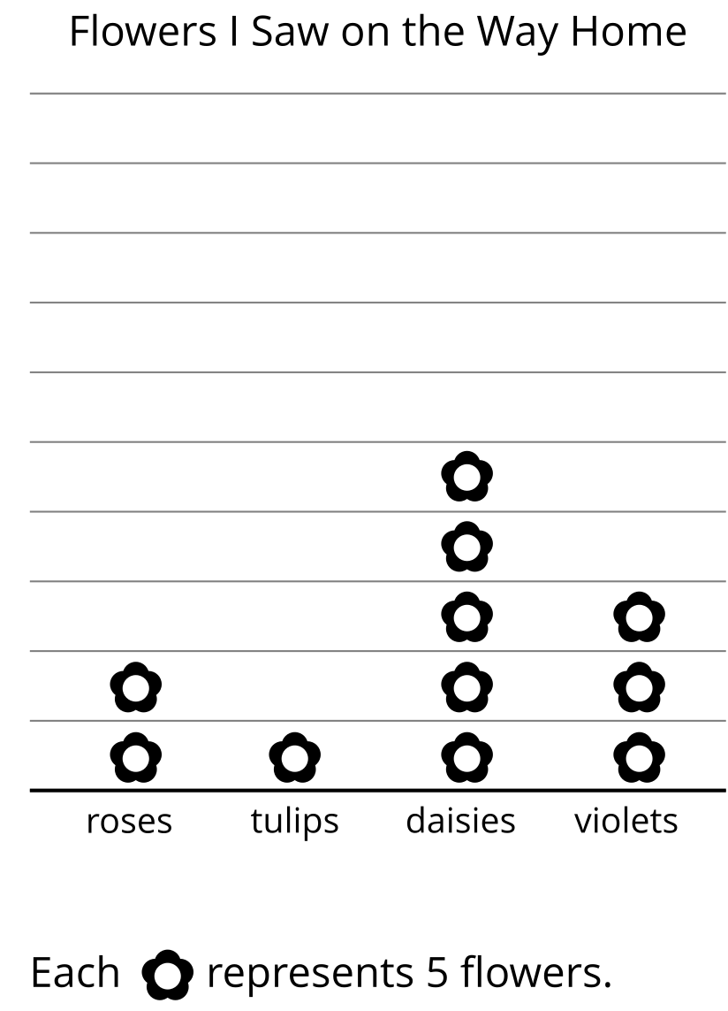
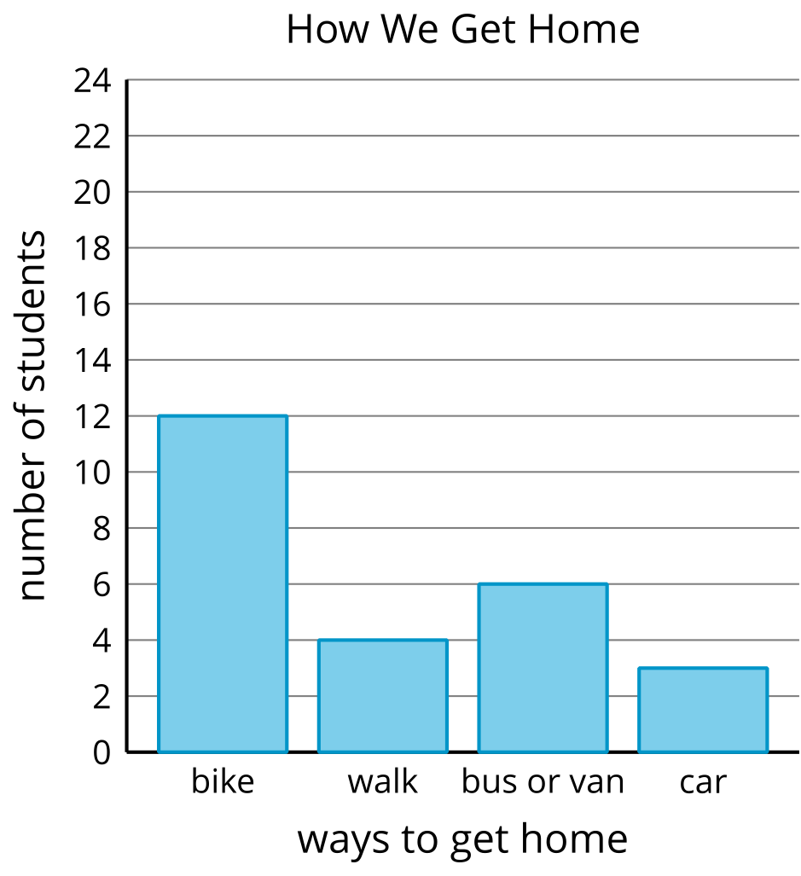
We asked and answered questions that could be answered by the graphs.
- How many more daisies were seen than violets?
- How many fewer students walk home than bike home?
- How many more students bike home than walk or ride in a car?
© CC BY 2021 Illustrative Mathematics®

