Unit 3 Lesson 6 Cumulative Practice Problems
- A group of friends is sharing $2\frac{1}{2}$ pounds of berries.
  - If each friend received $\frac{5}{4}$ of a pound of berries, how many friends are sharing the berries?
  - If 5 friends are sharing the berries, how many pounds of berries does each friend receive?
- $\frac{2}{5}$ kilogram of soil fills $\frac{1}{3}$ of a container. Can 1 kilogram of soil fit in the container? Explain or show your reasoning.
- After raining for $\frac{3}{4}$ of an hour, a rain gauge is $\frac{2}{5}$ filled. If it continues to rain at that rate for 15 more minutes, what fraction of the rain gauge will be filled?
  - To help answer this question, Diego wrote the equation $\frac{3}{4}÷\frac{2}{5}=?$. Explain why this equation does not represent the situation.
  - Write a multiplication equation and a division equation that do represent the situation.
- 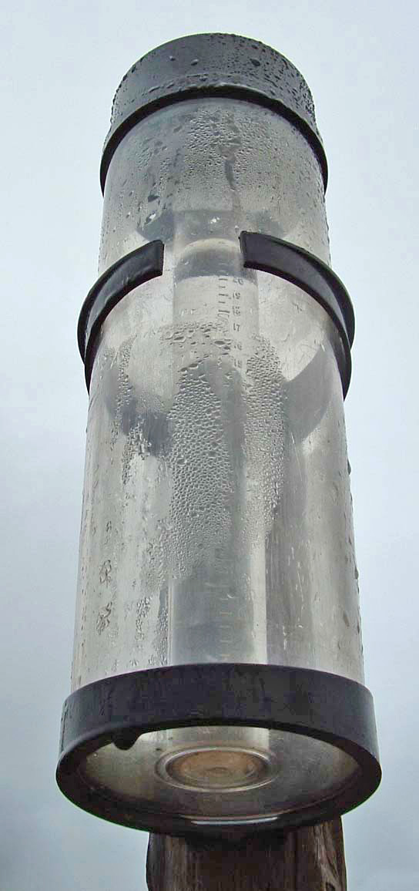
- 3 tickets to the museum cost $12.75. At this rate, what is the cost of:
  - 1 ticket?
  - 5 tickets?
- (From Unit 2, Lesson 6.)
- Elena went 60 meters in 15 seconds. Noah went 50 meters in 10 seconds. Elena and Noah both moved at a constant speed.
  - How far did Elena go in 1 second?
  - How far did Noah go in 1 second?
  - Who went faster? Explain or show your reasoning.
- (From Unit 2, Lesson 6.)
- The first row in the table shows a recipe for 1 batch of trail mix. Complete the table to show recipes for 2, 3, and 4 batches of the same type of trail mix.
- number of batches | - cups of cereal | - cups of almonds | - cups of raisins
- 1 | - 2 | - $\frac{1}{3}$ | - $\frac{1}{4}$
- 2
- 3
- 4
- (From Unit 2, Lesson 8.)
© CC BY Open Up Resources. Adaptations CC BY IM.

