Lesson 13: Amplitude and Midline
- Let's transform the graphs of trigonometric functions

13.1: Comparing Parabolas
Match each equation to its graph.
- $y=x^{2}$
- $y=3x^{2}$
- $y=3(x−1)^{2}$
- $y=3x^{2}−1$
- $y=x^{2}−1$

A
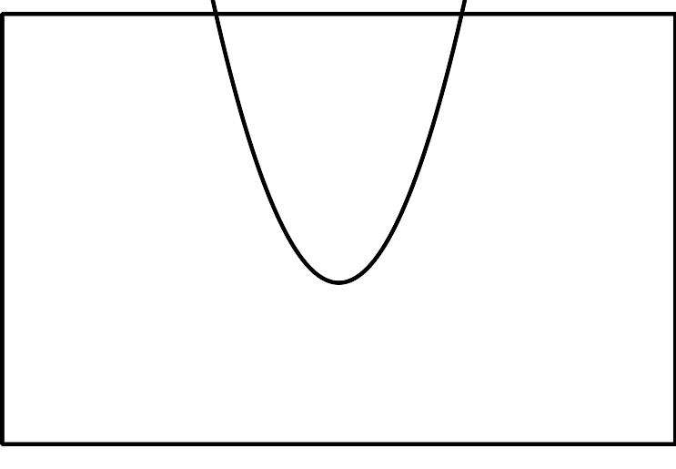

B
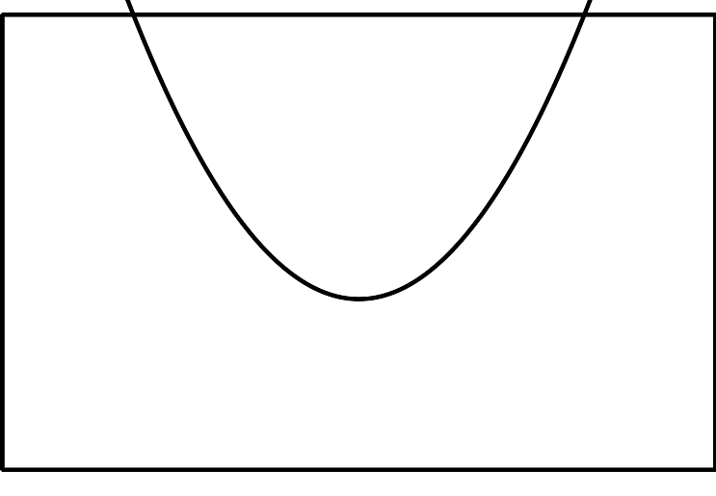

C
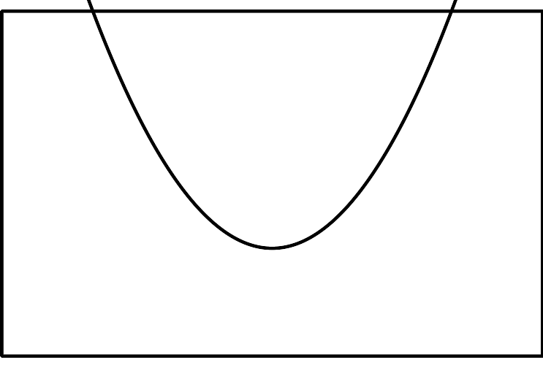

D
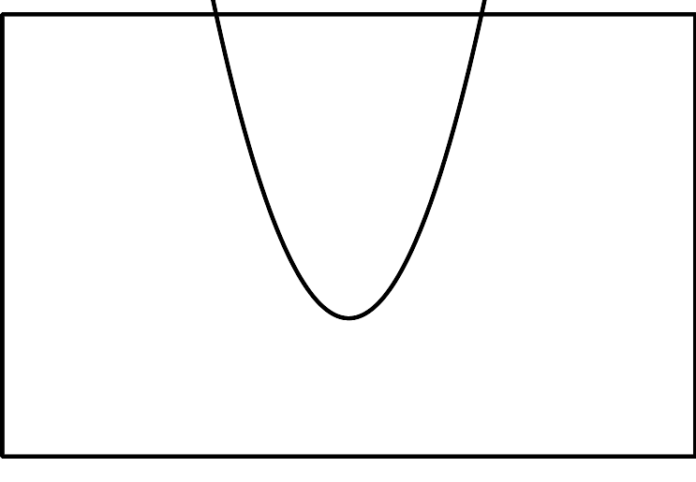

E
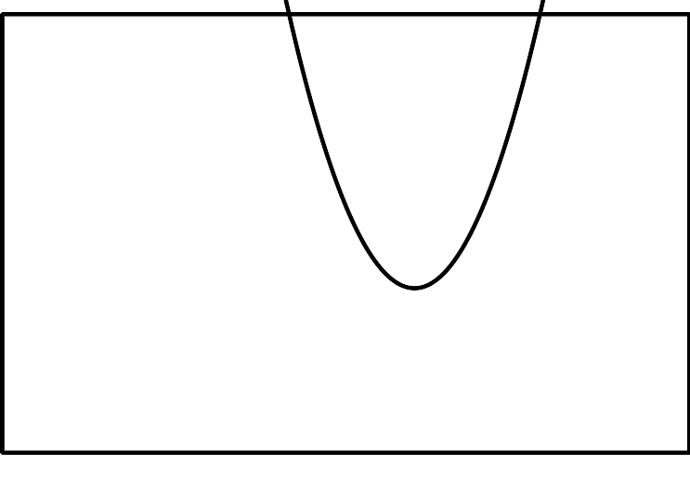
Be prepared to explain how you know which graph belongs with each equation.

13.2: Blowing in the Wind
Suppose a windmill has a radius of 1 meter and the center of the windmill is $(0,0)$ on a coordinate grid.
- Write a function describing the relationship between the height $h$ of $W$ and the angle of rotation $θ$. Explain your reasoning.
- Describe how your function and its graph would change if:
  - the windmill blade has length 3 meters.
  - The windmill blade has length 0.5 meter.
- Test your predictions using graphing technology.

13.3: Up, Up, and Away
- A windmill has radius 1 meter and its center is 8 meters off the ground. The point $W$ starts at the tip of a blade in the position farthest to the right and rotates counterclockwise. Write a function describing the relationship between the height $h$ of $W$, in meters, and the angle $θ$ of rotation.
- Graph your function using technology. How does it compare to the graph where the center of windmill is at $(0,0)$?
- What would the graph look like if the center of the windmill were 11 meters off the ground? Explain how you know.

Are you ready for more?
Here is the graph of a different function describing the relationship between the height $y$, in feet, of the tip of a blade and the angle of rotation $θ$ made by the blade. Describe the windmill.

Lesson 13 Summary
Suppose a bike wheel has radius 1 foot and we want to determine the height of a point $P$ on the wheel as it spins in a counterclockwise direction. The height $h$ in feet of the point $P$ can be modeled by the equation $h=\text{sin}(θ)+1$ where $θ$ is the angle of rotation of the wheel. As the wheel spins in a counterclockwise direction, the point first reaches a maximum height of 2 feet when it is at the top of the wheel, and then a minimum height of 0 feet when it is at the bottom.
The graph of the height of $P$ looks just like the graph of the sine function but it has been raised by 1 unit:
The horizontal line $h=1$, shown here as a dashed line, is called the midline of the graph.
What if the wheel had a radius of 11 inches instead? How would that affect the height $h$, in inches, of point $P$ over time? This wheel can also be modeled by a sine function, $h=11\text{sin}(θ)+11$, where $θ$ is the angle of rotation of the wheel. The graph of this function has the same wavelike shape as the sine function but its midline is at $h=11$ and its amplitude is different:
The amplitude of the function is the length from the midline to the maximum value, shown here with a dashed line, or, since they are the same, the length from the minimum value to the midline. For the graph of , the midline value is 11 and the maximum is 22. This means the amplitude is 11 since $22−11=11$.
© CC BY 2019 by Illustrative Mathematics®

