Lesson 1: Number Puzzles
Let’s solve some puzzles!

1.1: Notice and Wonder: A Number Line
What do you notice? What do you wonder?
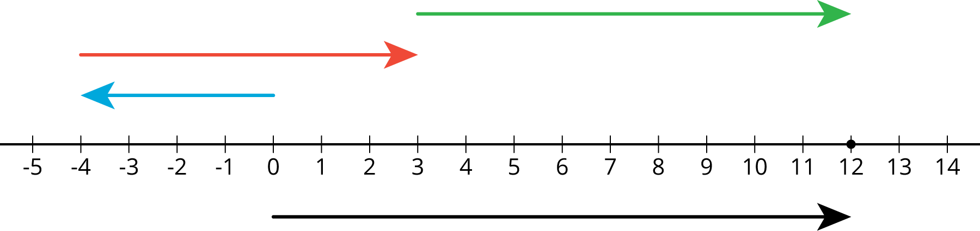

1.2: Telling Temperatures
Solve each puzzle. Show your thinking. Organize it so it can be followed by others.
- The temperature was very cold. Then the temperature doubled.
Then the temperature dropped by 10 degrees. Then the temperature increased by 40 degrees. The temperature is now 16 degrees. What was the starting temperature?
- Lin ran twice as far as Diego. Diego ran 300 m farther than Jada. Jada ran $\frac{1}{3}$ the distance that Noah ran. Noah ran 1200 m. How far did Lin run?

1.3: Making a Puzzle
Write another number puzzle with at least three steps. On a different piece of paper, write a solution to your puzzle.

Trade puzzles with your partner and solve theirs. Make sure to show your thinking.

With your partner, compare your solutions to each puzzle. Did they solve them the same way you did? Be prepared to share with the class which solution strategy you like best.

Are you ready for more?
Here is a number puzzle that uses math. Some might call it a magic trick!
- Think of a number.
- Double the number.
- Add 9.
- Subtract 3.
- Divide by 2.
- Subtract the number you started with.
- The answer should be 3.
Why does this always work? Can you think of a different number
puzzle that uses math (like this one) that will always result in 5?

Lesson 1 Summary
Here is an example of a puzzle problem:
Twice a number plus 4 is 18. What is the number?
There are many different ways to represent and solve puzzle problems.
- We can reason through it.
Twice a number plus 4 is 18.
Then twice the number is $18−4=14$.
That means the number is 7.
- We can draw a diagram.
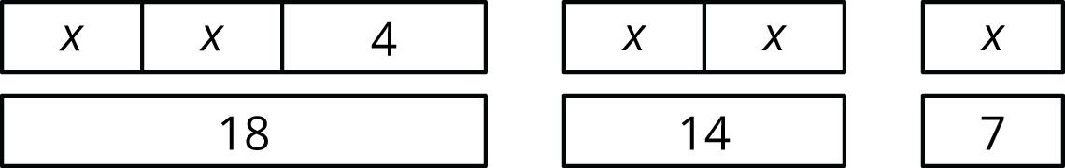
- We can write and solve an equation. $2x+4=18$ $2x=14$ $x=7$
Reasoning and diagrams help us see what is going on and why the answer is what it is. But as number puzzles and story problems get more complex, those methods get harder, and equations get more and more helpful. We will use different kinds of diagrams to help us understand problems and strategies in future lessons, but we will also see the power of writing and solving equations to answer increasingly more complex mathematical problems.
© CC BY Open Up Resources. Adaptations CC BY IM.

