Lesson 11 Practice Problems
- Match each equation to its solution and to the story it describes.
- Equations:
  - $5x−7=3$
  - $7=3\left(5+x\right)$
  - $3x+5=\text{-}7$
  - $\frac{1}{3}\left(x+7\right)=5$
- Solutions:
  - -4
  - $\frac{\text{-}8}{3}$
  - 2
  - 8
- Stories:
  - The temperature is $\text{-}7$. Since midnight the temperature tripled and then rose 5 degrees. What was temperature at midnight?
  - Jada has 7 pink roses and some white roses. She gives all of them away: 5 roses to each of her 3 favorite teachers. How many white roses did she give away?
  - A musical instrument company reduced the time it takes for a worker to build a guitar. Before the reduction it took 5 hours. Now in 7 hours they can build 3 guitars. By how much did they reduce the time it takes to build each guitar?
  - A club puts its members into 5 groups for an activity. After 7 students have to leave early, there are only 3 students left to finish the activity. How many students were in each group?
- The baby giraffe weighed 132 pounds at birth. He gained weight at a steady rate for the first 7 months until his weight reached 538 pounds. How much did he gain each month?
- Six teams are out on the field playing soccer. The teams all have the same number of players. The head coach asks for 2 players from each team to come help him move some equipment. Now there are 78 players on the field. Write and solve an equation whose solution is the number of players on each team.
- The points $\left(2,\text{-}4\right)$, $\left(x,y\right)$, $A$, and $B$ all lie on the line. Find an equation relating $x$ and $y$.
- 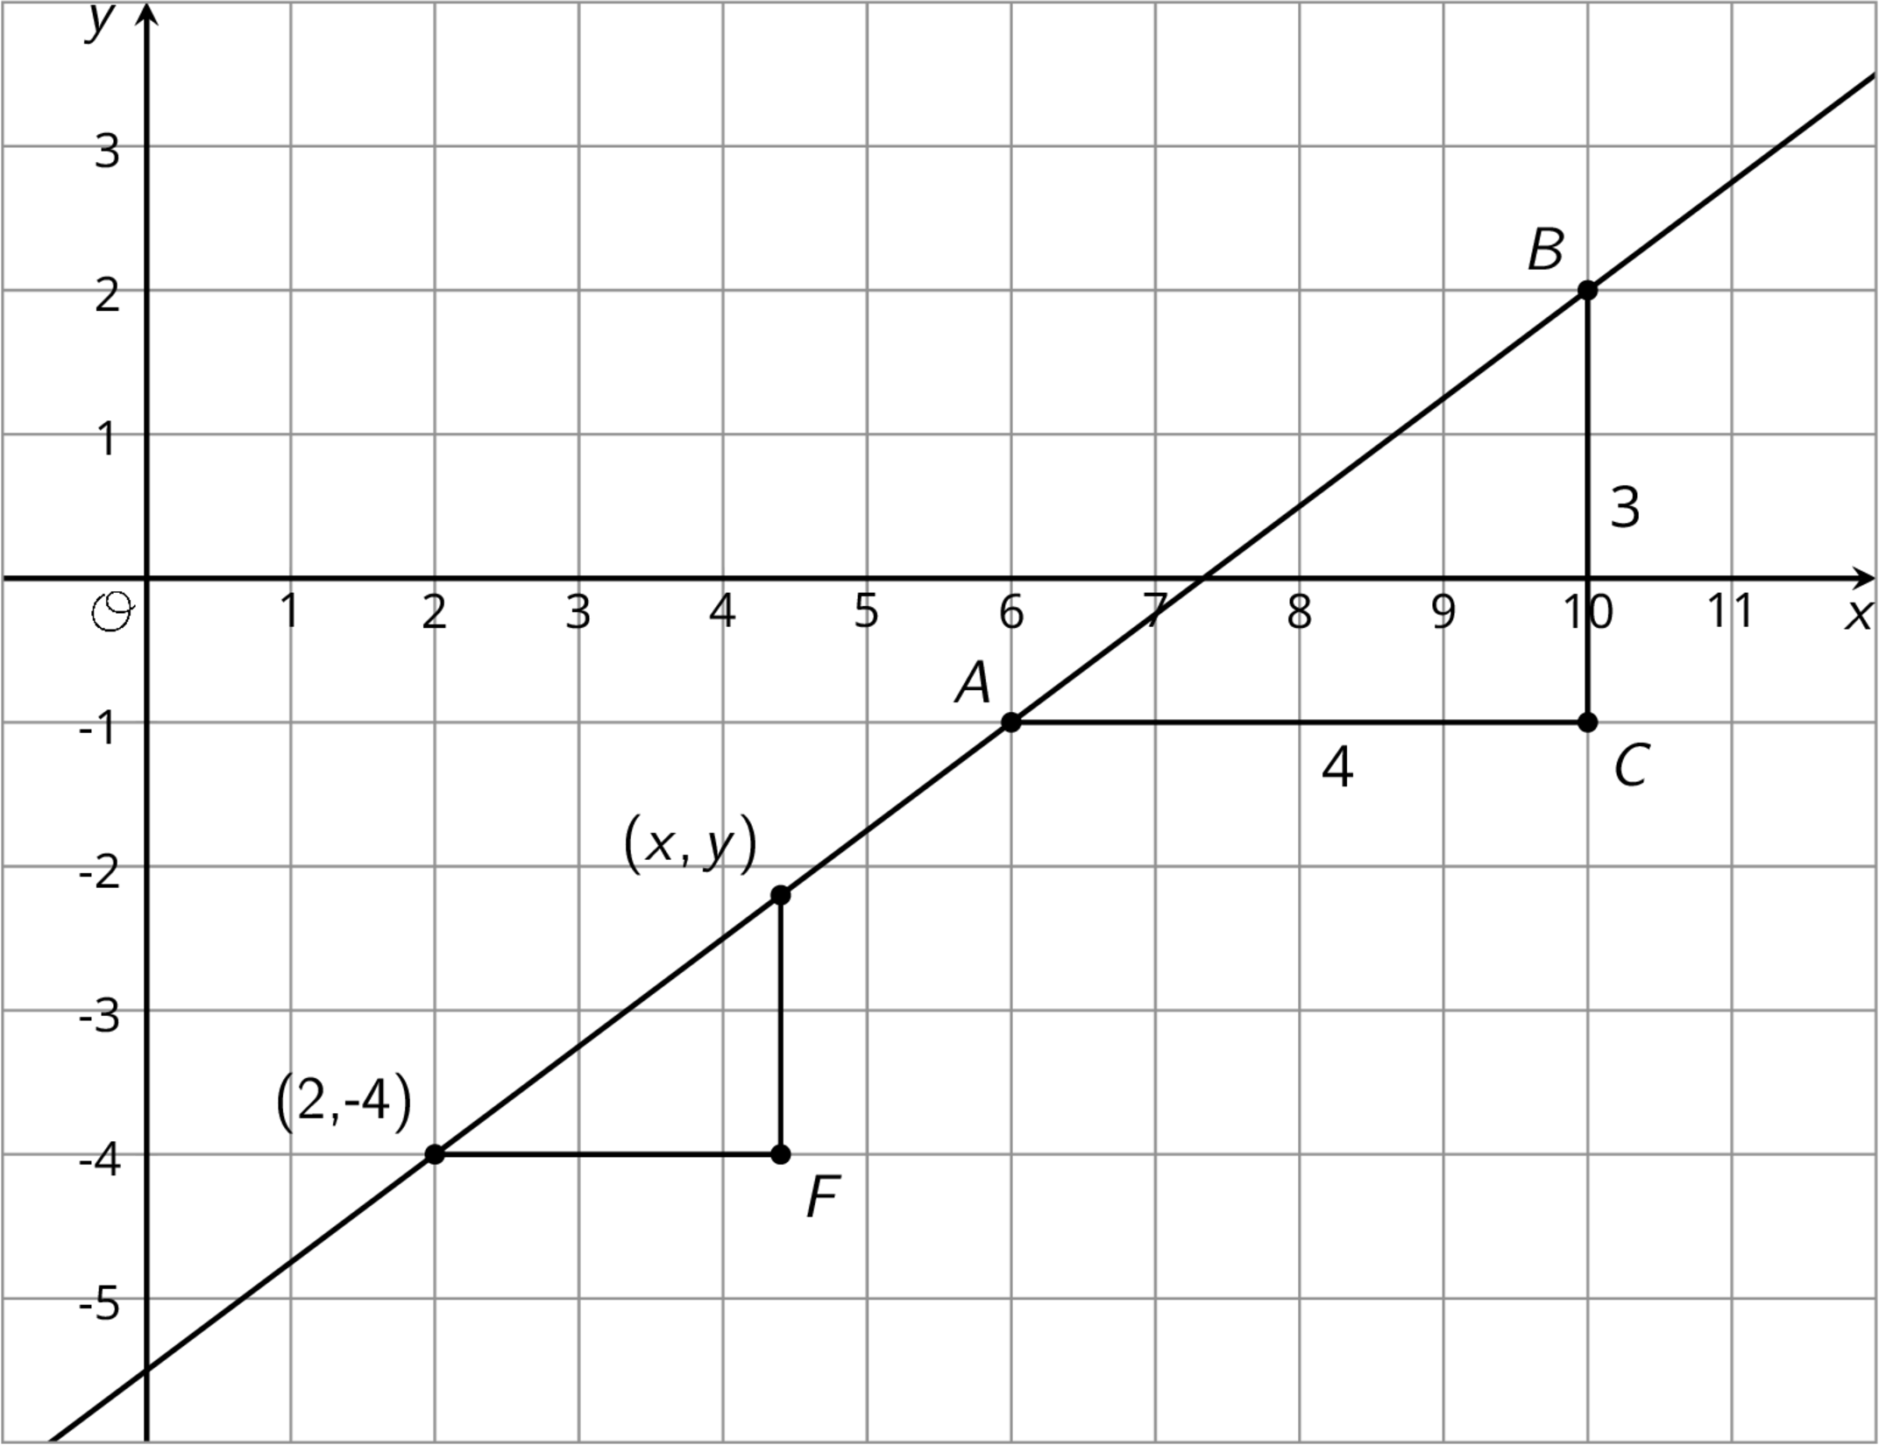
- (From Unit 2, Lesson 16.)
© CC BY Open Up Resources. Adaptations CC BY IM.

