Lesson 3: Congruent Triangles, Part 1
- Let’s use transformations to be sure that two triangles are congruent.

3.1: True or . . . Sometimes True?: Triangles
If triangle $ABC$ is congruent to triangle $A^{′}B^{′}C^{′}$. . .
- What must be true?
- What could possibly be true?
- What definitely can’t be true?

3.2: Invisible Triangles
Player 1: You are the transformer. Take the transformer card.
Player 2: Select a triangle card. Do not show it to anyone. Study the diagram to figure out which sides and which angles correspond. Tell Player 1 what you have figured out.
Player 1: Take notes about what they tell you so that you know which parts of their triangles correspond. Think of a sequence of rigid motions you could tell your partner to get them to take one of their triangles onto the other. Be specific in your language. The notes on your card can help with this.
Player 2: Listen to the instructions from the transformer. Use tracing paper to follow their instructions. Draw the image after each step. Let them know when they have lined up 1, 2, or all 3 vertices on your triangles.

Are you ready for more?
Replay invisible triangles, but with a twist. This time, the transformer can only use reflections—the last 2 sentence frames on the transformer card. You may wish to include an additional sentence frame: Reflect _____ across the angle bisector of angle _____.

3.3: Why Do They Coincide?
Noah and Priya were playing Invisible Triangles. For card 3, Priya told Noah that in triangles $ABC$ and $DEF$:
- $\overset{¯}{AB}≅\overset{¯}{DE}$
- $\overset{¯}{AC}≅\overset{¯}{DF}$
- $\overset{¯}{BC}≅\overset{¯}{EF}$
- $∠A≅∠D$
- $∠B≅∠E$
- $∠C≅∠F$
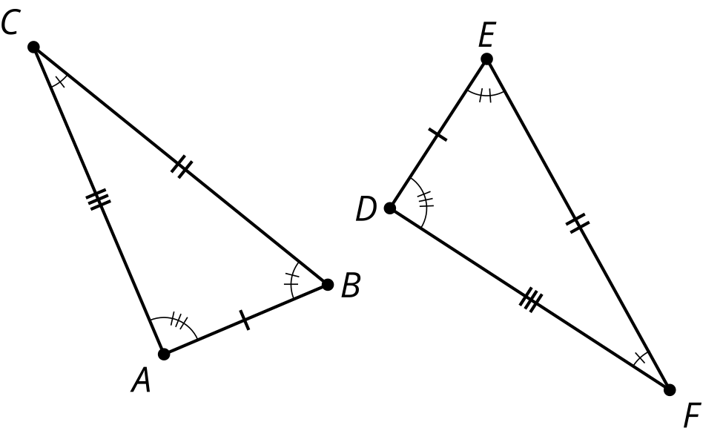
Here are the steps Noah had to tell Priya to do before all 3 vertices coincided:
- Translate triangle $ABC$ by the directed line segment from $A$ to $D$.
- Rotate the image, triangle $A^{′}B^{′}C^{′}$, using $D$ as the center, so that rays $A^{″}B^{″}$ and $DE$ line up.
- Reflect the image, triangle $A^{″}B^{″}C^{″}$, across line $DE$.
After those steps, the triangles were lined up perfectly. Now Noah and Priya are working on explaining why their steps worked, and they need some help. Answer their questions.
First, we translate triangle $ABC$ by the directed line segment from $A$ to $D$. Point $A^{′}$ will coincide with $D$ because we defined our transformation that way. Then, rotate the image, triangle $A^{′}B^{′}C^{′}$, by the angle $B^{′}DE$, so that rays $A^{″}B^{″}$ and $DE$ line up.
- We know that rays $A^{″}B^{″}$ and $DE$ line up because we said they had to, but why do points $B^{″}$ and $E$ have to be in the exact same place?
- Finally, reflect the image, triangle $A^{″}B^{″}C^{″}$ across $DE$.
  - How do we know that now, the image of ray $A^{″}C^{″}$ and ray $DF$ will line up?
  - How do we know that the image of point $C^{″}$ and point $F$ will line up exactly?

Lesson 3 Summary
If all corresponding parts of 2 triangles are congruent, then one triangle can be taken exactly onto the other triangle using a sequence of translations, rotations, and reflections. The congruence of corresponding parts justifies that the vertices of the triangles will line up exactly.
One of the most common ways to line up the vertices is through a translation to get one pair of vertices to line up, followed by a rotation to get a second pair of vertices to line up, and if needed, a reflection to get the third pair of vertices lined up. There are multiple ways to justify why the vertices must line up if the triangles are congruent, but here is one way to do it:
First, translate triangle $ABC$ by the directed line segment from $A$ to $D$. Points $A$ and $D$ coincide after translating because we defined our translation that way! Then, rotate the image of triangle $ABC$ using $D$ as the center, so that rays $A^{′}B^{′}$ and $DE$ line up.

$\overset{¯}{AB}≅\overset{¯}{DE},\overset{¯}{BC}≅\overset{¯}{EF},\overset{¯}{AC}≅\overset{¯}{DF},$ $∠A≅∠D,∠B≅∠E,∠C≅∠F$
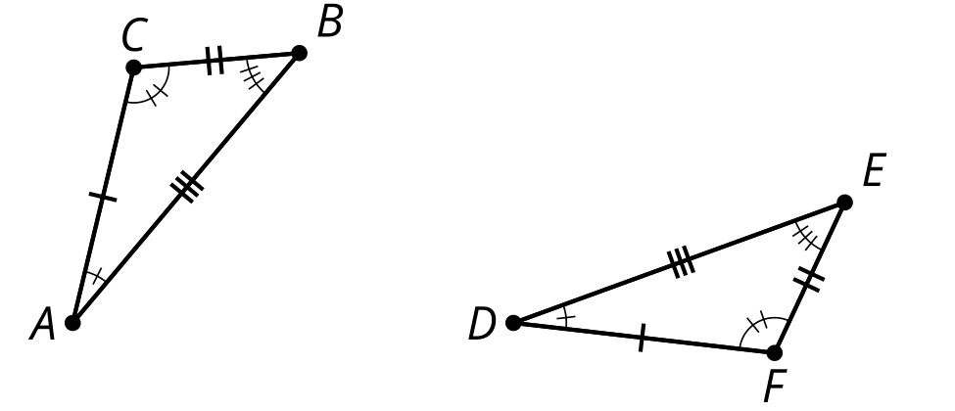
We know that rays $A^{′}B^{′}$ and $DE$ line up because that’s how we defined the rotation. The distance $AB$ is the same as the distance $DE$, because translations and rotations don’t change distances. Since points $B^{′}$ and $E$ are the same distance along the same ray from $D$, they have to be in the same place.
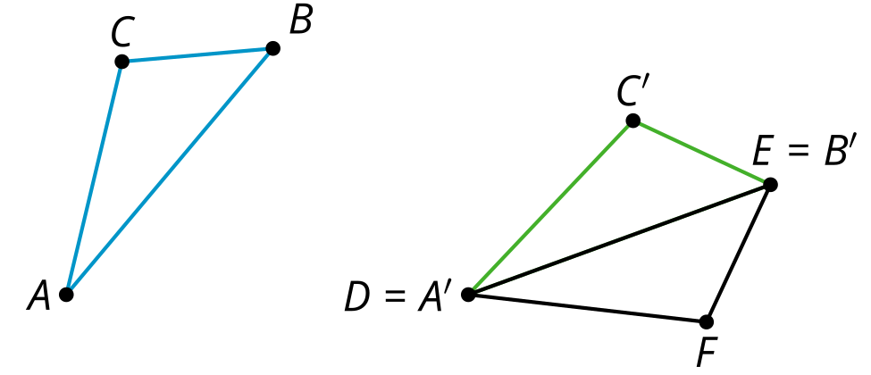
If necessary, reflect triangle $A^{′}B^{′}C^{′}$ across $DE$ so that the image of $C$ is on the same side of $DE$ as $F$. We know angle $A$ is congruent to angle $D$ because translation, rotation, and reflection don’t change angles.
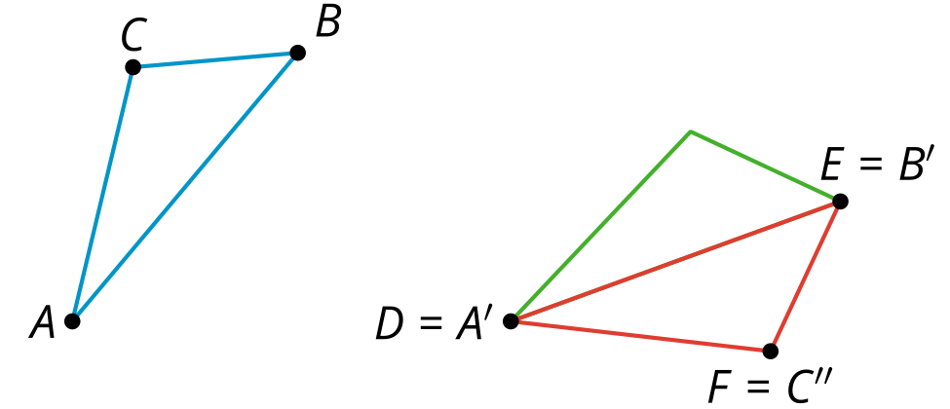
$C^{″}$ must be on ray $DF$ since both $C^{″}$ and $F$ are on the same side of $DE$ and make the same angle with it at $D$. We know the distance $AC$ is the same as the distance $DF$, so that means $C^{″}$ is the same distance from $A^{″}$ as $F$ is from $D$ (because translations and rotations preserve distance). Since $F$ and $C^{″}$ are the same distance along the same ray from $D$, they have to be in the same place.
© CC BY 2019 by Illustrative Mathematics®

