Lesson 3: Count 2 Groups of Scattered Images
- Let’s find out how many things there are in two scattered groups.

3.1: Count Organized and Scattered Images

- 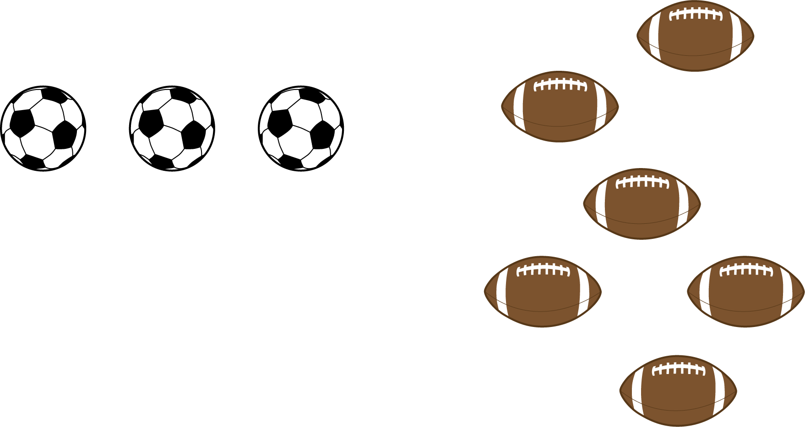
- There are
- balls.

- 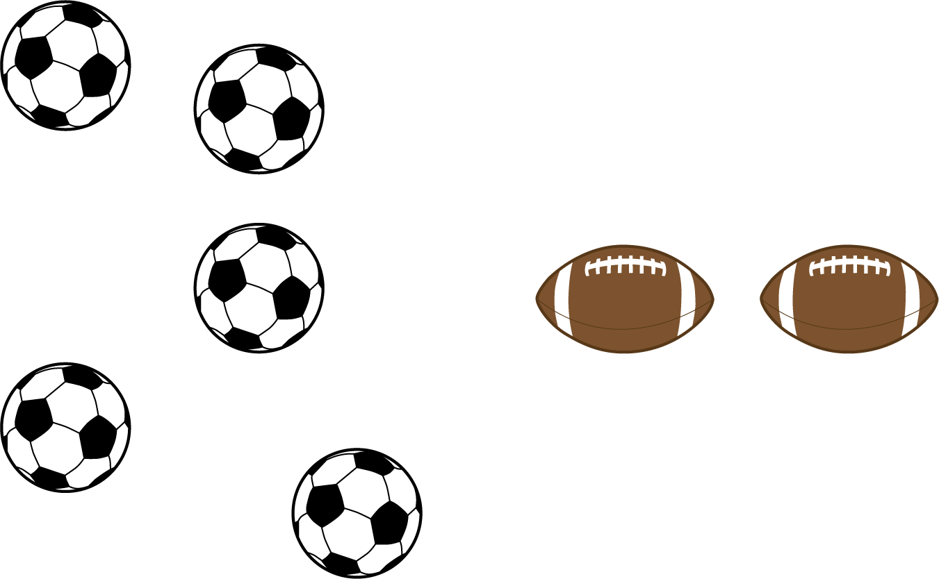
- There are
- balls.

- 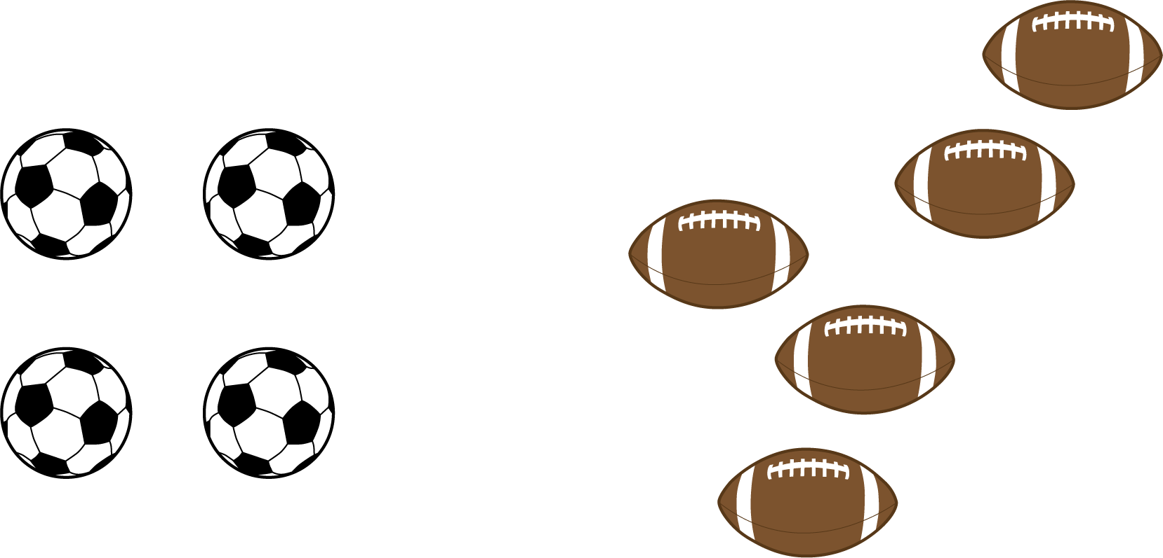
- There are
- balls.

- 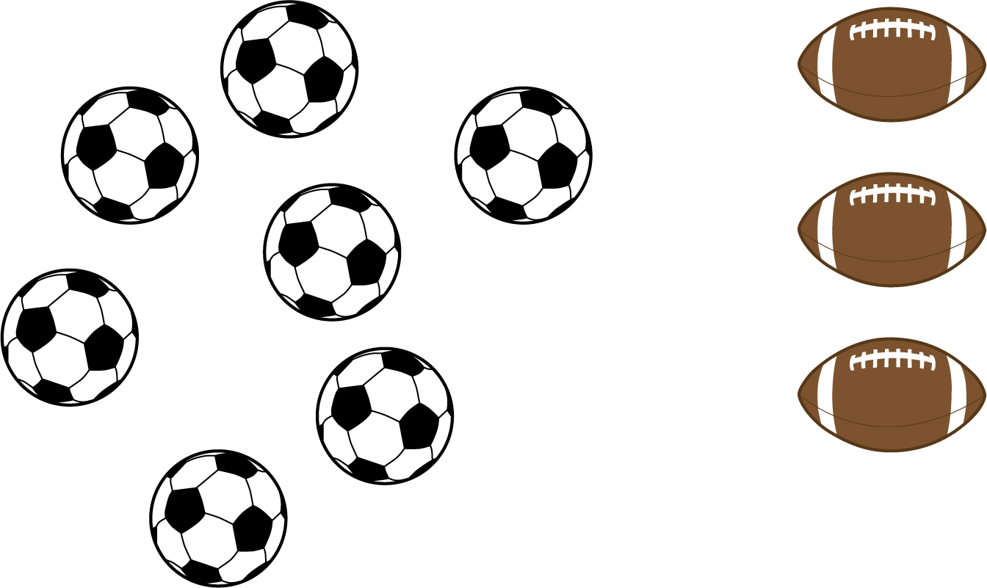
- There are
- balls.

3.2: Count Scattered Images

- 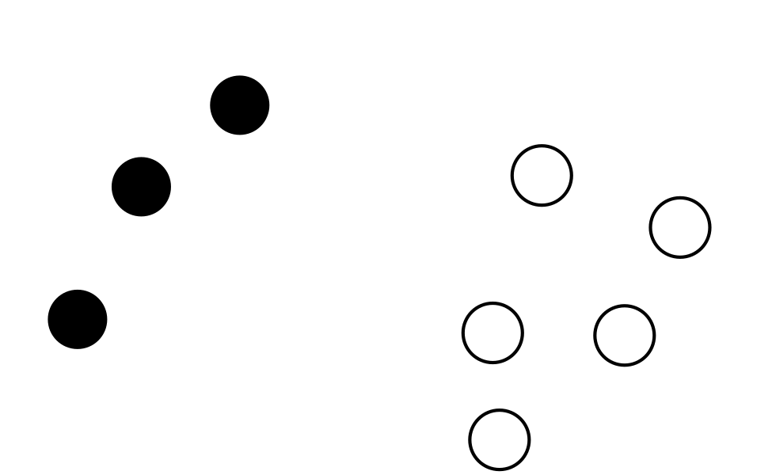
- There are
- circles.

- There are
- circles.

- There are
- circles.

- 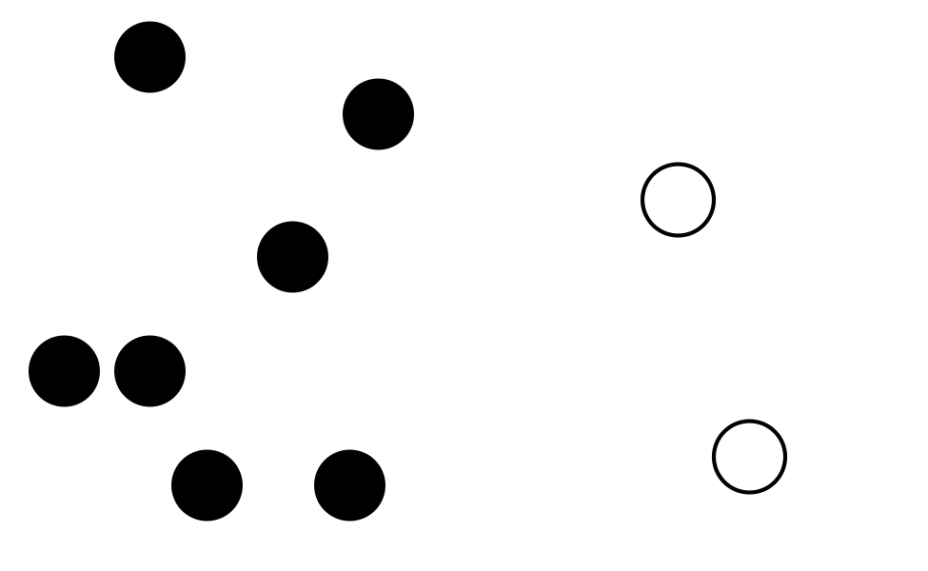
- There are
- circles.

3.3: Centers: Choice Time
Choose a center.
Roll and Add
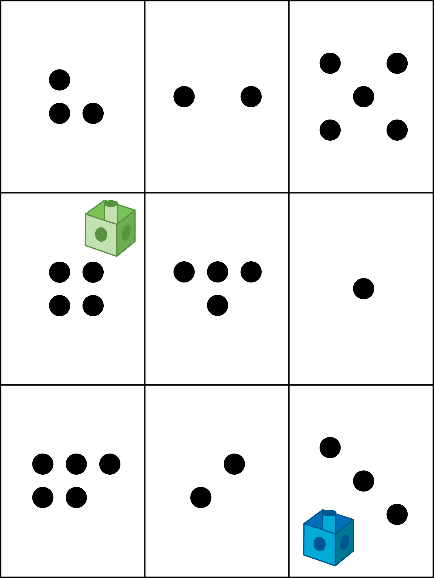
Math Libs
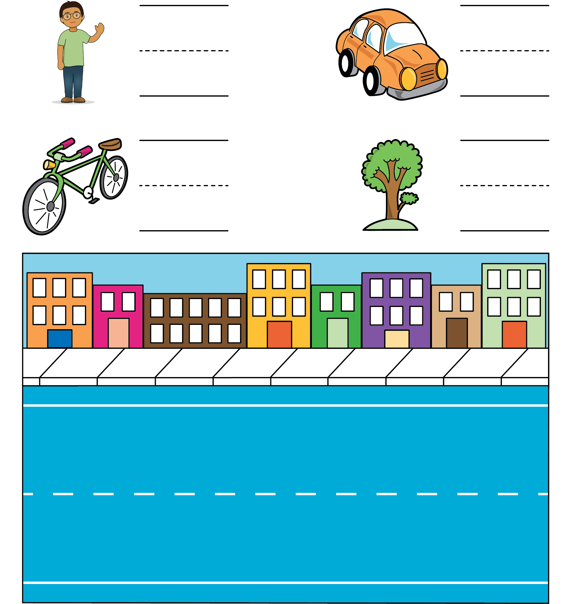
Match Mine
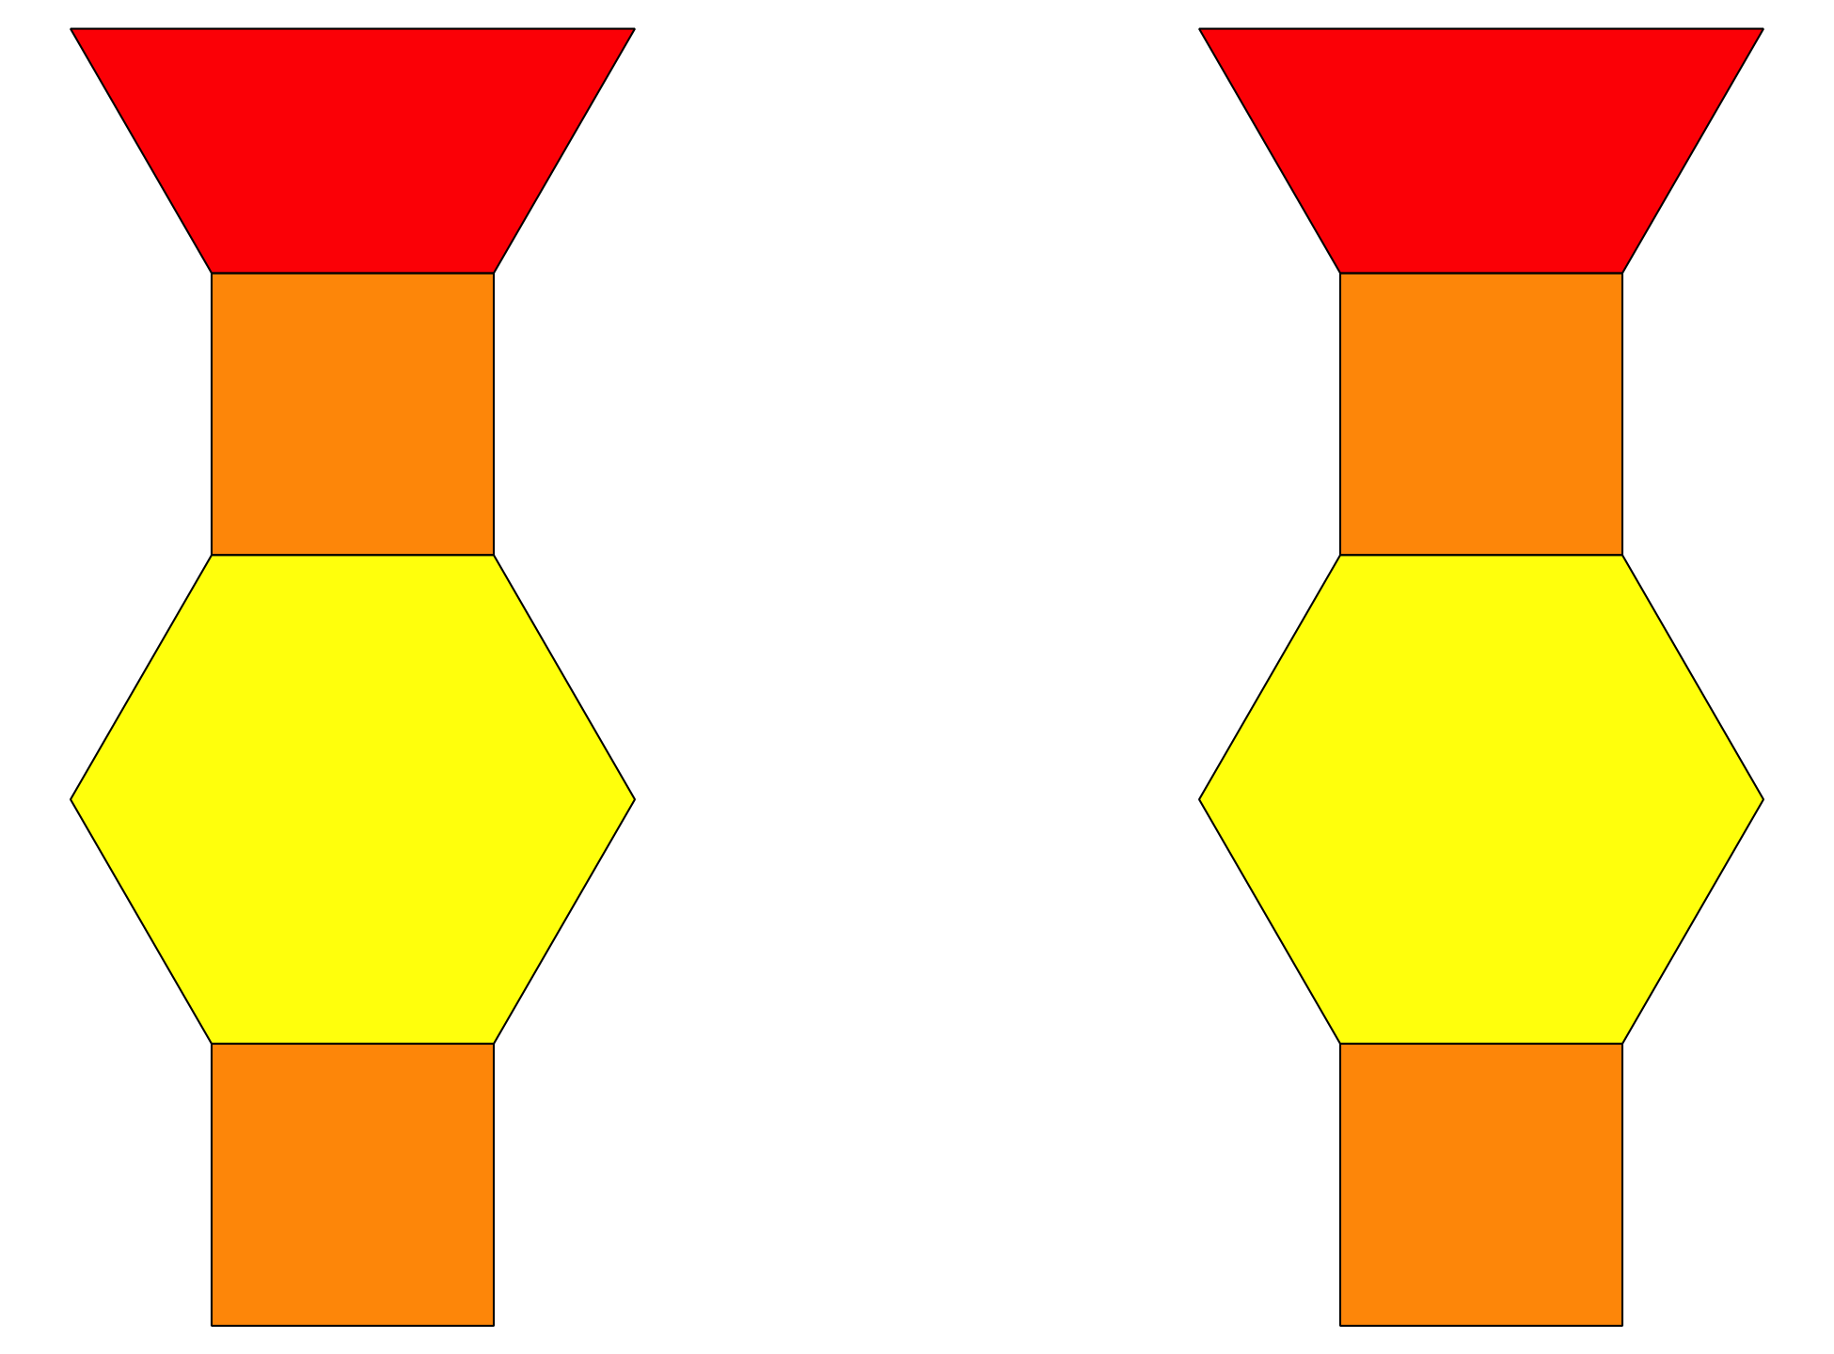
© CC BY 2021 Illustrative Mathematics®

