Lesson 15: Decompose a Ten and a Hundred to Subtract

Standards Alignments
Addressing | 2.NBT.A.2, 2.NBT.B.7, 2.NBT.B.9

Teacher-facing Learning Goals
- Subtract 2 three-digit numbers using place value strategies that include decomposing 2 units.

Student-facing Learning Goals
- Let’s subtract within 1,000.

Lesson Purpose
The purpose of this lesson is for students to subtract 2 three-digit numbers using strategies based on place value.
In previous lessons, students subtracted 2 three-digit numbers and decomposed a ten or a hundred in order to subtract by place. Students analyzed problems to anticipate when one or more units may be decomposed and used their analysis to choose their method and their steps.
In this lesson, students subtract 2 three-digit numbers that require decomposing a hundred and a ten when subtracting by place. They connect the use of base-ten blocks or diagrams to written methods that use numbers and equations. Throughout the lesson, students interpret and share methods that use words and equations to show subtracting by place (MP2, MP7). However, students should be encouraged to attend to the numbers in expressions and may use base-ten blocks, base-ten diagrams, and any other representations that make sense to them.

Access for:

Students with Disabilities
- Engagement (Activity 2)

English Learners
- MLR8 (Activity 2)

Instructional Routines
Choral Count (Warm-up)

Materials to Gather
- Base-ten blocks: Activity 1, Activity 2

Materials to Copy
- Walk About and Subtract Cards (groups of 24): Activity 2

Lesson Timeline
Warm-up | 10 min
Activity 1 | 15 min
Activity 2 | 20 min
Lesson Synthesis | 10 min
Cool-down | 5 min

Teacher Reflection Question
What part of the lesson went really well today in terms of students learning? What did you do that made that part go well?

Cool-down
(to be completed at the end of the lesson) 5min
Find the Error

Standards Alignments
Addressing | 2.NBT.B.7

Student-facing Task Statement
Noah found the value of $532−358$. Here is his work.
$500−300=200$
$50−30=20$
$8−2=6$
$200+20+6=226$
- Explain Noah's error.
- Show Noah a way to find the value of $532−358$.

Student Responses
- Noah found the value of $558−332$ not $532−358$. If he wants to subtract by place, he would have to decompose. You can’t just switch the digits around.
- 174. Sample responses:

  - 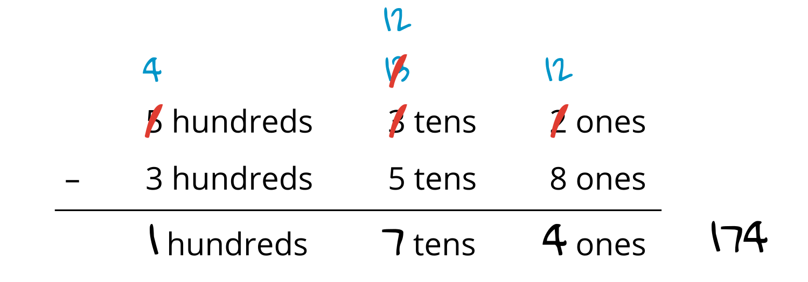
  - Students draw a base-ten diagram that shows $432−358$. Students show decomposing a hundred and a ten. They show subtracting 358 and clearly label to show the difference as 174.

