Lesson 6: Choose a Scale
- Let’s choose a scale for our bar graph.

Warm-up: Notice and Wonder: Bar Graph Scales
What do you notice? What do you wonder?
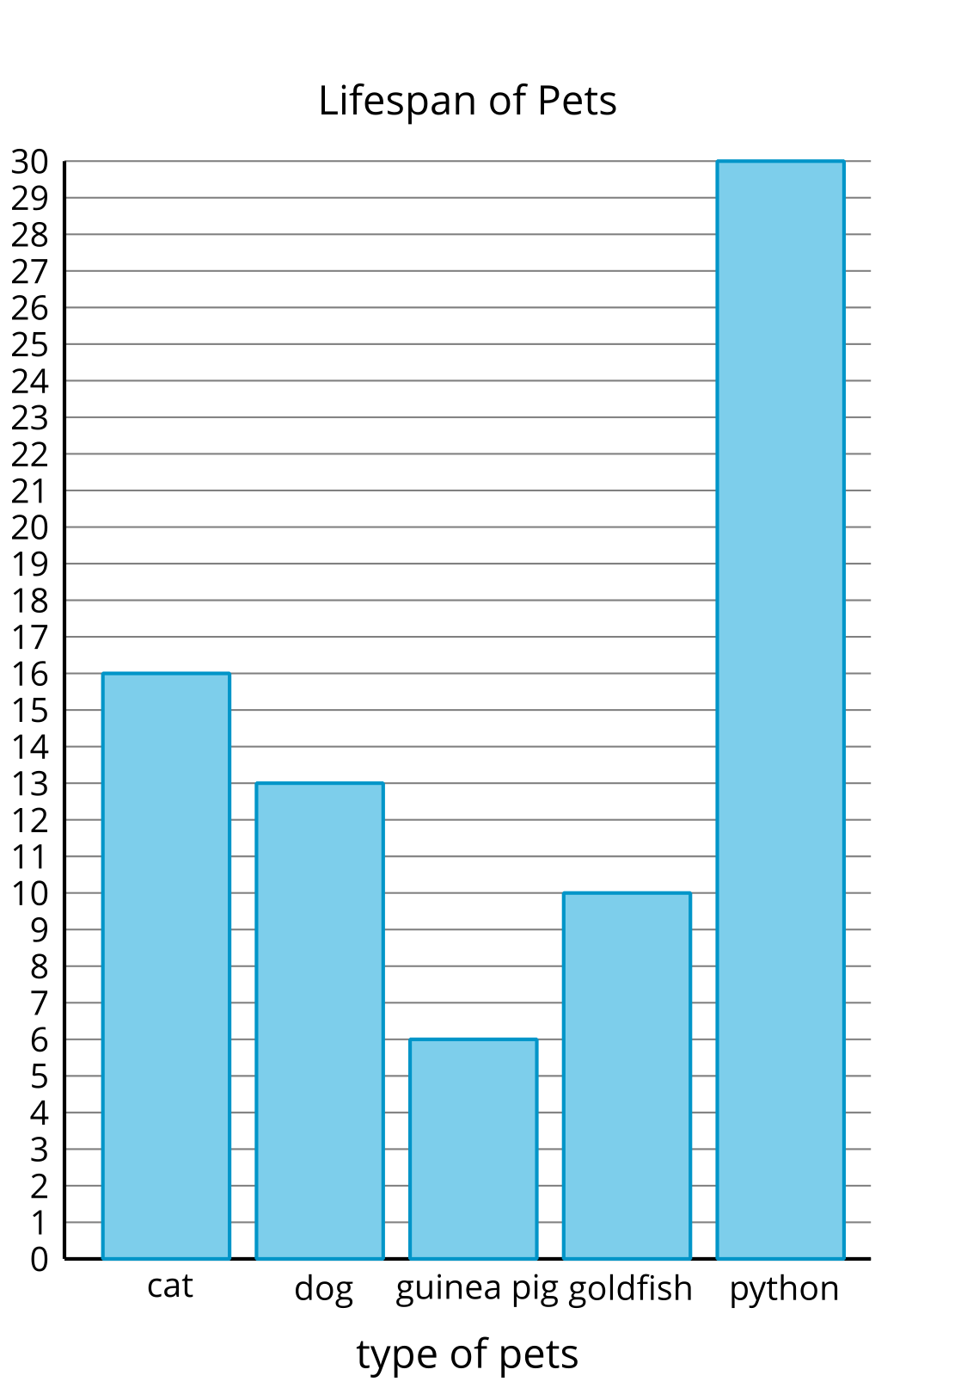
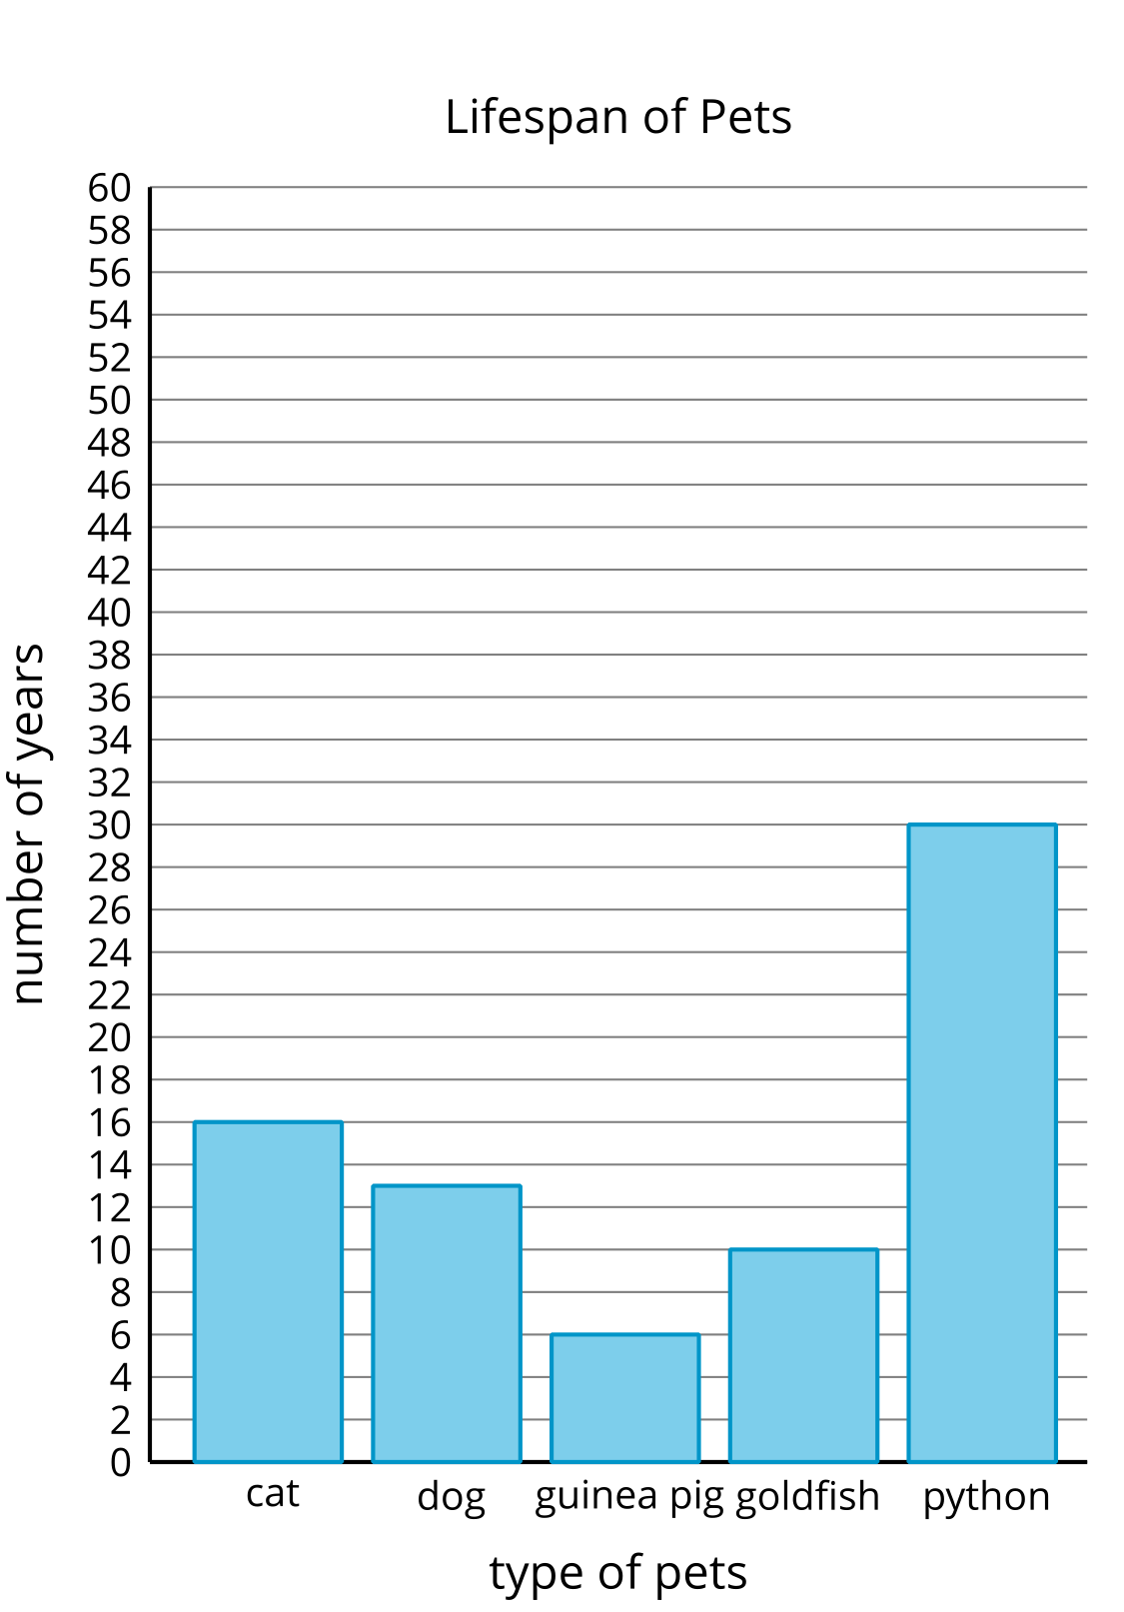
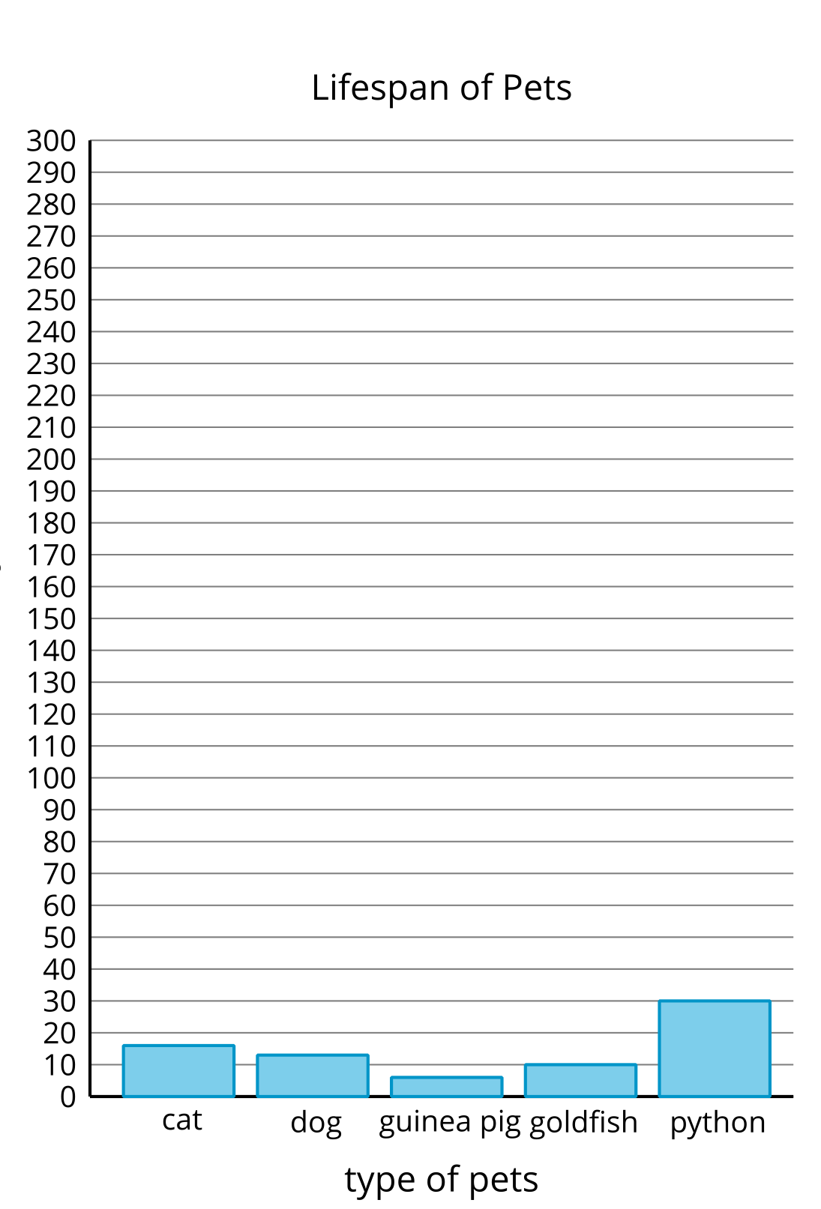

6.1: Represent Pattern Blocks
Here is a collection of pattern blocks.
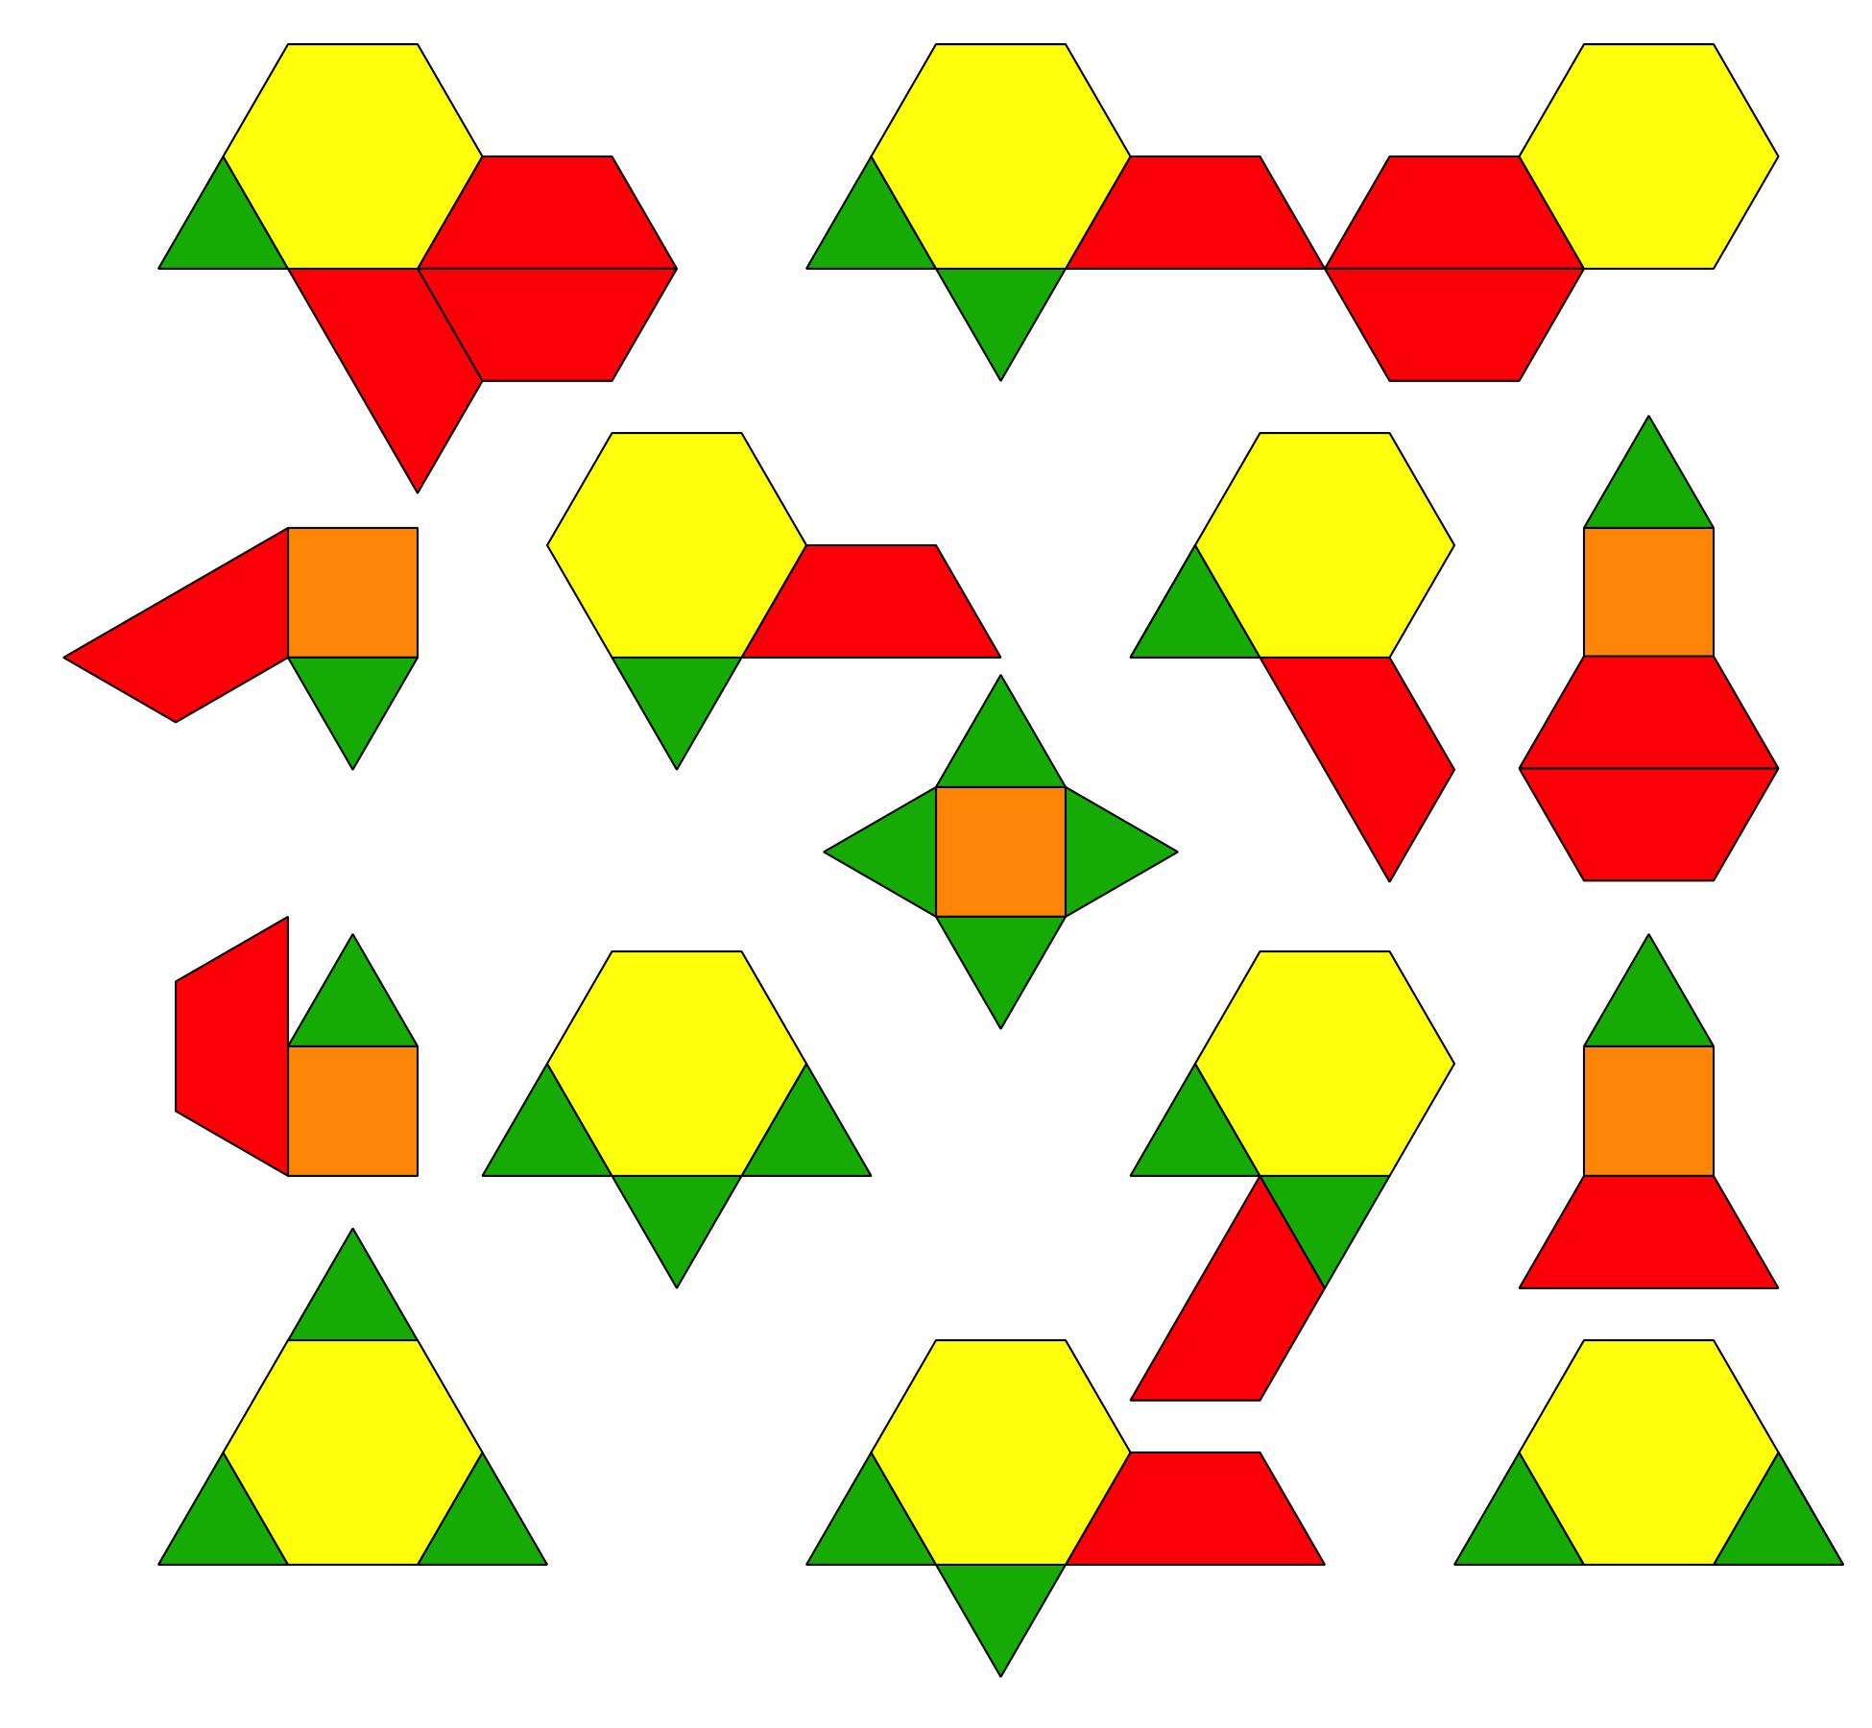
Mai, Noah, and Priya want to make a bar graph to represent the number of triangles, squares, trapezoids, and hexagons in the collection.
- Mai says the scale of the bar graph should be 2.
- Noah says the scale of the bar graph should be 5.
- Priya says the scale of the bar graph should be 10.
- Who do you agree with? Explain your reasoning.
- Use the scale that you chose to create a scaled bar graph to represent the collection of pattern blocks.
- 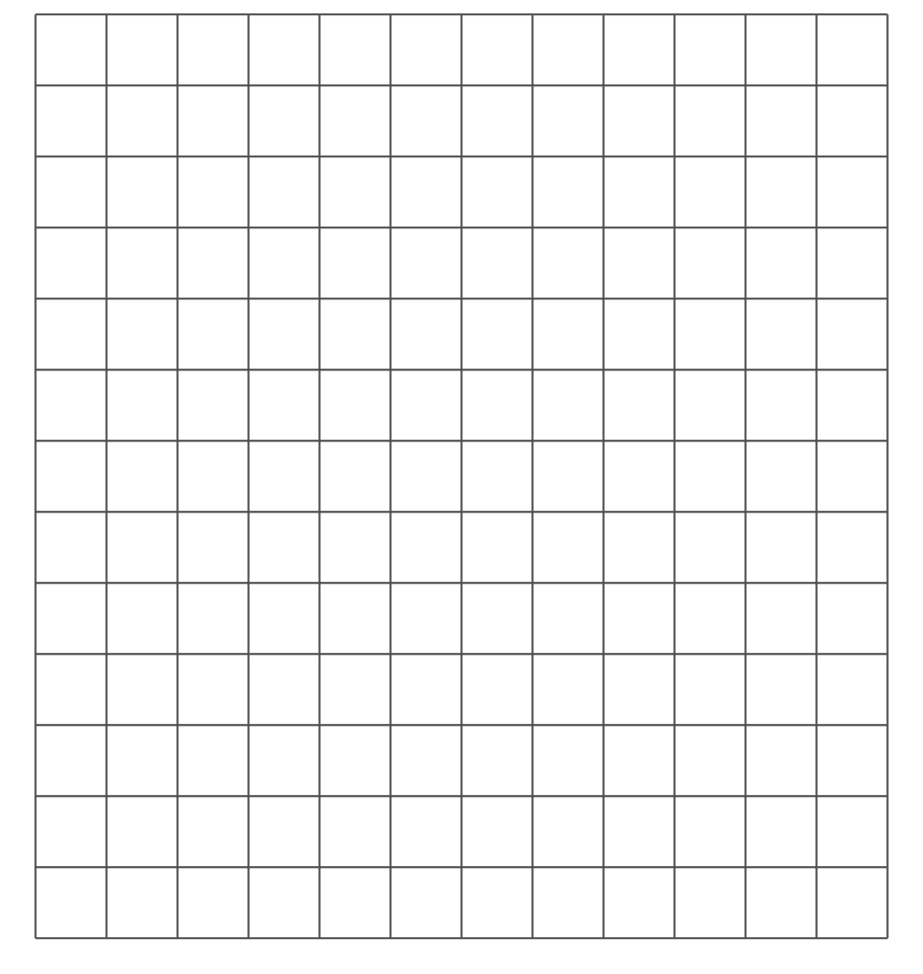

6.2: Represent More Data in a Scaled Bar Graph
All the third-grade students at school were asked, “What is your favorite time of the year?” Their responses are shown in this table:
favorite time of the year | number of students
winter | 24
spring | 13
summer | 40
fall | 22
Use the data from this table to create a scaled bar graph.
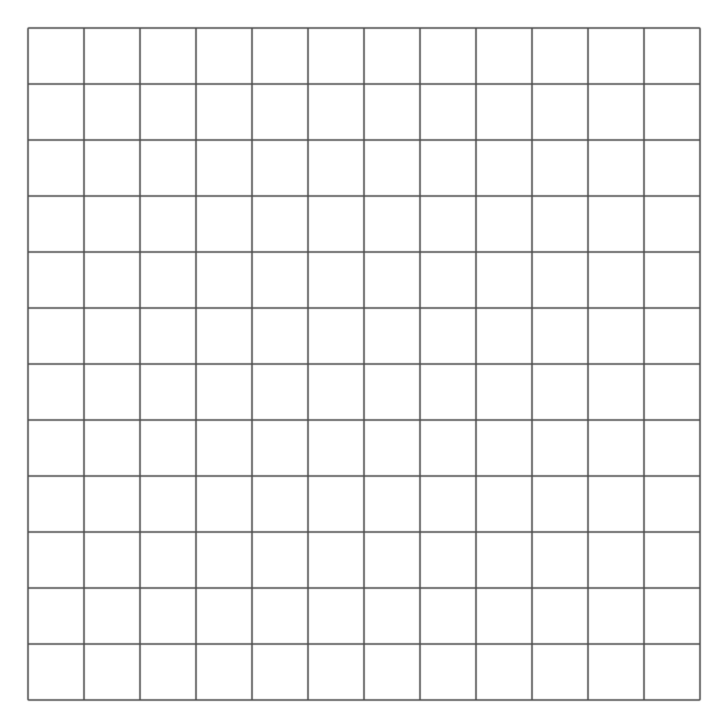
© CC BY 2021 Illustrative Mathematics®

