## Unit 5 Lesson 22: Observing More Patterns in Scatter Plots

### 1 Notice and Wonder: Clustering (Warm up)

#### Student Task Statement

What do you Notice? What do you Wonder?

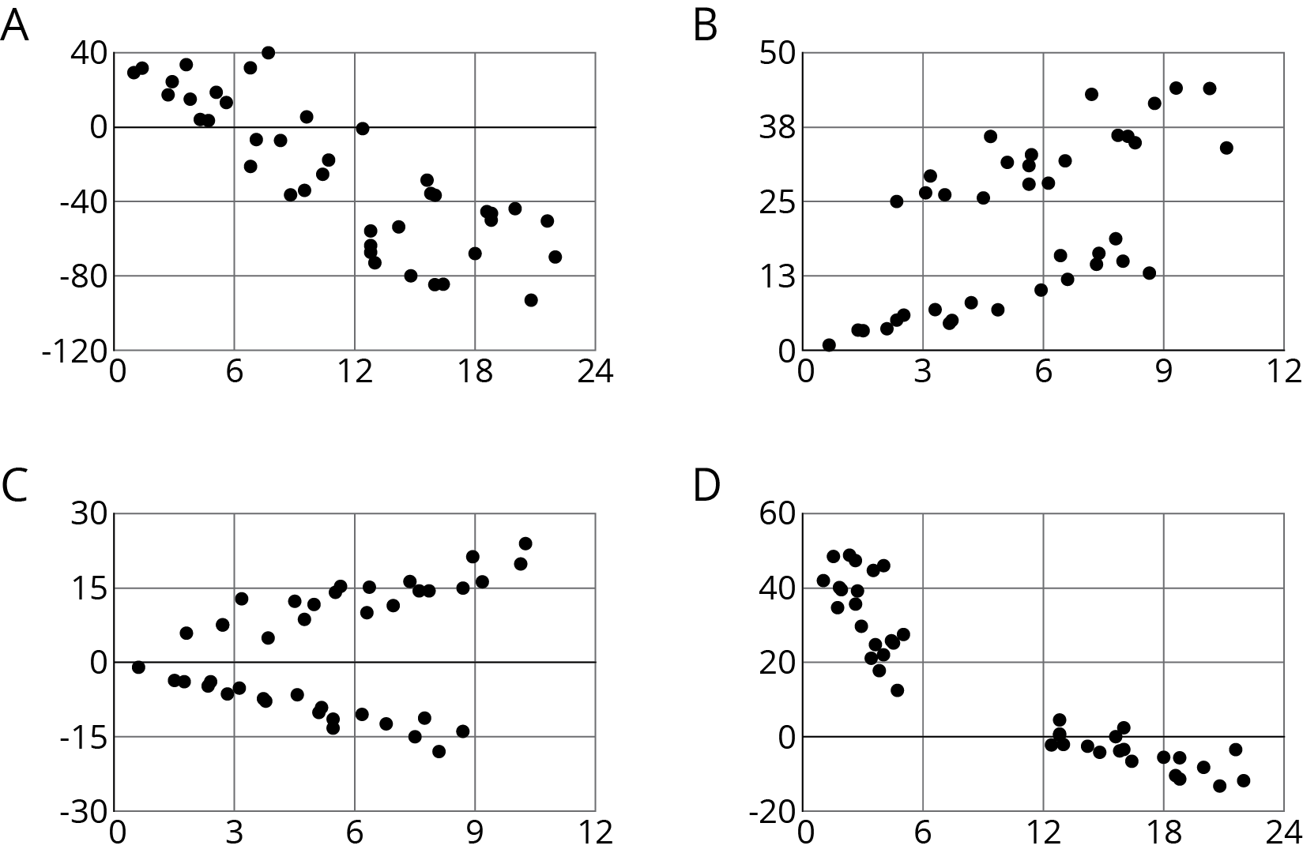

### 2 Scatter Plot City

#### Student Task Statement

Your teacher will give you a set of cards. Each card shows a scatter plot.

1. Sort the cards into categories and describe each category.
2. Explain the reasoning behind your categories to your partner. Listen to your partner’s reasoning for their categories.
3. Sort the cards into two categories: positive associations and negative associations. Compare your sorting with your partner’s and discuss any disagreements.
4. Sort the cards into two categories: linear associations and non-linear associations. Compare your sorting with your partner’s and discuss any disagreements.

### 3 Animal Brains

#### Student Task Statement

Is there an association between the weight of an animal’s body and the weight of the animal’s brain?

Use the data in the table to make a scatter plot. Are there any outliers?

|  |  |  |
| --- | --- | --- |
| animal | body weight (kg) | brain weight (g) |
| cow | 465 | 423 |
| grey wolf | 36 | 120 |
| goat | 28 | 115 |
| donkey | 187 | 419 |
| horse | 521 | 655 |
| potar monkey | 10 | 115 |
| cat | 3 | 26 |
| giraffe | 529 | 680 |
| gorilla | 207 | 406 |
| human | 62 | 1,320 |
| rhesus monkey | 7 | 179 |
| kangaroo | 35 | 56 |
| sheep | 56 | 175 |
| jaguar | 100 | 157 |
| chimpanzee | 52 | 440 |
| pig | 192 | 180 |

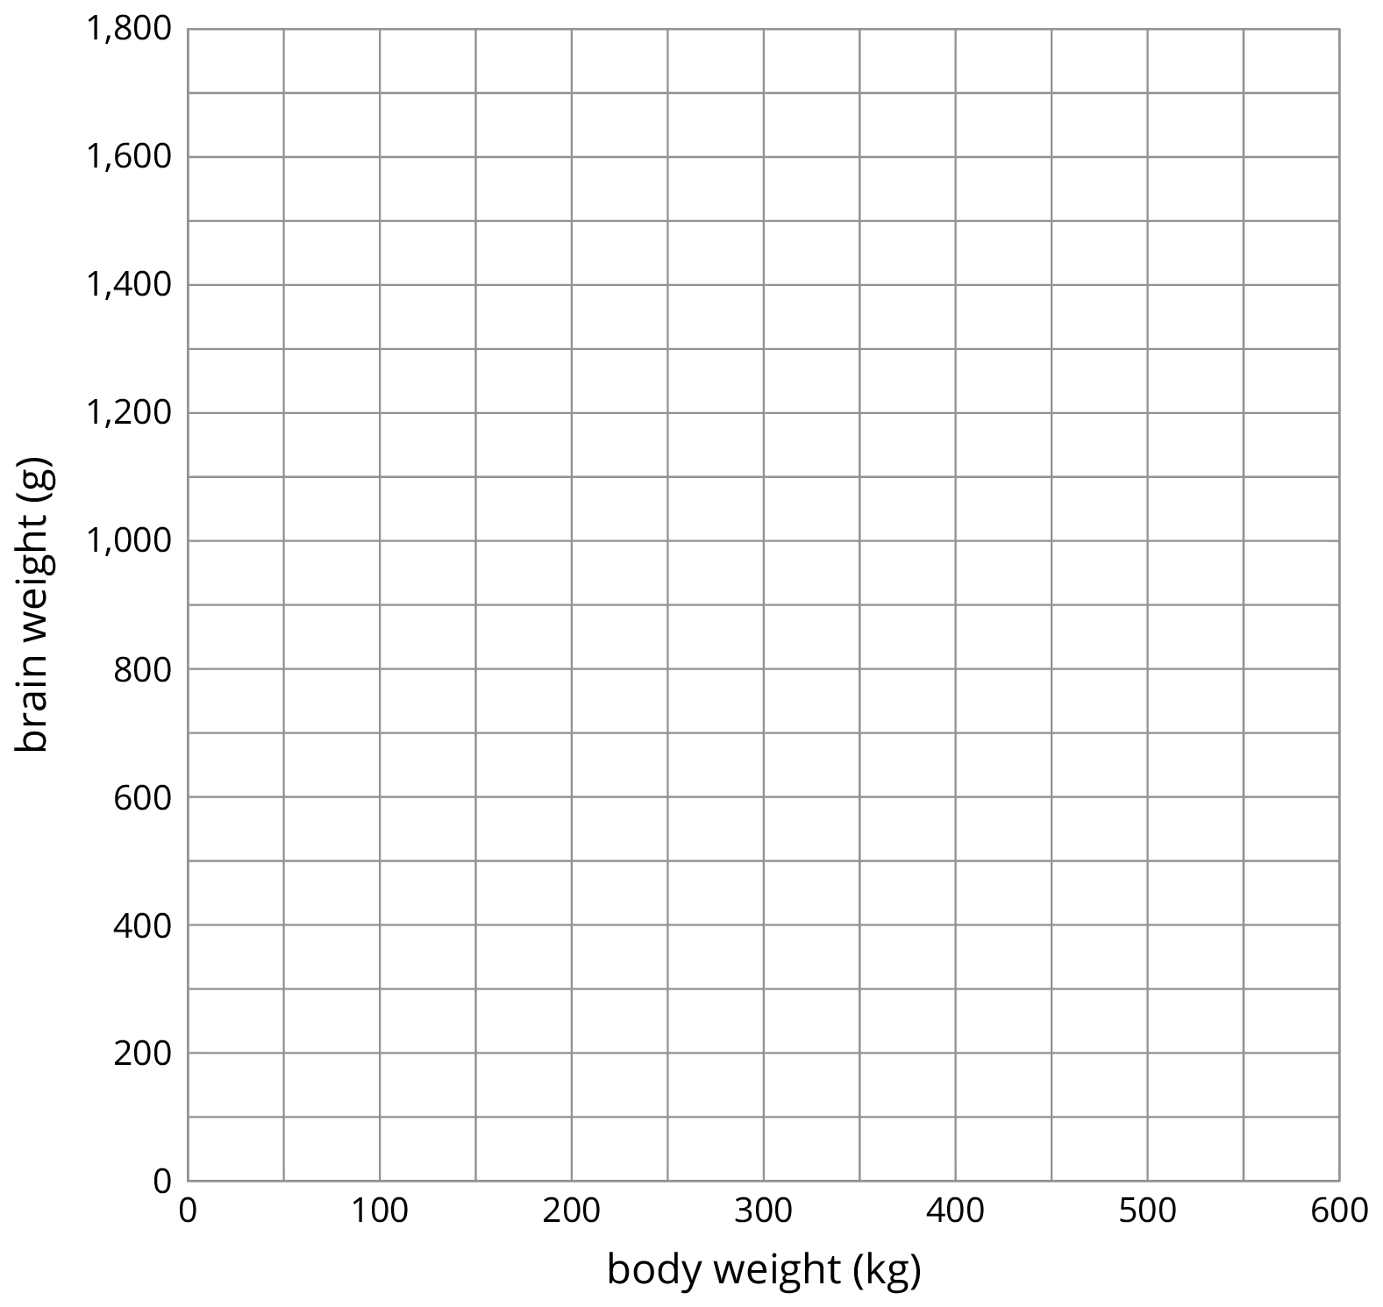

1. After removing the outliers, does there appear to be an association between body weight and brain weight? Describe the association in a sentence.
2. Using a piece of pasta and a straightedge, fit a line to your scatter plot, and estimate its slope. What does this slope mean in the context of brain and body weight?
3. Does the fitted line help you identify more outliers?



© CC BY Open Up Resources. Adaptations CC BY IM.