Lesson 11: Stained-Glass Windows

11.1: Cost of a Stained-Glass Window
The students in art class are designing a stained-glass window to hang in the school entryway. The window will be 3 feet tall and 4 feet wide. Here is their design.
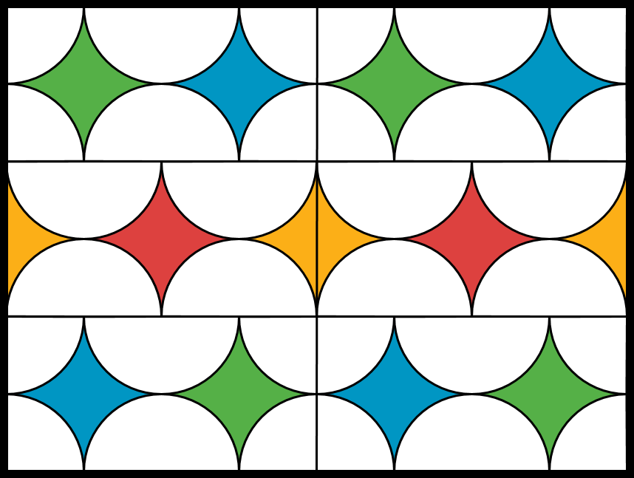
They have raised $100 for the project. The colored glass costs $5 per square foot and the clear glass costs $2 per square foot. The material they need to join the pieces of glass together costs 10 cents per foot and the frame around the window costs $4 per foot.
Do they have enough money to cover the cost of making the window?

11.2: A Bigger Window
A local community member sees the school’s stained-glass window and really likes the design. They ask the students to create a larger copy of the window using a scale factor of 3. Would $450 be enough to buy the materials for the larger window? Explain or show your reasoning.

11.3: Invent Your Own Design
Draw a stained-glass window design that could be made for less than $450. Show your thinking. Organize your work so it can be followed by others.
© CC BY Open Up Resources. Adaptations CC BY IM.

