Unit 8 Lesson 2 Cumulative Practice Problems
- Sixth-grade students were asked, “What grade are you in?” Explain why this is not a statistical question.
- Lin and her friends went out for ice cream after school. The following questions came up during their trip. Select all the questions that are statistical questions.
  - How far are we from the ice cream shop?
  - What is the most popular ice cream flavor this week?
  - What does a group of 4 people typically spend on ice cream at this shop?
  - Do kids usually prefer to get a cup or a cone?
  - How many toppings are there to choose from?
- Here is a list of questions about the students and teachers at a school. Select all the questions that are statistical questions.
  - What is the most popular lunch choice?
  - What school do these students attend?
  - How many math teachers are in the school?
  - What is a common age for the teachers at the school?
  - About how many hours of sleep do students generally get on a school night?
  - How do students usually travel from home to school?
- Here is a list of statistical questions. What data would you collect and analyze to answer each question? For numerical data, include the unit of measurement that you would use.
  - What is a typical height of female athletes on a team in the most recent international sporting event?
  - Are most adults in the school football fans?
  - How long do drivers generally need to wait at a red light in Washington, DC?
- Describe the scale you would use on the coordinate plane to plot each set of points. What value would you assign to each unit of the grid?
  - $(1,\text{-}6)$, $(\text{-}7,\text{-}8)$, $(\text{-}3,7)$, $(0,9)$
  - $(\text{-}20,\text{-}30)$, $(\text{-}40,10)$, $(20,\text{-}10)$, $(5,\text{-}20)$
  - $(\frac{\text{-}1}{3},\text{-}1),(\frac{2}{3},\text{-}1\frac{1}{3}),(\frac{\text{-}4}{3},\frac{2}{3}),(\frac{1}{6},0)$
- 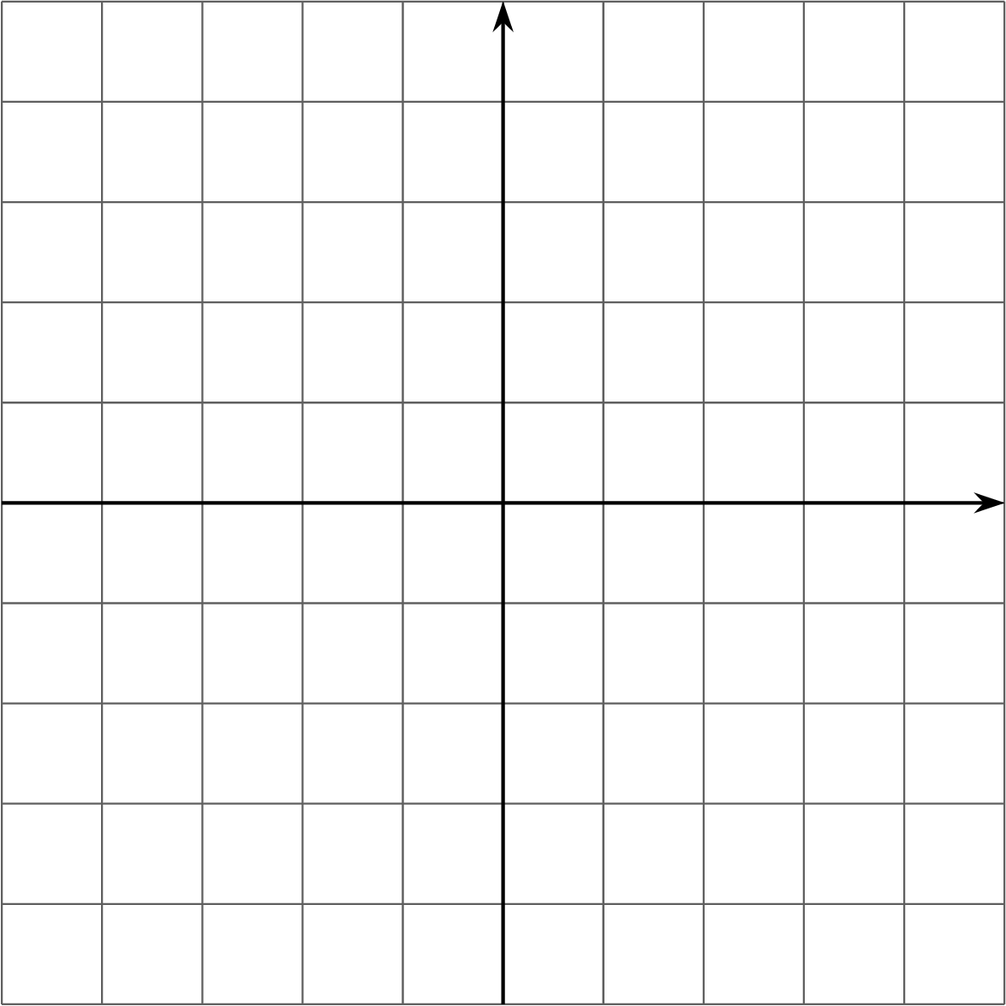
- (From Unit 7, Lesson 13.)
- Noah’s water bottle contains more than 1 quart of water but less than $1\frac{1}{2}$ quarts. Let $w$ be the amount of water in Noah’s bottle, in quarts. Select all the true statements.
  - $w$ could be $\frac{3}{4}$.
  - $w$ could be 1.
  - $w>1$
  - $w$ could be $\frac{4}{3}$.
  - $w$ could be $\frac{5}{4}$.
  - $w$ could be $\frac{5}{3}$.
  - $w>1.5$
- (From Unit 7, Lesson 9.)
- Order these numbers from least to greatest:
- $|\text{-}17|$
- $|\text{-}18|$
- -18
- $|19|$
- 20
- (From Unit 7, Lesson 7.)
© CC BY Open Up Resources. Adaptations CC BY IM.

