Lesson 5 Practice Problems
- Write with a single exponent: (ex: $\frac{1}{10}⋅\frac{1}{10}={10}^{\text{-}2}$)
  - $\frac{1}{10}⋅\frac{1}{10}⋅\frac{1}{10}$
  - $\frac{1}{10}⋅\frac{1}{10}⋅\frac{1}{10}⋅\frac{1}{10}⋅\frac{1}{10}⋅\frac{1}{10}⋅\frac{1}{10}$
  - ${\left(\frac{1}{10}⋅\frac{1}{10}⋅\frac{1}{10}⋅\frac{1}{10}\right)}^{2}$
  - ${\left(\frac{1}{10}⋅\frac{1}{10}⋅\frac{1}{10}\right)}^{3}$
  - ${\left(10⋅10⋅10\right)}^{\text{-}2}$
- Write each expression as a single power of 10.
  - ${10}^{\text{-}3}⋅{10}^{\text{-}2}$
  - ${10}^{4}⋅{10}^{\text{-}1}$
  - $\frac{{10}^{5}}{{10}^{7}}$
  - ${\left({10}^{\text{-}4}\right)}^{5}$
  - ${10}^{\text{-}3}⋅{10}^{\text{2}}$
  - $\frac{{10}^{\text{-}9}}{{10}^{5}}$
- Select all of the following that are equivalent to $\frac{1}{10,000}$:
  - ${\left(10,​000\right)}^{\text{-}1}$
  - $\left(\text{-}10,​000\right)$
  - ${\left(100\right)}^{\text{-}2}$
  - ${\left(10\right)}^{\text{-}4}$
  - ${\left(\text{-}10\right)}^{2}$
- Match each equation to the situation it describes. Explain what the constant of proportionality means in each equation.
- Equations:
  - $y=3x$
  - $\frac{1}{2}x=y$
  - $y=3.5x$
  - $y=\frac{5}{2}x$
- Situations:
  - A dump truck is hauling loads of dirt to a construction site. After 20 loads, there are 70 square feet of dirt.
  - I am making a water and salt mixture that has 2 cups of salt for every 6 cups of water.
  - A store has a “4 for $10” sale on hats.
  - For every 48 cookies I bake, my students get 24.
- (From Unit 3, Lesson 2.)

  - Explain why triangle $ABC$ is similar to $EDC$.
  - 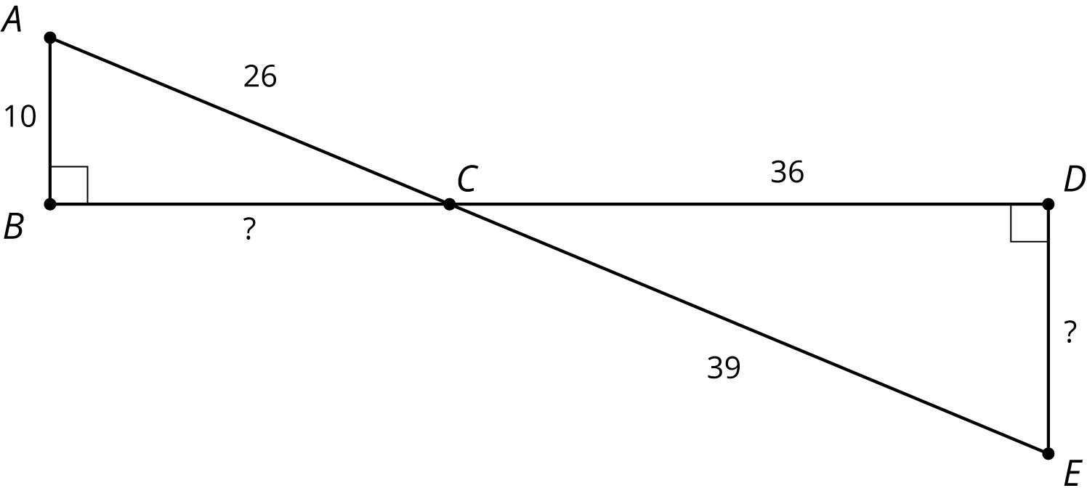
  - Find the missing side lengths.
- (From Unit 2, Lesson 8.)
© CC BY Open Up Resources. Adaptations CC BY IM.

