Unit 7 Lesson 7: Circles in Triangles

1 The Largest Circle (Warm up)

Student Task Statement
Use a compass to draw the largest circle you can find that fits inside each triangle.
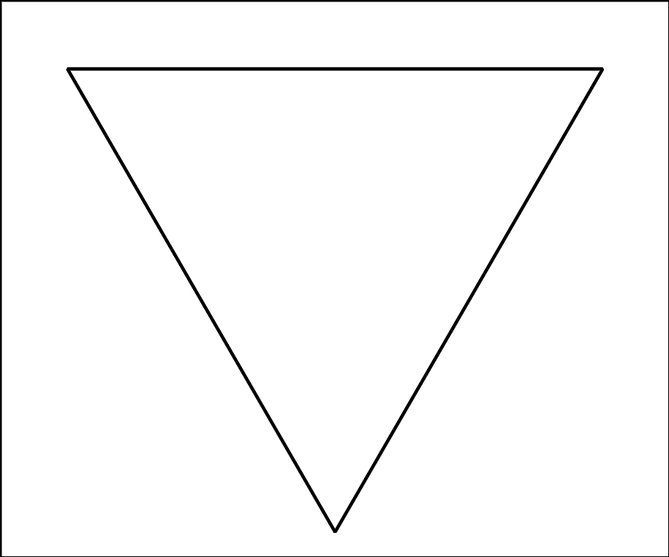

2 The Inner Circle

Student Task Statement
- Mark 3 points and connect them with a straightedge to make a large triangle. The triangle should not be equilateral.
- Construct the incenter of the triangle.
- Construct the segments that show the distance from the incenter to the sides of the triangle.
- Construct a circle centered at the incenter using one of the segments you just constructed as a radius.
- Would it matter which of the three segments you use? Explain your thinking.

Activity Synthesis
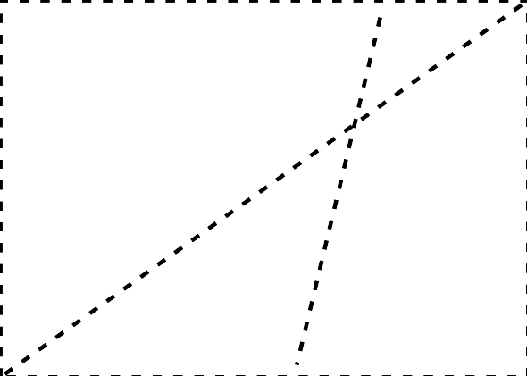

3 Equilateral Centers

Student Task Statement
The image shows an equilateral triangle $ABC$. The angle bisectors are drawn. The incenter is plotted and labeled $D$.
Prove that the incenter is also the circumcenter.
© CC BY 2019 by Illustrative Mathematics®

