Lesson 15: Quadratic Equations with Irrational Solutions
- Let’s find exact solutions to quadratic equations even if the solutions are irrational.

15.1: Roots of Squares
Here are some squares whose vertices are on a grid.
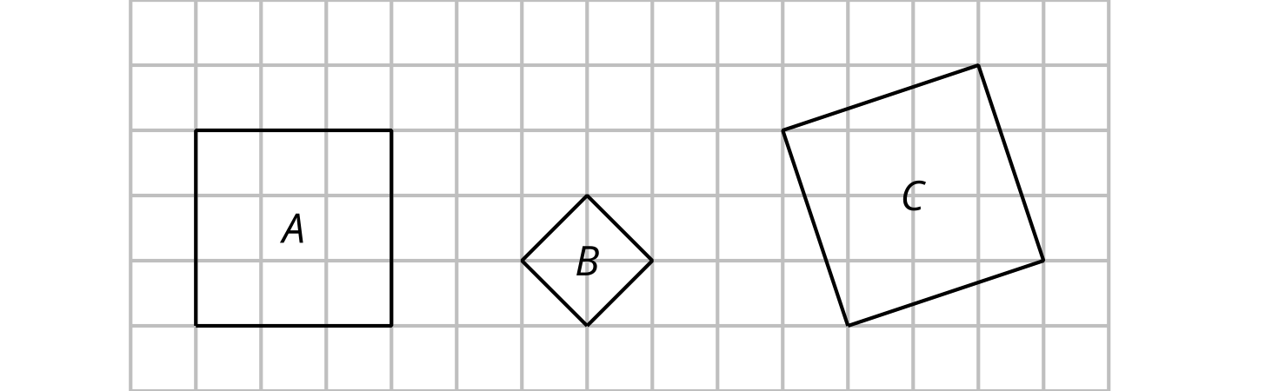
Find the area and the side length of each square.
square | area (square units) | side length (units)
A
B
C

15.2: Solutions Written as Square Roots
Solve each equation. Use the $±$ notation when appropriate.
- $x^{2}−13=\text{-}12$
- ${\left(x−6\right)}^{2}=0$
- $x^{2}+9=0$
- $x^{2}=18$
- $x^{2}+1=18$
- ${\left(x+1\right)}^{2}=18$

15.3: Finding Irrational Solutions by Completing the Square
Here is an example of an equation being solved by graphing and by completing the square.
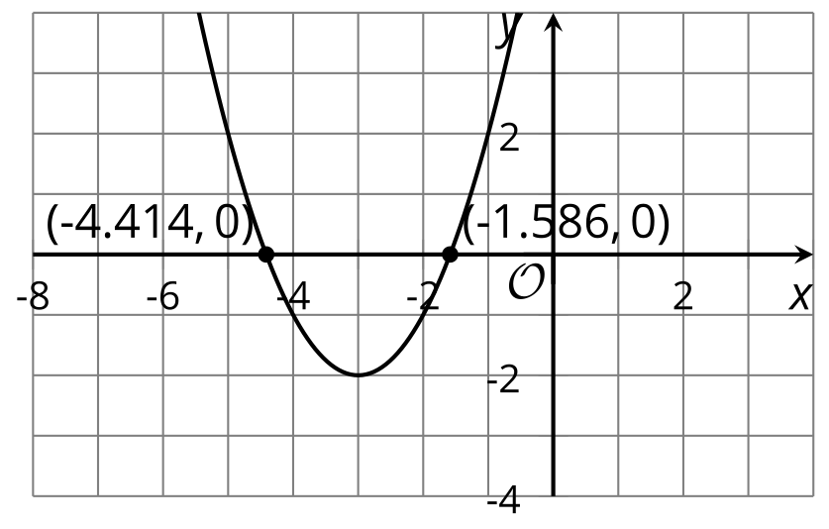
$\begin{matrix}x^{2}+6x+7 & =0 \\ x^{2}+6x+9 & =2 \\ {\left(x+3\right)}^{2} & =2 \\ x+3 & =±\sqrt{2} \\ x & =\text{-}3±\sqrt{2}\end{matrix}$
Verify: $\sqrt{2}$ is approximately 1.414. So $\text{-}3+\sqrt{2}≈\text{-}1.586$ and $\text{-}3−\sqrt{2}≈\text{-}4.414$.
For each equation, find the exact solutions by completing the square and the approximate solutions by graphing. Then, verify that the solutions found using the two methods are close. If you get stuck, study the example.
- $x^{2}+4x+1=0$
- $x^{2}−10x+18=0$
- $x^{2}+5x+\frac{1}{4}=0$
- $x^{2}+\frac{8}{3}x+\frac{14}{9}=0$

Are you ready for more?
Write a quadratic equation of the form $ax^{2}+bx+c=0$ whose solutions are $x=5−\sqrt{2}$ and $x=5+\sqrt{2}$.

Lesson 15 Summary
When solving quadratic equations, it is important to remember that:
- Any positive number has two square roots, one positive and one negative, because there are two numbers that can be squared to make that number. (For example, $6^{2}$ and ${\left(\text{-}6\right)}^{2}$ both equal 36, so 6 and -6 are both square roots of 36.)
- The square root symbol (3) can be used to express the positive square root of a number. For example, the square root of 36 is 6, but it can also be written as $\sqrt{36}$ because $\sqrt{36}⋅\sqrt{36}=36$.
- To express the negative square root of a number, say 36, we can write -6 or $\text{-}\sqrt{36}$.
- When a number is not a perfect square—for example, 40—we can express its square roots by writing $\sqrt{40}$ and $\text{-}\sqrt{40}$.
How could we write the solutions to an equation like ${\left(x+4\right)}^{2}=11$? This equation is saying, “something squared is 11.” To make the equation true, that something must be $\sqrt{11}$ or $\text{-}\sqrt{11}$. We can write:
$\begin{matrix}x+4=\sqrt{11} & \text{or} x+4=\text{-}\sqrt{11} \\ x=\text{-}4+\sqrt{11} & \text{or} x=\text{-}4−\sqrt{11}\end{matrix}$
A more compact way to write the two solutions to the equation is: $x=\text{-}4±\sqrt{11}$.
About how large or small are those numbers? Are they positive or negative? We can use a calculator to compute the approximate values of both expressions:
$\text{-}4+\sqrt{11}≈\text{-}0.683 \text{or} \text{-}4−\sqrt{11}≈\text{-}7.317$
We can also approximate the solutions by graphing. The equation ${\left(x+4\right)}^{2}=11$ is equivalent to ${\left(x+4\right)}^{2}−11=0$, so we can graph the function $y={\left(x+4\right)}^{2}−11$ and find its zeros by locating the $x$-intercepts of the graph.
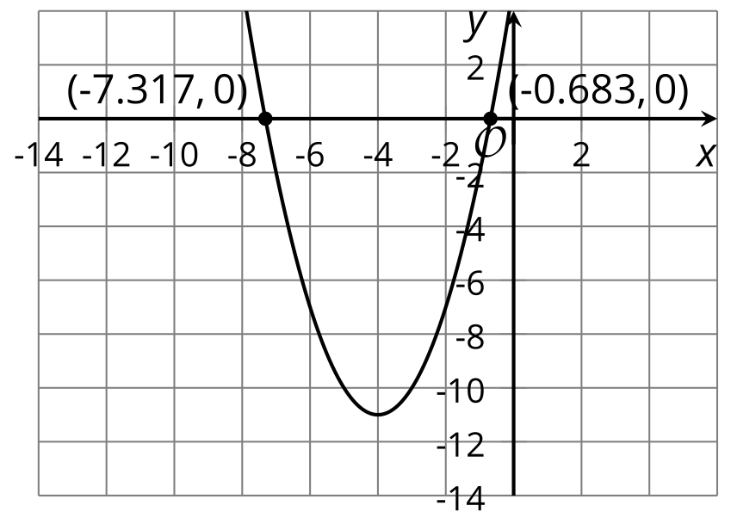
© CC BY 2019 by Illustrative Mathematics®

