Lesson 4: Congruent Triangles, Part 2
- Let’s figure out if there are shortcuts for being sure two triangles are congruent.

4.1: Make That Triangle
Draw triangle $ABC$ with these measurements:
- Angle $A$ is 40 degrees.
- Angle $B$ is 20 degrees.
- Angle $C$ is 120 degrees.
- Segment $AB$ is 5 centimeters.
- Segment $AC$ is 2 centimeters.
- Segment $BC$ is 3.7 centimeters.
Highlight each piece of given information that you used. Check your triangle to make sure the remaining measurements match.

4.2: Info Gap: Too Much Information
Your teacher will give you either a problem card or a data card. Do not show or read your card to your partner.
If your teacher gives you the data card:
- Silently read the information on your card.
- Ask your partner “What specific information do you need?” and wait for your partner to ask for information. Only give information that is on your card. (Do not figure out anything for your partner!)
- Before telling your partner the information, ask “Why do you need to know (that piece of information)?”
- Read the problem card, and solve the problem independently.
- Share the data card, and discuss your reasoning.
If your teacher gives you the problem card:
- Silently read your card and think about what information you need to answer the question.
- Ask your partner for the specific information that you need.
- Explain to your partner how you are using the information to solve the problem.
- When you have enough information, share the problem card with your partner, and solve the problem independently.
- Read the data card, and discuss your reasoning.

Are you ready for more?
Elena wonders whether she could play the Info Gap with area included as an extra piece of information in the data cards. She draws a card with this information and asks Han to play.
- If Han asks for 2 sides and the area, do you think this will be enough information for Han to draw a congruent triangle?
- If Han asks for 2 angles and the area, do you think this will be enough information for Han to draw a congruent triangle?

Area = 5.4 cm$​^{2}$
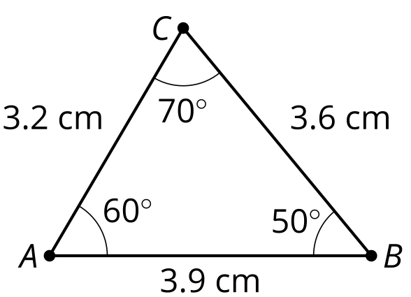

4.3: Too Little Information?
Jada and Tyler were playing the Info Gap, using Card 3.
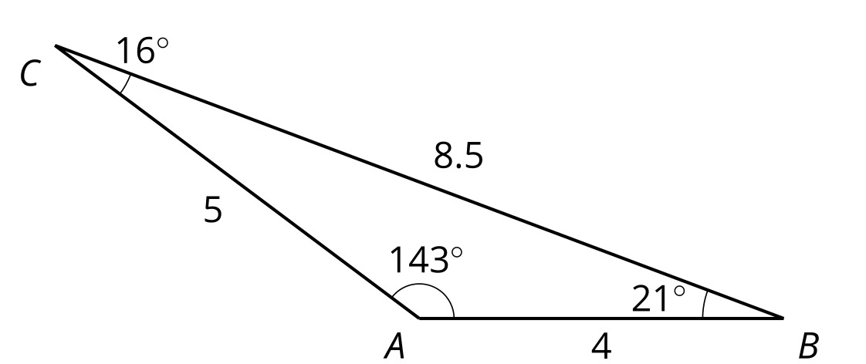
Tyler asked, “Can I have 2 sides and an angle?”
Jada told Tyler that one angle was ${16}^{∘}$, one side was 5 cm, and one side was 4 cm. Here is the triangle Tyler made:
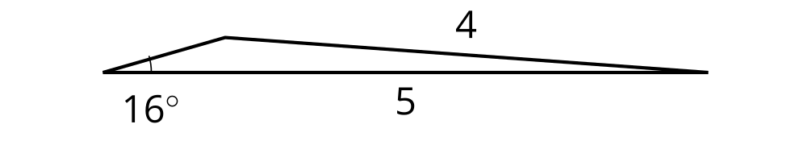
- Is Tyler’s triangle congruent to the triangle on the Data Card?
- Did Tyler do anything that didn’t match Jada’s instructions?
- How could Tyler have made a more specific request for 2 sides and an angle so that his triangle was guaranteed to match Jada’s?

Lesson 4 Summary
If we know that every pair of corresponding parts is congruent, then we know the 2 triangles are congruent. But we don‘t need that much information. If we know the angles of a triangle are 30 degrees and 60 degrees, we can figure out the third angle is 90 degrees. So when we start drawing a triangle, the triangle is complete before we measure every angle. Figuring out which sets of measurements are enough to draw a complete triangle tells us which sets of measurements are enough to prove triangles are congruent. Here are 3 sets of measurements that appear to be enough information to prove that the 2 triangles will be congruent:
- Two pairs of corresponding sides are congruent and the angles between those sides are congruent.
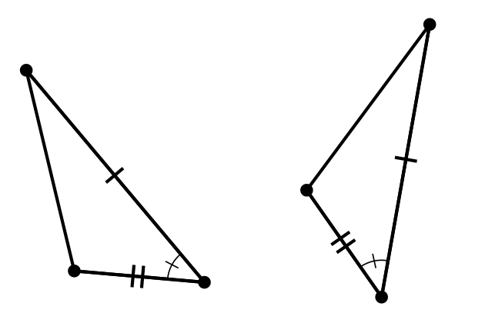
- Two pairs of corresponding angles are congruent and the sides between those angles are congruent.
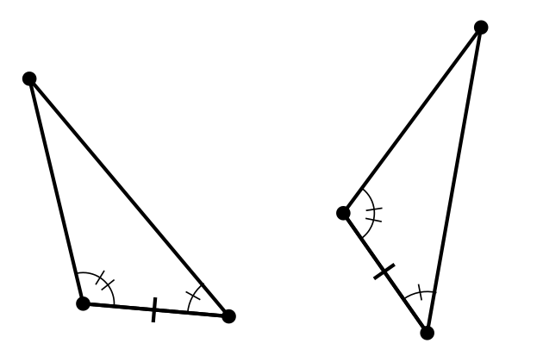
- Three pairs of corresponding sides are congruent.
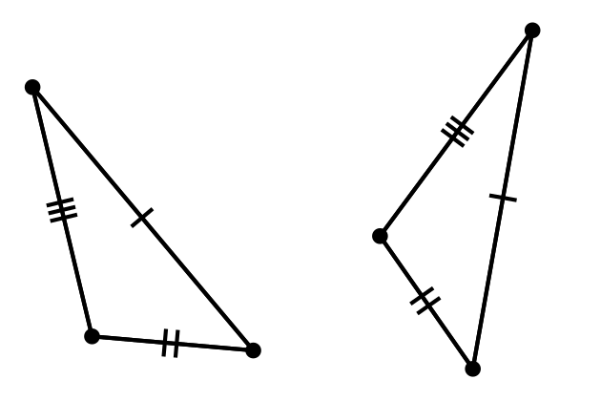
© CC BY 2019 by Illustrative Mathematics®

