Unit 5 Lesson 10 Cumulative Practice Problems
- The graph shows the distance of a car from home as a function of time.
- 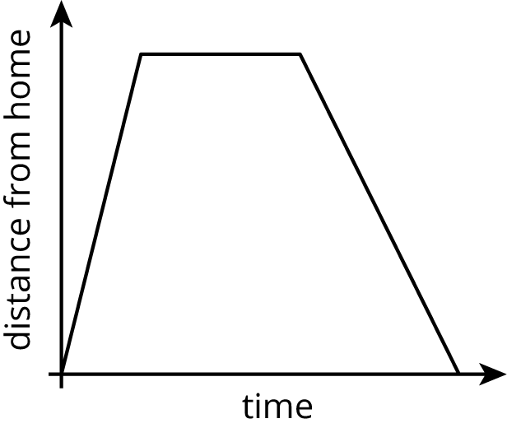
- Describe what a person watching the car may be seeing.
- The equation and the graph represent two functions. Use the equation $y=4$ and the graph to answer the questions.
- 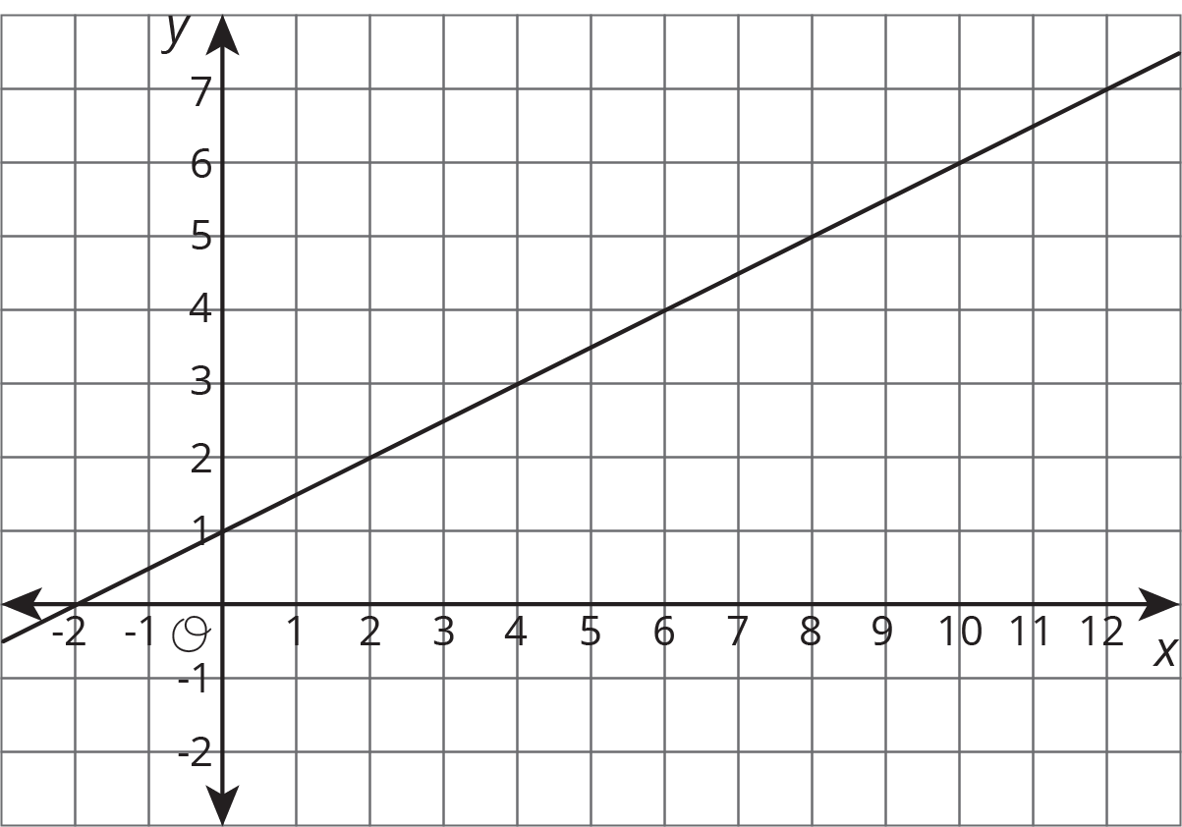
  - When $x$ is 4, is the output of the equation or the graph greater?
  - What value for $x$ produces the same output in both the graph and the equation?
- (From Unit 5, Lesson 7.)
- This graph shows a trip on a bike trail. The trail has markers every 0.5 km showing the distance from the beginning of the trail.
- 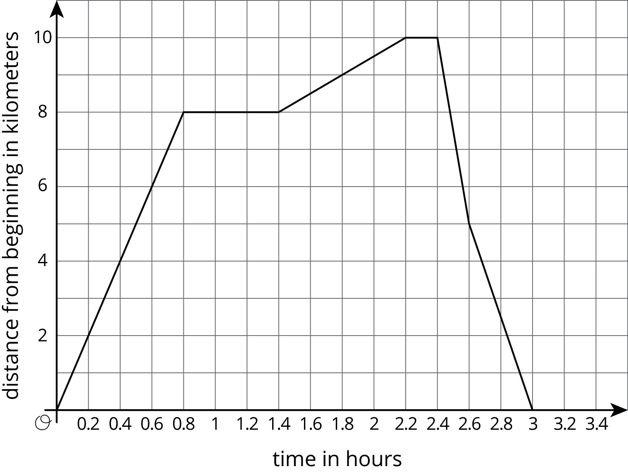
  - When was the bike rider going the fastest?
  - When was the bike rider going the slowest?
  - During what times was the rider going away from the beginning of the trail?
  - During what times was the rider going back towards the beginning of the trail?
  - During what times did the rider stop?
- The expression $\text{-}25t+1250$ represents the volume of liquid of a container after $t$ seconds. The expression $50t+250$ represents the volume of liquid of another container after $t$ seconds. What does the equation $\text{-}25t+1250=50t+250$ mean in this situation?
- (From Unit 4, Lesson 9.)
© CC BY Open Up Resources. Adaptations CC BY IM.

