Lesson 18: Compare Without Multiplying
- Let’s compare expressions, without evaluating them.

Warm-up: Notice and Wonder: Expressions and Number Lines
What do you notice? What do you wonder?
$\frac{2}{3}×5$

18.1: Approximate Location
- Label each expression at its approximate location on the number line.
- Partner A
  - $\frac{2}{5}×12$
  - $\frac{5}{3}×12$
  - $\frac{7}{7}×12$
- Partner B
  - $\frac{4}{7}×12$
  - $\frac{8}{5}×12$
  - $\frac{9}{9}×12$
- 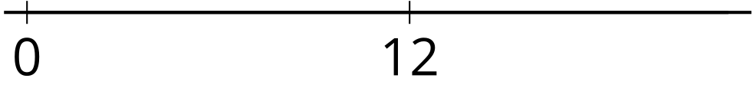
- Choose a number to put in each box to make the statement true.
  - 000011×12>12
  - 000015×12=12
  - 130000×12<12

18.2: An Unknown Number
- 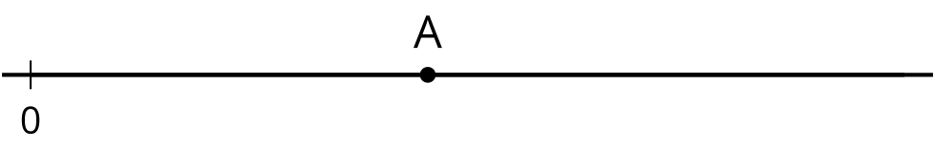
- The number A is shown on the number line. Label the approximate location of the value of each expression. Explain or show your reasoning.
  - $\frac{1}{4}×A$
  - $2×A$
  - $\frac{13}{8}×A$
  - $\frac{2}{3}×A$
- Is $\frac{13}{8}×\frac{11}{39}$ less than, greater than, or equal to $\frac{11}{39}$? Explain or show your reasoning.
- Is $\frac{2}{3}×\frac{17}{53}$ less than, greater than, or equal to $\frac{17}{53}$? Explain or show your reasoning.
© CC BY 2021 Illustrative Mathematics®

