Lesson 4: Add with Objects
- Let’s use counters to add.

4.1: Add Counters
- Count out 2 counters.
Add 2 more counters.
- There are
- counters altogether.
- Count out 5 counters.
Add 3 more counters.
- There are
- counters altogether.
- Count out 2 counters.
Add 4 more counters.
- There are
- counters altogether.
- Count out 6 counters.
Add 3 more counters.
- There are
- counters altogether.

4.2: Introduce 5-Frames, Add

4.3: Centers: Choice Time
Choose a center.
5-frames
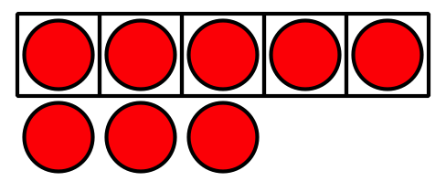
Roll and Add
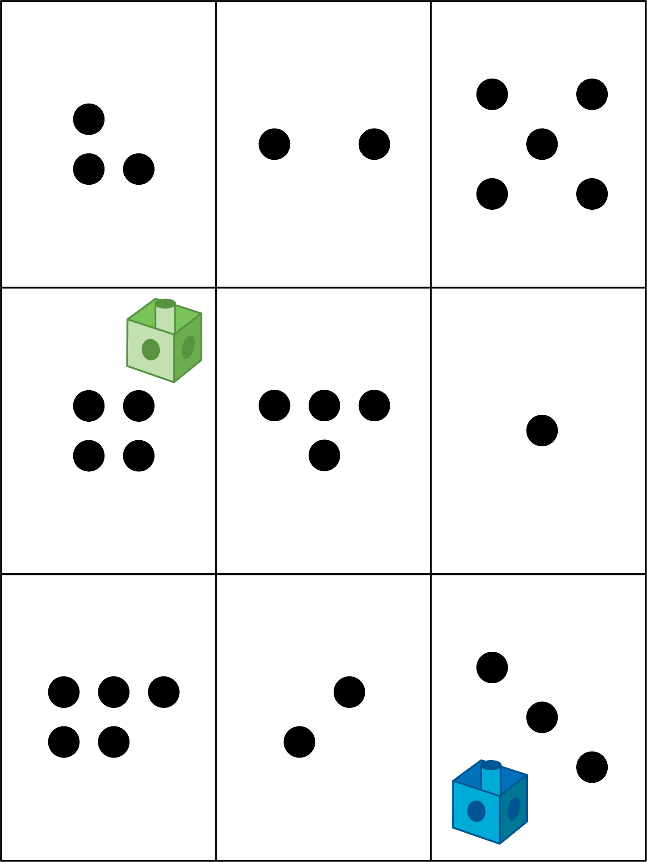
Math Libs
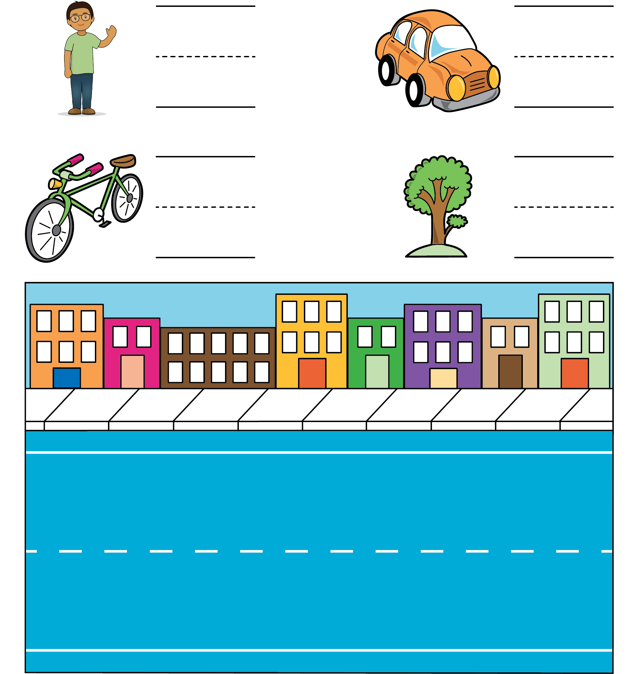
Match Mine
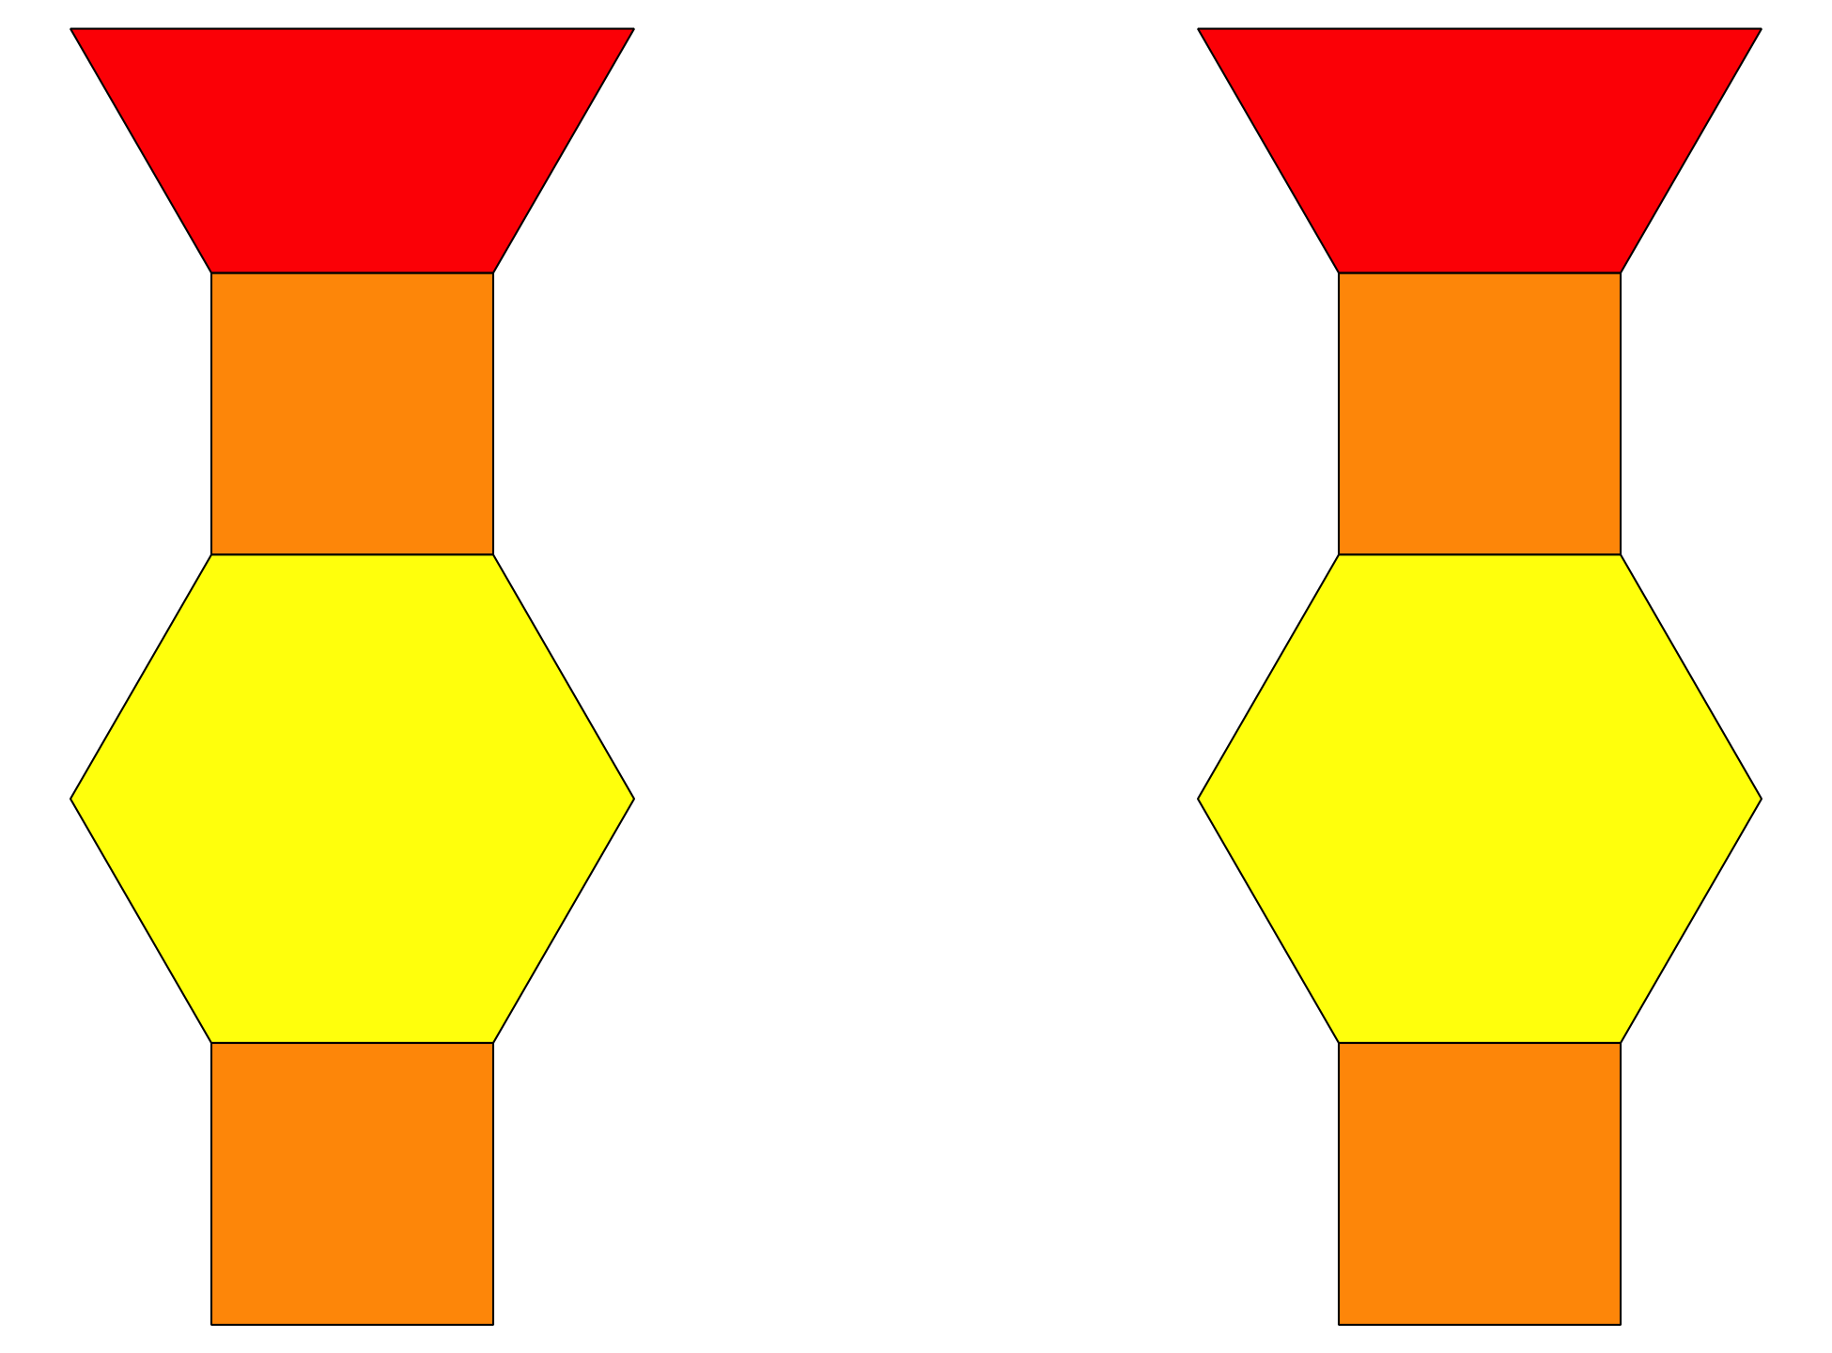
© CC BY 2021 Illustrative Mathematics®

