## Unit 6 Lesson 20: Finding Cone Dimensions

### 1 Number Talk: Thirds (Warm up)

#### Student Task Statement

For each equation, decide what value, if any, would make it true.

### 2 An Unknown Radius (Optional)

#### Student Task Statement

The volume of a cone with radius is given by the formula .

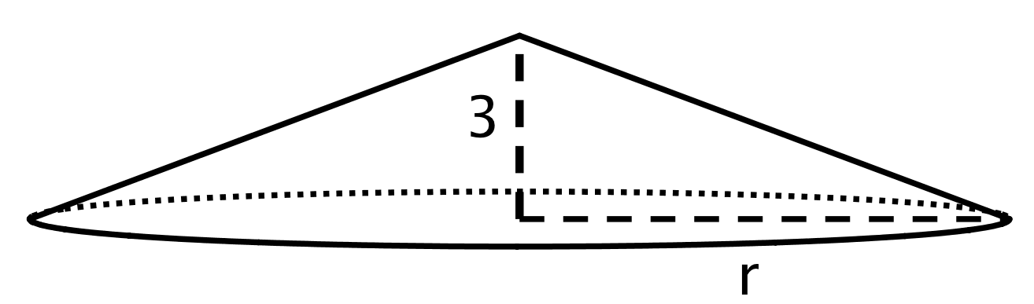

The volume of this cone with height 3 units and radius is cubic units. This statement is true:

 What does the radius of this cone have to be? Explain how you know.

### 3 Cones with Unknown Dimensions

#### Student Task Statement

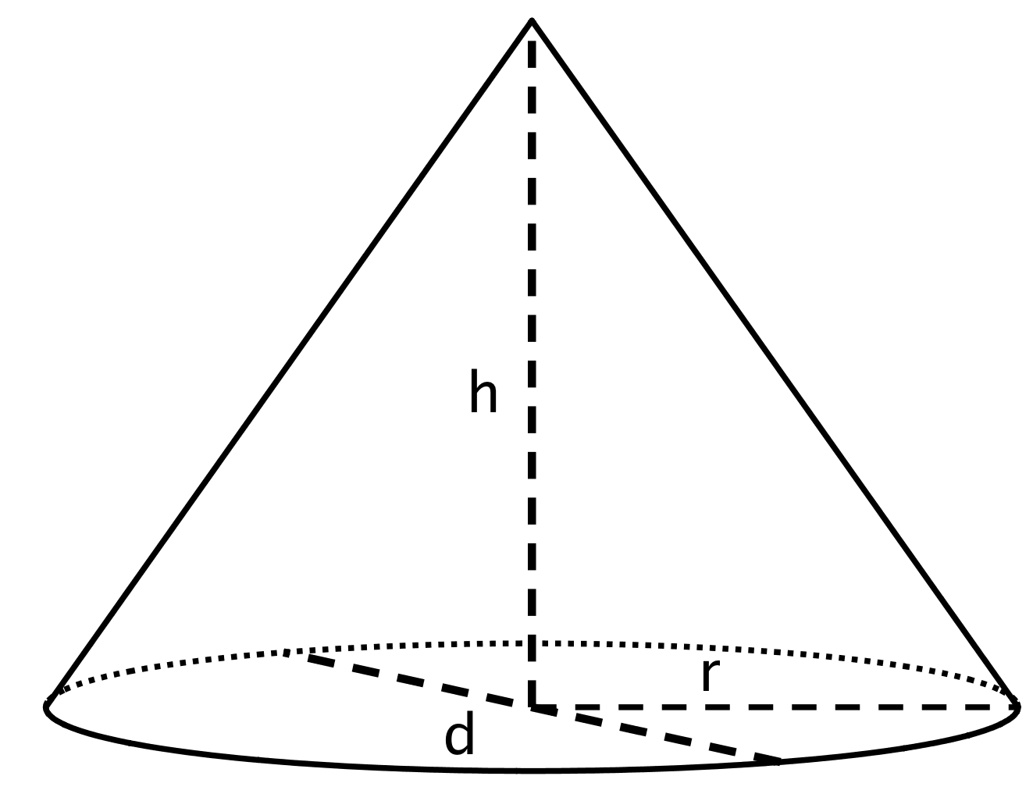

Each row of the table has some information about a particular cone. Complete the table with the missing dimensions.

|  |  |  |  |  |
| --- | --- | --- | --- | --- |
| diameter (units) | radius (units) | area of the base (square units) | height (units) | volume of cone (cubic units) |
|  | 4 |  | 3 |  |
|  |  |  | 6 |  |
|  |  |  |  |  |
| 20 |  |  |  |  |
|  |  |  | 12 |  |
|  |  |  | 3 | 3.14 |

### 4 Popcorn Deals

#### Student Task Statement

A movie theater offers two containers:

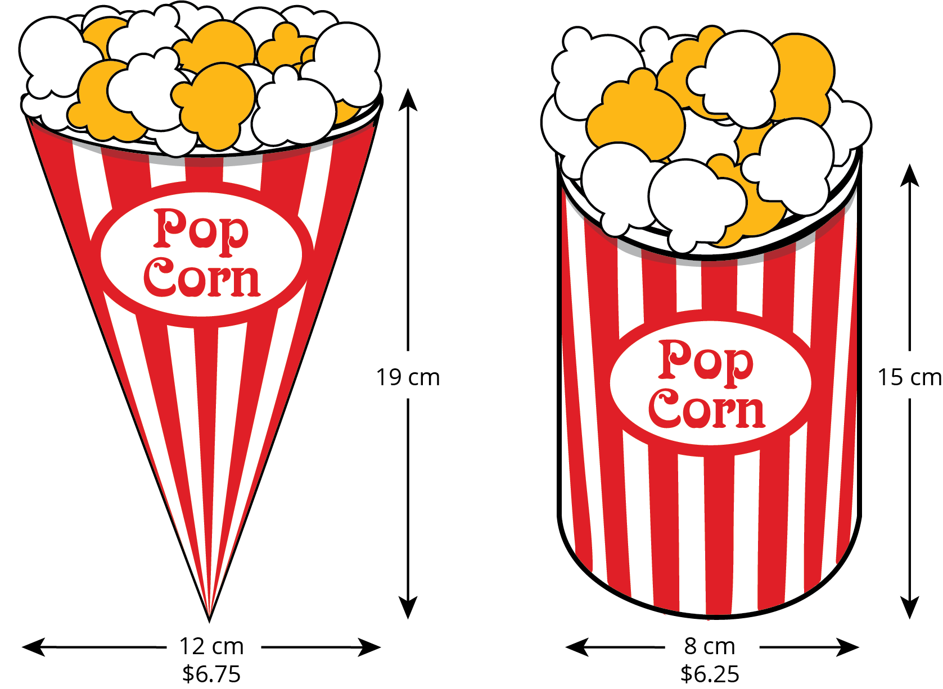

Which container is the better value? Use 3.14 as an approximation for .



© CC BY Open Up Resources. Adaptations CC BY IM.