## Unit 4 Lesson 6: Increasing and Decreasing

### 1 Improving Their Game (Warm up)

#### Student Task Statement

Here are the scores from 3 different sports teams from their last 2 games.

|  |  |  |
| --- | --- | --- |
| sports team | total points in game 1 | total points in game 2 |
| football team | 22 | 30 |
| basketball team | 100 | 108 |
| baseball team | 4 | 12 |

1. What do you notice about the teams’ scores? What do you wonder?
2. Which team improved the most? Explain your reasoning.

### 2 More Cereal and a Discounted Shirt

#### Student Task Statement

1. ​​

* A cereal box says that now it contains 20% more. Originally, it came with 18.5 ounces of cereal. How much cereal does the box come with now?
* 

1. ​​

* The price of a shirt is $18.50, but you have a coupon that lowers the price by 20%. What is the price of the shirt after using the coupon?
* 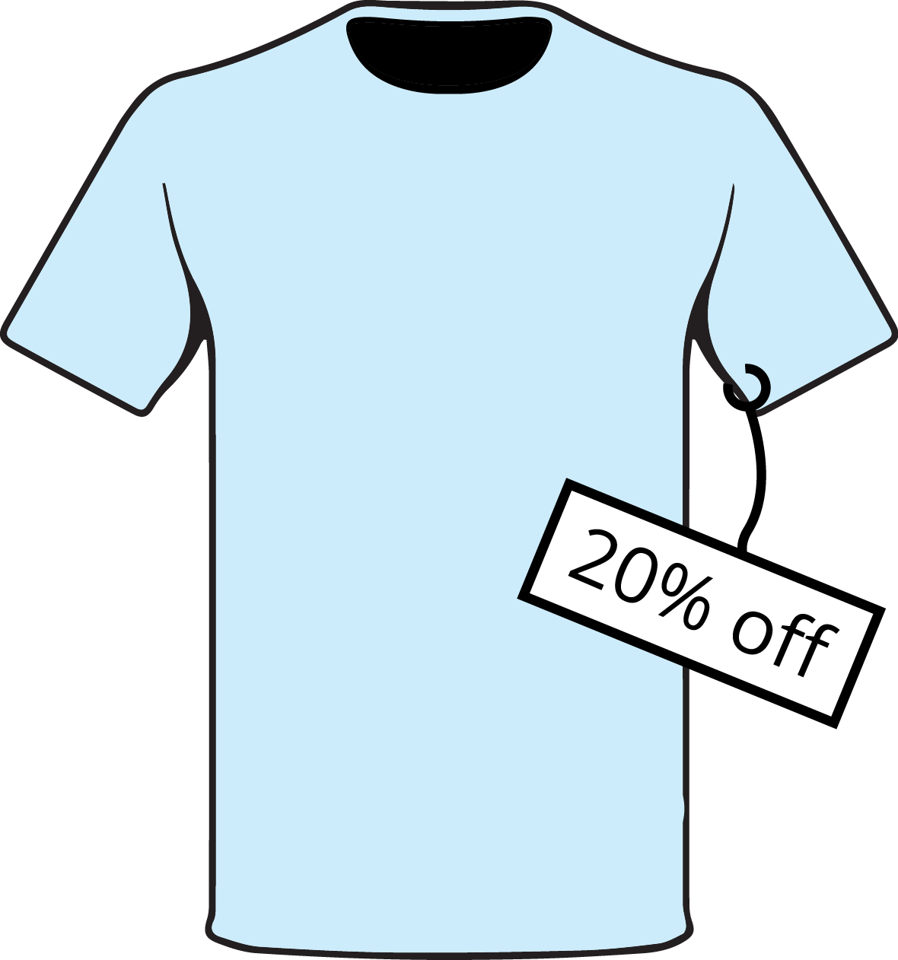

### 3 Using Tape Diagrams

#### Images for Launch

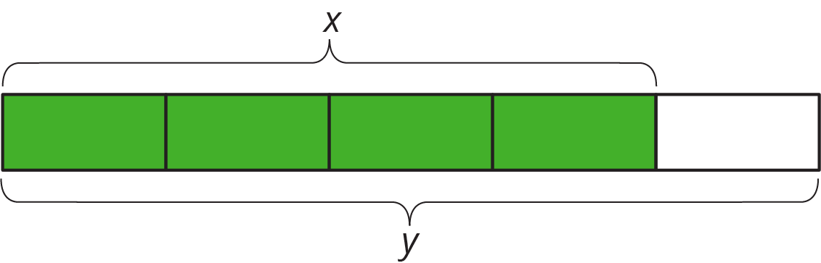

#### Student Task Statement

1. Match each situation to a diagram. Be prepared to explain your reasoning.
   1. Compared with last year’s strawberry harvest, this year’s strawberry harvest is a 25% increase.
   2. This year’s blueberry harvest is 75% of last year’s.
   3. Compared with last year, this year’s peach harvest decreased 25%.
   4. This year’s plum harvest is 125% of last year’s plum harvest.

* 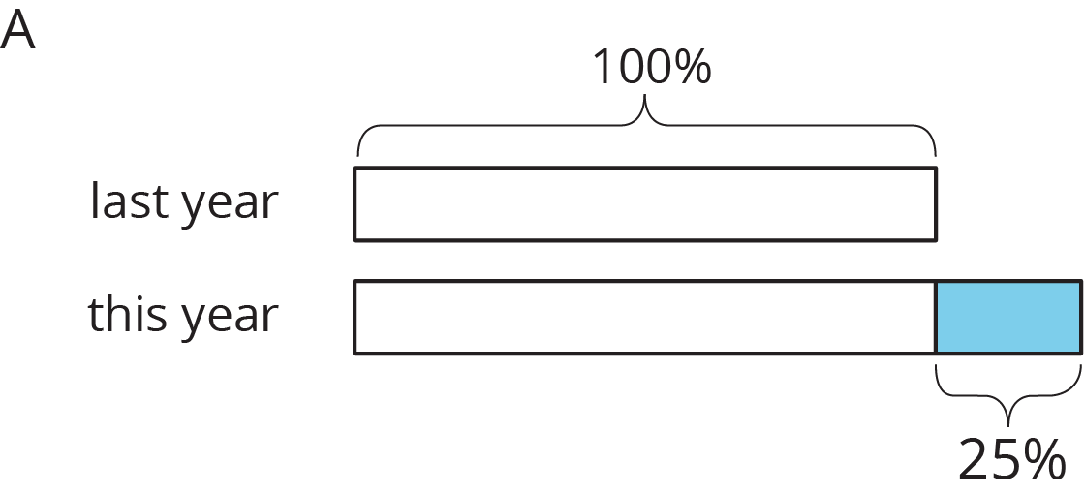
* 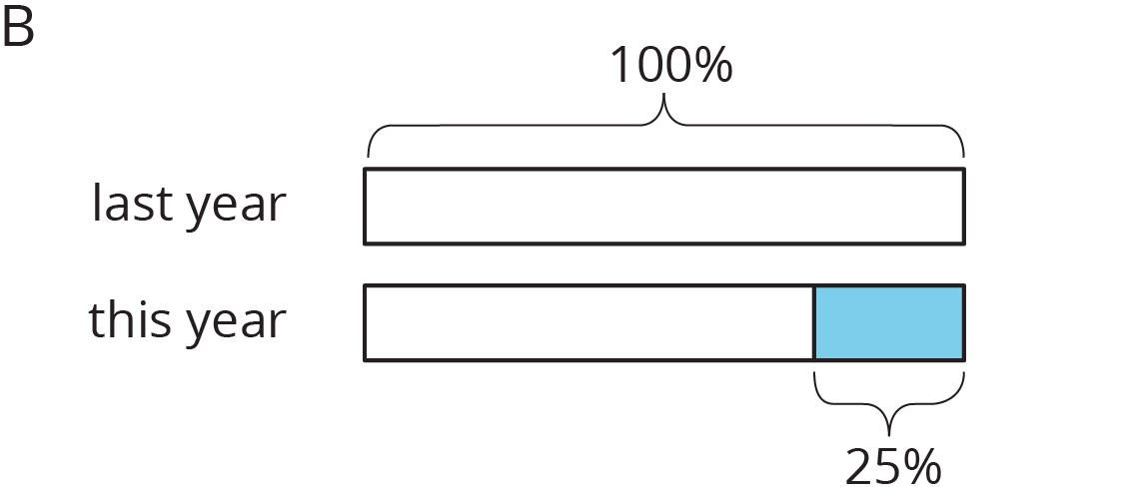

1. Draw a diagram to represent these situations.
   1. The number of ducks living at the pond increased by 40%.
   2. The number of mosquitoes decreased by 80%.

### 4 Agree or Disagree: Percentages (Optional)

#### Student Task Statement

Do you agree or disagree with each statement? Explain your reasoning.

1. Employee A gets a pay raise of 50%. Employee B gets a pay raise of 45%. So Employee A gets the bigger pay raise.
2. Shirts are on sale for 20% off. You buy two of them. As you pay, the cashier says, “20% off of each shirt means 40% off of the total price.”



© CC BY Open Up Resources. Adaptations CC BY IM.