Unit 7 Lesson 11: Slicing Solids

1 Prisms, Pyramids, and Polyhedra (Warm up)

Student Task Statement
Describe each shape as precisely as you can.
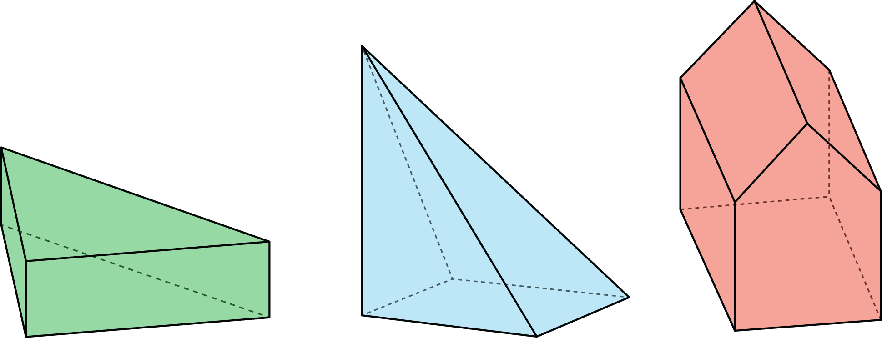

2 What's the Cross Section?

Student Task Statement
Here is a rectangular prism and a pyramid with the same base and same height.
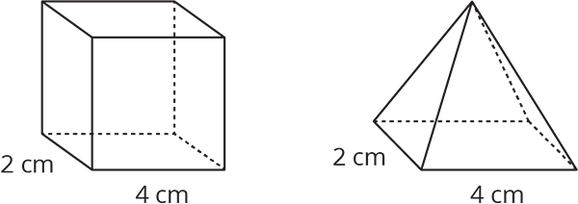
- Think about slicing each solid parallel to its base, halfway up. What shape would each cross section be? What is the same about the two cross sections? What is different?
- Think about slicing each solid parallel to its base, near the top. What shape would each cross section be? What is the same about the two cross sections? What is different?

3 Card Sort: Cross Sections

Student Task Statement
Your teacher will give you a set of cards. Sort the images into groups that make sense to you. Be prepared to explain your reasoning.

4 Drawing Cross Sections (Optional)

Student Task Statement
Draw and describe each cross section.
- Here is a picture of a rectangular prism, 4 units by 2 units by 3 units.
- 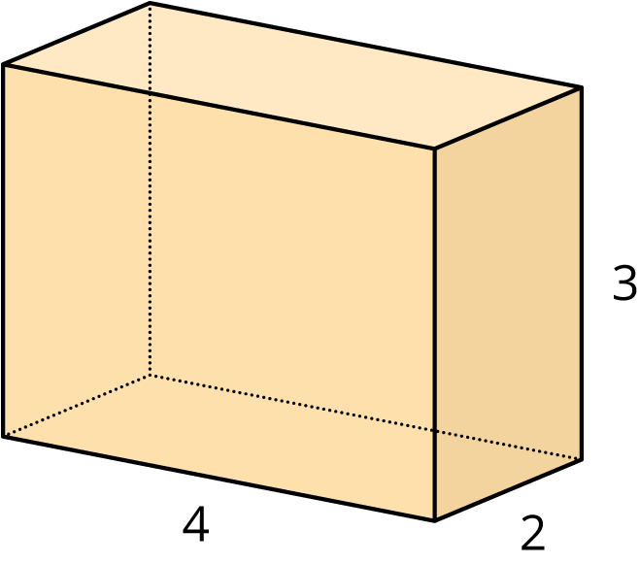
  - A plane cuts the prism parallel to the bottom and top faces.
  - 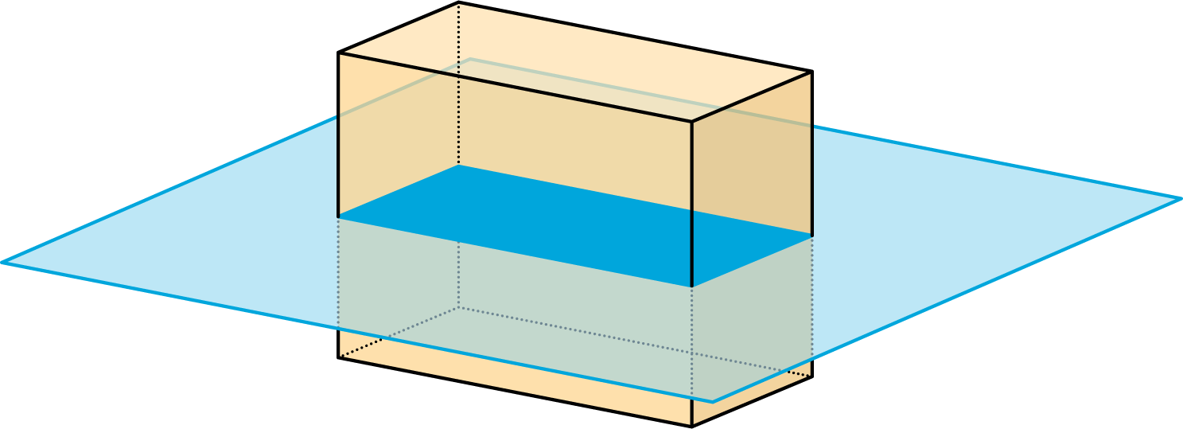
  - The plane moves up and cuts the prism at a different height.
  - 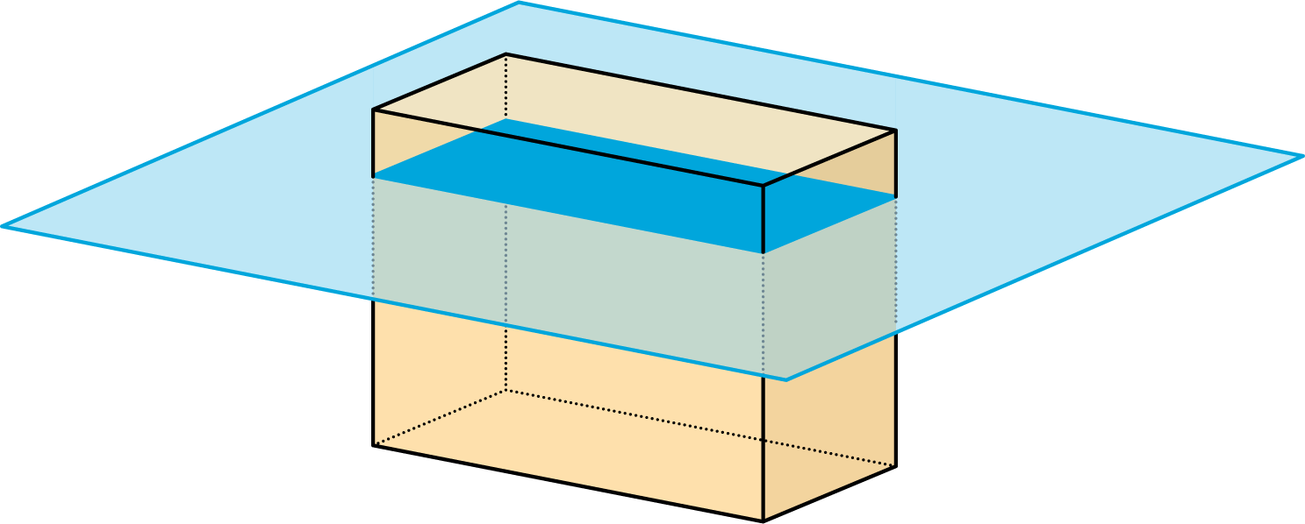
  - A vertical plane cuts the prism diagonally.
  - 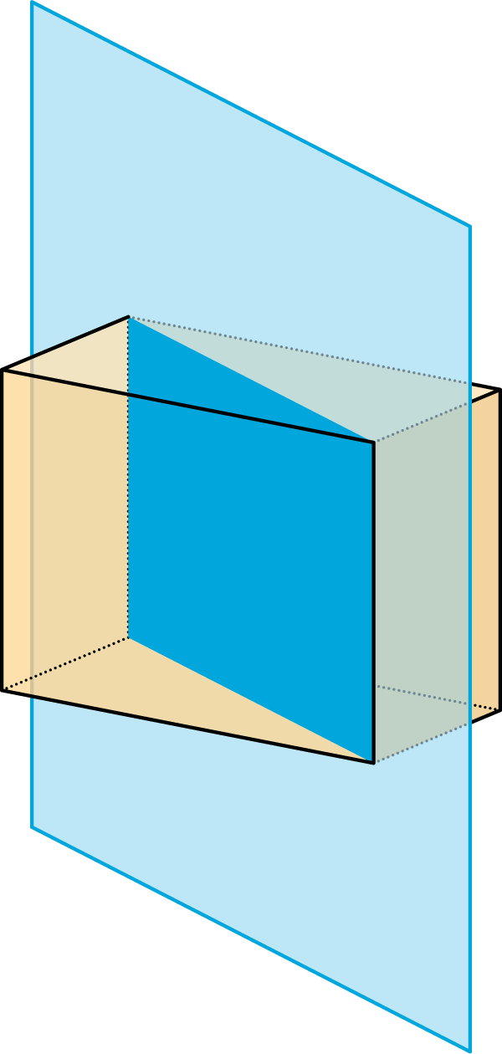
- A square pyramid has a base that is 4 units by 4 units. Its height is also 4 units.
  - A plane cuts the pyramid parallel to the base.
  - 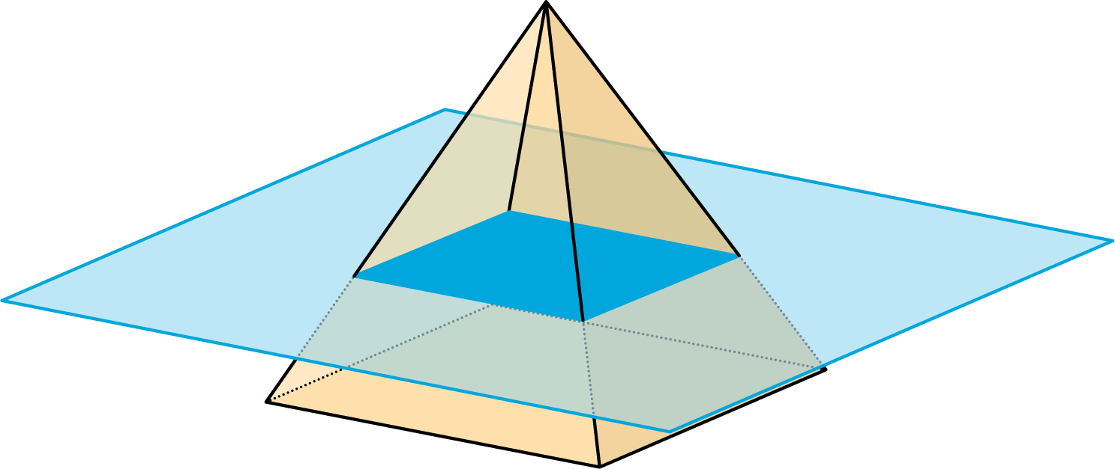
  - A vertical plane cuts the prism.
  - 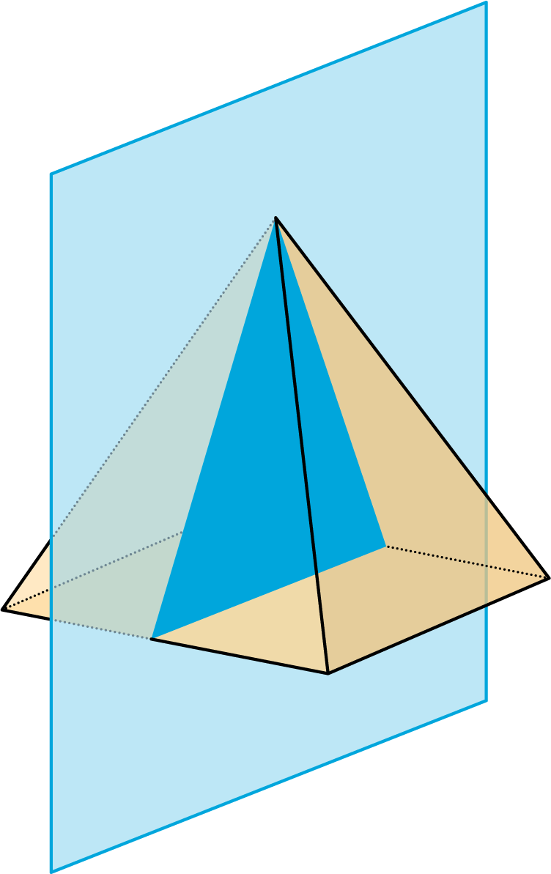
- A cube has an edge of length 4.
  - A plane cuts off the corner of the cube.
  - 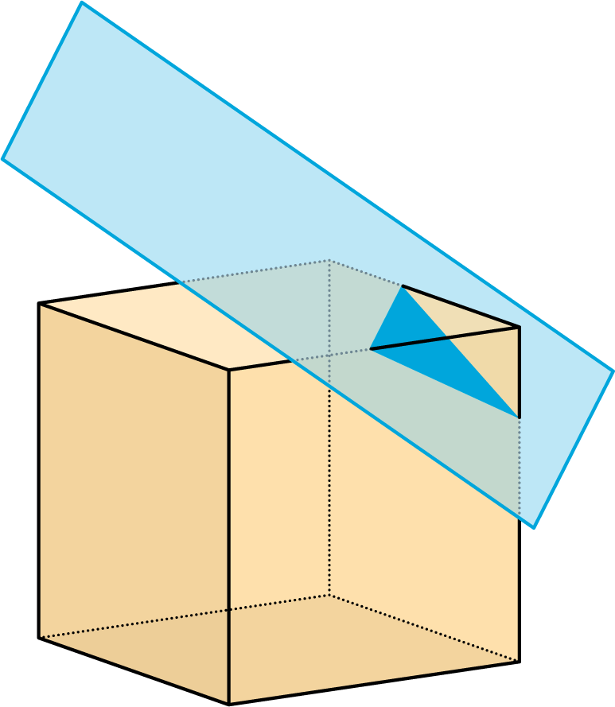
  - The plane moves farther from the corner and makes a cut through the middle of the cube.
  - 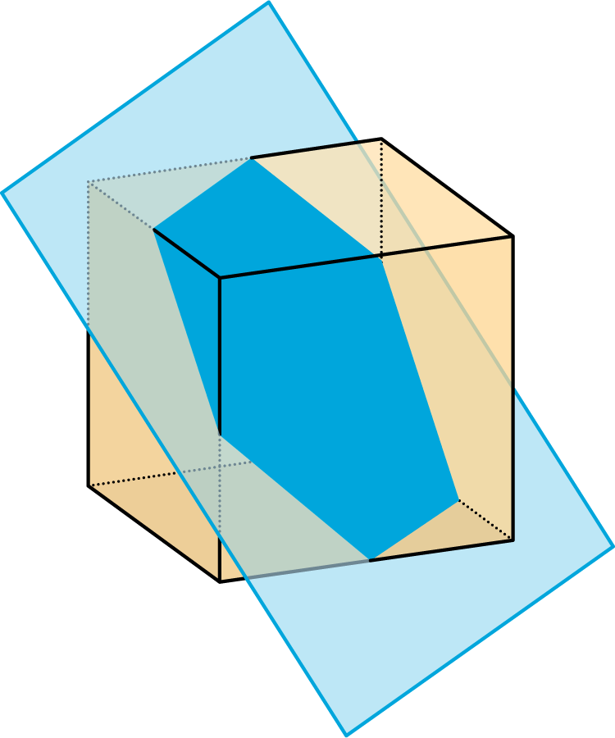
© CC BY Open Up Resources. Adaptations CC BY IM.

