Lesson 12: Maneras de representar situaciones de medidas

Standards Alignments
Addressing | 3.MD.A.2
Building Towards | 3.MD.A.2

Teacher-facing Learning Goals
- Ask and answer questions about situations involving measurements.
- Interpret representations of situations involving measurements.

Student-facing Learning Goals
- Démosle sentido y representemos situaciones de medidas en una feria.

Lesson Purpose
The purpose of this lesson is for students to make sense of situations involving measurements, interpret representations of the situations, and ask and answer questions about them.
In previous lessons, students estimated and measured weights and liquid volumes. They learned a variety of methods and representations to solve problems involving all four operations, and used representations that made sense to them.
In this lesson, students make sense of tape diagrams (MP2), which better represent the continuous nature of measurement contexts. The context of a fair is used in this lesson and subsequent ones.

Access for:

Students with Disabilities
- Engagement (Activity 2)

English Learners
- MLR8 (Activity 2)

Instructional Routines
Card Sort (Activity 2), MLR5 Co-craft Questions (Activity 1), Notice and Wonder (Warm-up)

Materials to Gather
- Tools for creating a visual display: Activity 1

Materials to Copy
- Card Sort: Giant Pumpkins, Spanish (groups of 2): Activity 2

Lesson Timeline
Warm-up | 10 min
Activity 1 | 20 min
Activity 2 | 15 min
Lesson Synthesis | 10 min
Cool-down | 5 min

Teacher Reflection Question
How did you see students using their prior mathematical knowledge to solve problems involving the four operations in these new measurement contexts?

Cool-down
(to be completed at the end of the lesson) 5min
¿Cuál diagrama corresponde?

Standards Alignments
Addressing | 3.MD.A.2

Student-facing Task Statement
¿Cuál diagrama corresponde a esta situación? Explica cómo razonaste.
Un agricultor de calabazas usó 52 litros de agua para regar 13 plántulas y los repartió equitativamente entre 13 ellas. ¿Cuánta agua usó para cada plántula?
A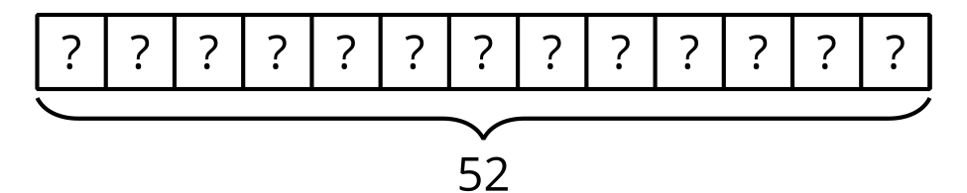
B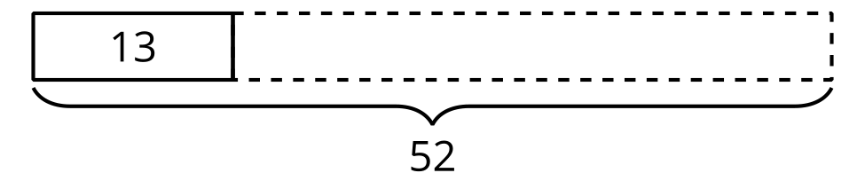

Student Responses
A. The diagram has 13 parts and each part represents a seedling, but we don’t know how much water each seedling got.

