Lesson 1 Practice Problems
- A sandwich store charges $20 to have 3 turkey subs delivered and $26 to have 4 delivered.
  - Is the relationship between number of turkey subs delivered and amount charged proportional? Explain how you know.
  - How much does the store charge for 1 additional turkey sub?
  - Describe a rule for determining how much the store charges based on the number of turkey subs delivered.
- Which question cannot be answered by the solution to the equation $3x=27$?
  - Elena read three times as many pages as Noah. She read 27 pages. How many pages did Noah read?
  - Lin has 27 stickers. She gives 3 stickers to each of her friends. With how many friends did Lin share her stickers?
  - Diego paid $27 to have 3 pizzas delivered and $35 to have 4 pizzas delivered. What is the price of one pizza?
  - The coach splits a team of 27 students into 3 groups to practice skills. How many students are in each group?
- The area of the Mojave desert is 25,000 square miles. A scale drawing of the Mojave desert has an area of 10 square inches. What is the scale of the map?
- (From Unit 2, Lesson 7.)
- Each picture shows two polygons, one labeled Polygon A and one labeled Polygon B. Describe how to move Polygon A into the position of Polygon B using a transformation.

  - 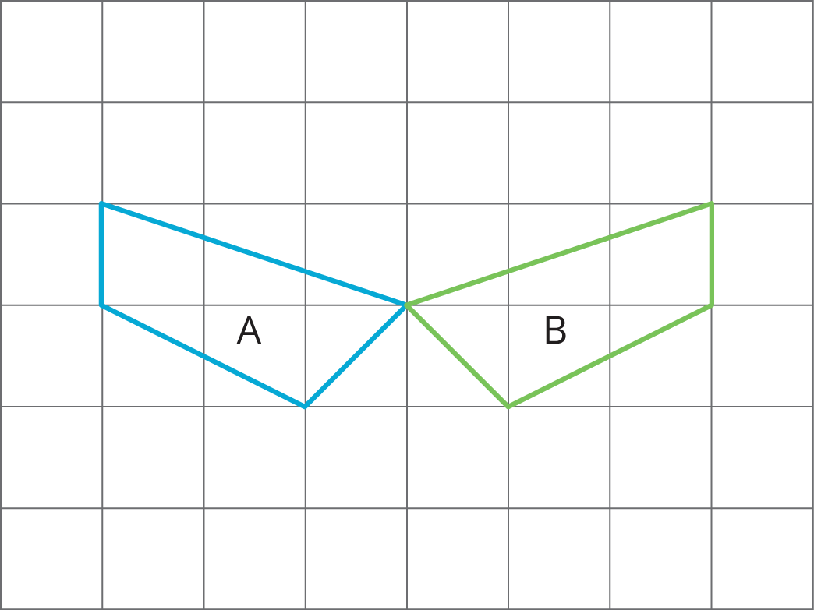

  - 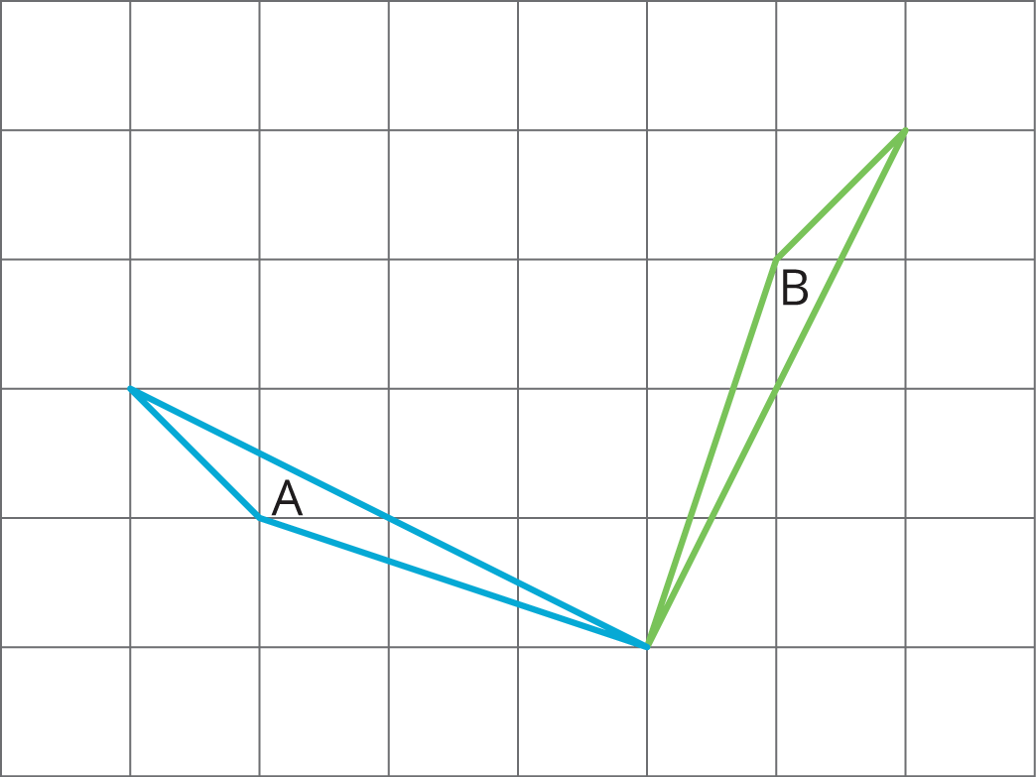

  - 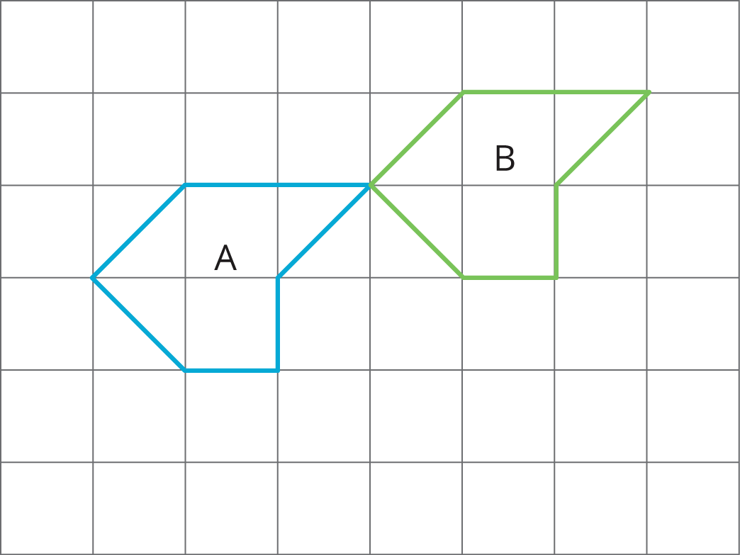
- (From Unit 1, Lesson 3.)
© CC BY Open Up Resources. Adaptations CC BY IM.

