Unit 4 Lesson 14: Strategic Solving

1 Equal Perimeters (Warm up)

Student Task Statement
The triangle and the square have equal perimeters.
- Find the value of $x$.
- What is the perimeter of each of the figures?
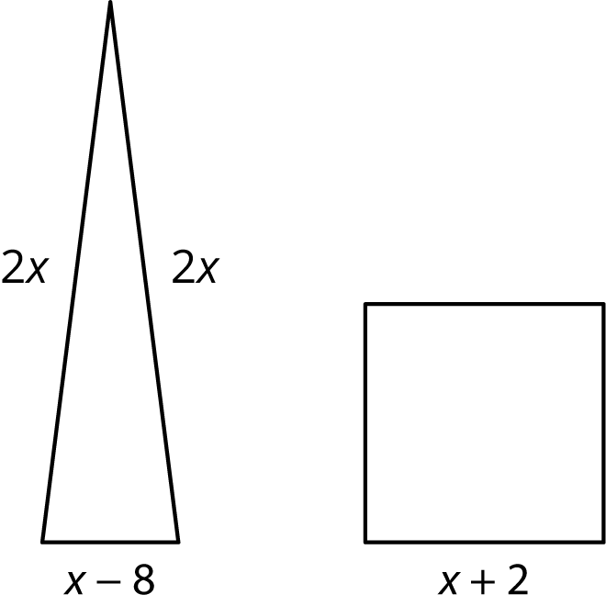

2 Predicting Solutions

Student Task Statement
Without solving, identify whether these equations have a solution that is positive, negative, or zero.
- $\frac{x}{6}=\frac{3x}{4}$
- $7x=3.25$
- $7x=32.5$
- $3x+11=11$
- $9−4x=4$
- $\text{-}8+5x=\text{-}20$
- $\text{-}\frac{1}{2}\left(\text{-}8+5x\right)=\text{-}20$

3 Which Would You Rather Solve?

Student Task Statement
Here are a lot of equations:
A. $\text{-}\frac{5}{6}\left(8+5b\right)=75+\frac{5}{3}b$
B. $\text{-}\frac{1}{2}\left(t+3\right)−10=\text{-}6.5$
C. $\frac{10−v}{4}=2\left(v+17\right)$
D. $2\left(4k+3\right)−13=2\left(18−k\right)−13$
E. $\frac{n}{7}−12=5n+5$
F. $3\left(c−1\right)+2\left(3c+1\right)=\text{-}\left(3c+1\right)$
G. $\frac{4m−3}{4}=\text{-}\frac{9+4m}{8}$
H. $p−5\left(p+4\right)=p−\left(8−p\right)$
I. $2\left(2q+1.5\right)=18−q$
J. $2r+49=\text{-}8\left(\text{-}r−5\right)$
- Without solving, identify 3 equations that you think would be least difficult to solve and 3 equations you think would be most difficult to solve. Be prepared to explain your reasoning.
- Choose 3 equations to solve. At least one should be from your "least difficult" list and one should be from your "most difficult" list.
© CC BY Open Up Resources. Adaptations CC BY IM.

