Unit 1 Lesson 8: Moves in Parallel

1 Line Moves (Warm up)

Student Task Statement
For each diagram, describe a translation, rotation, or reflection that takes line $ℓ$ to line $ℓ^{′}$. Then plot and label $A^{′}$ and $B^{′}$, the images of $A$ and $B$.
- 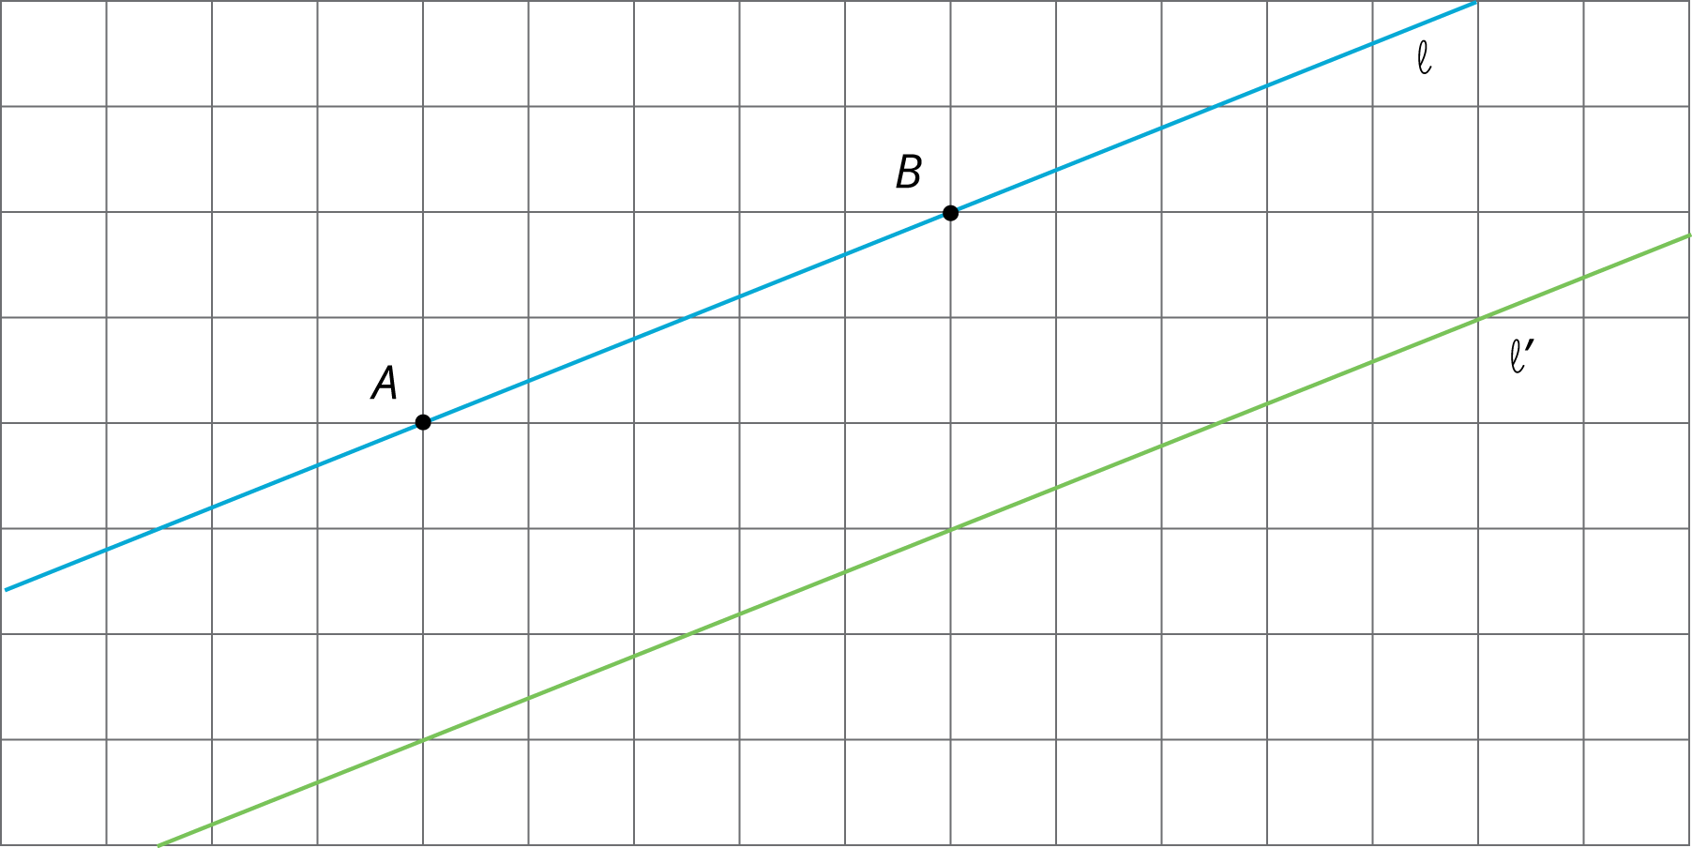
- 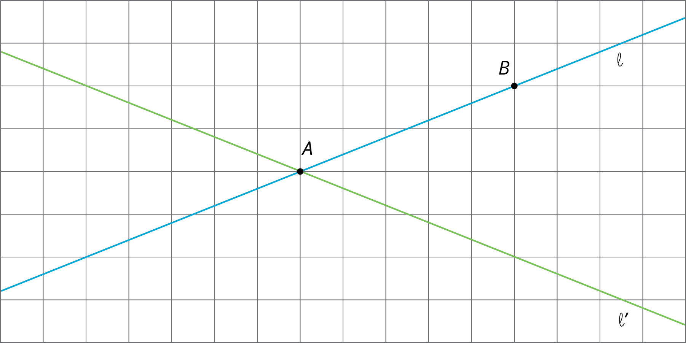

2 Parallel Lines

Images for Launch
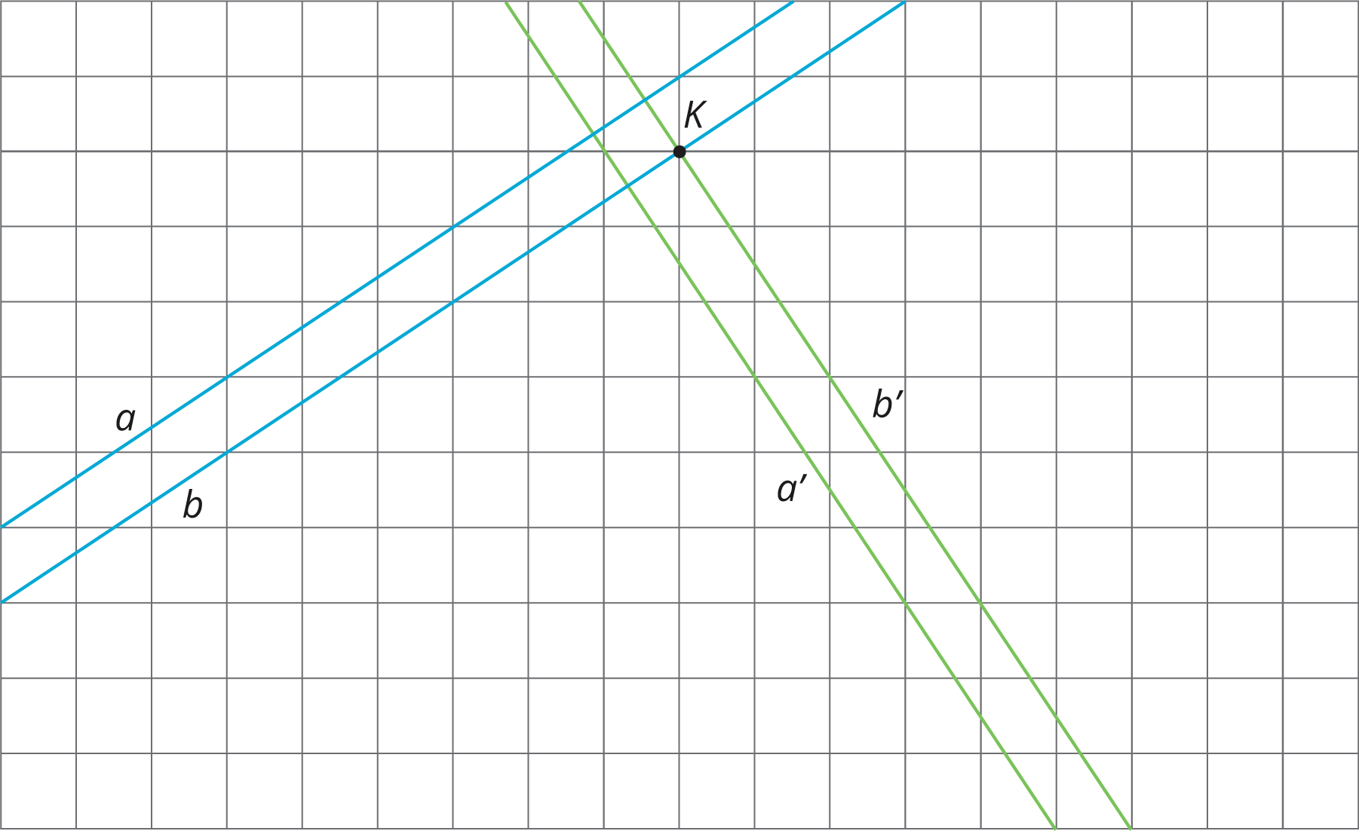

Student Task Statement
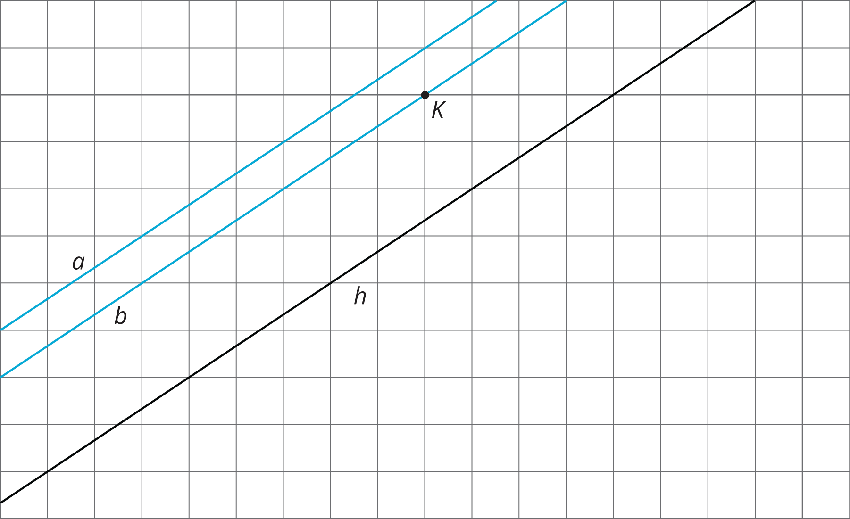
Use a piece of tracing paper to trace lines $a$ and $b$ and point $K$. Then use that tracing paper to draw the images of the lines under the three different transformations listed.
As you perform each transformation, think about the question:
What is the image of two parallel lines under a rigid transformation?
- Translate lines $a$ and $b$ 3 units up and 2 units to the right.
  - What do you notice about the changes that occur to lines $a$ and $b$ after the translation?
  - What is the same in the original and the image?
- Rotate lines $a$ and $b$ counterclockwise 180 degrees using $K$ as the center of rotation.
  - What do you notice about the changes that occur to lines $a$ and $b$ after the rotation?
  - What is the same in the original and the image?
- Reflect lines $a$ and $b$ across line $h$.
  - What do you notice about the changes that occur to lines $a$ and $b$ after the reflection?
  - What is the same in the original and the image?

3 Let’s Do Some 180’s

Student Task Statement
- The diagram shows a line with points labeled $A$, $C$, $D$, and $B$.
  - On the diagram, draw the image of the line and points $A$, $C$, and $B$ after the line has been rotated 180 degrees around point $D$.
  - Label the images of the points $A^{′}$, $B^{′}$, and $C^{′}$.
  - What is the order of all seven points? Explain or show your reasoning.
- The diagram shows a line with points $A$ and $C$ on the line and a segment $AD$ where $D$ is not on the line.
  - Rotate the figure 180 degrees about point $C$. Label the image of $A$ as $A^{′}$ and the image of $D$ as $D^{′}$.
  - What do you know about the relationship between angle $CAD$ and angle $CA^{′}D^{′}$? Explain or show your reasoning.
- 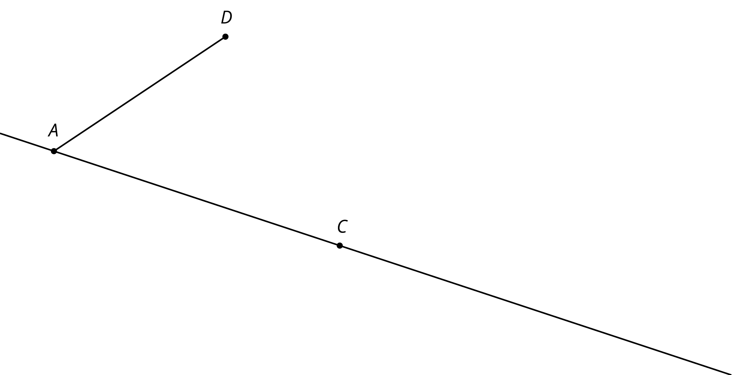
- The diagram shows two lines $ℓ$ and $m$ that intersect at a point $O$ with point $A$ on $ℓ$ and point $D$ on $m$.
  - Rotate the figure 180 degrees around $O$. Label the image of $A$ as $A^{′}$ and the image of $D$ as $D^{′}$.
  - What do you know about the relationship between the angles in the figure? Explain or show your reasoning.
- 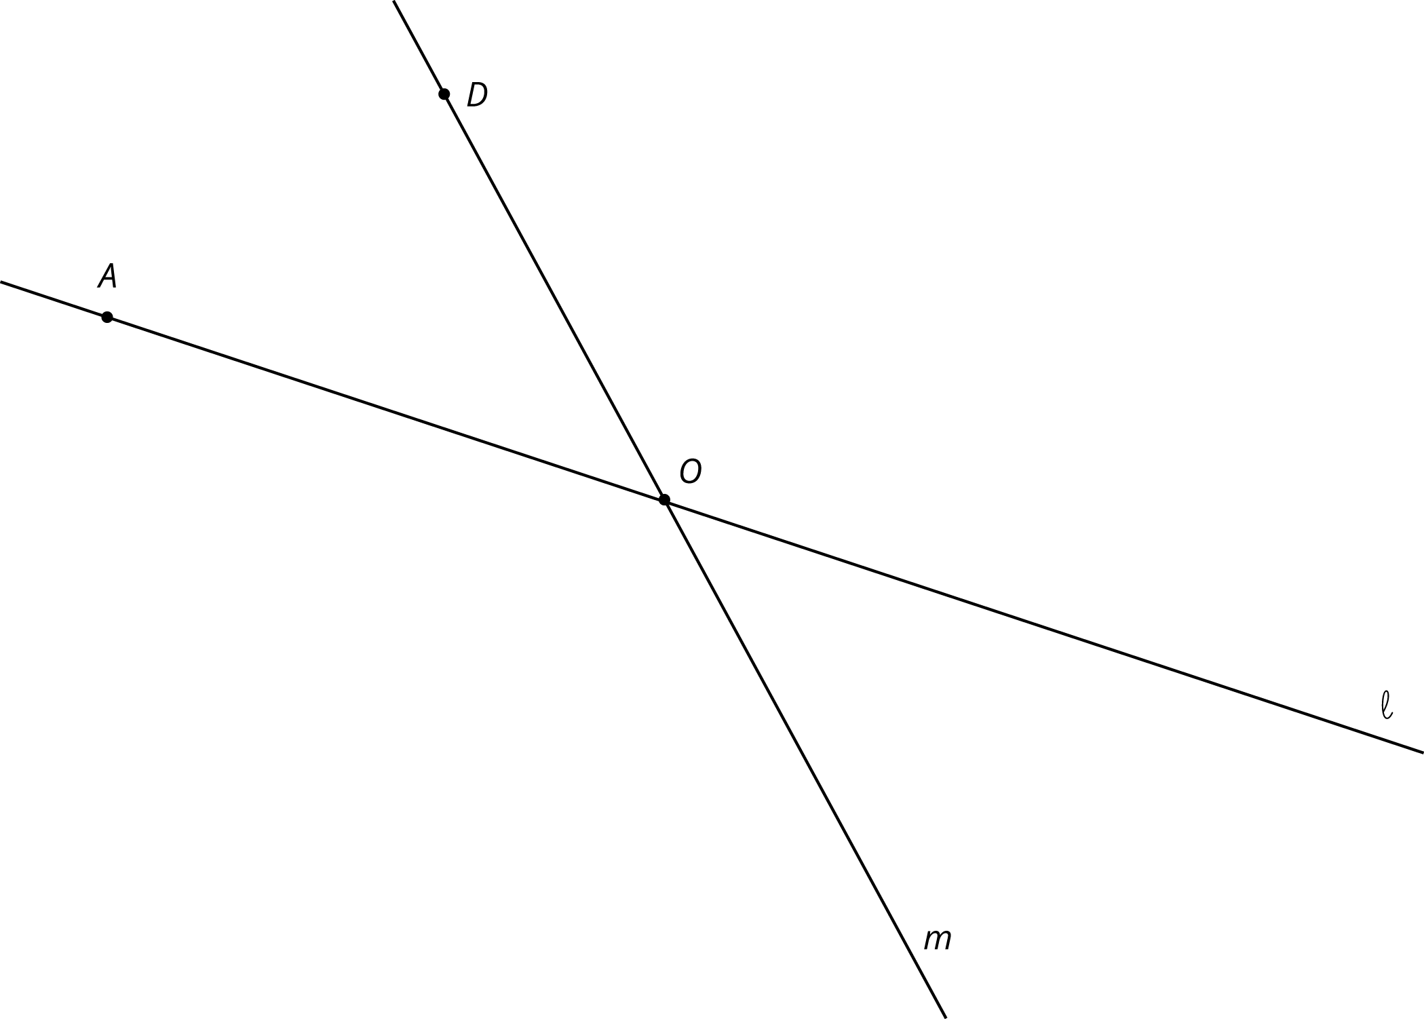
© CC BY Open Up Resources. Adaptations CC BY IM.

