Lesson 2: Revisiting Right Triangles
- Let’s recall and use some things we know about right triangles.

2.1: Notice and Wonder: A Right Triangle
What do you notice? What do you wonder?
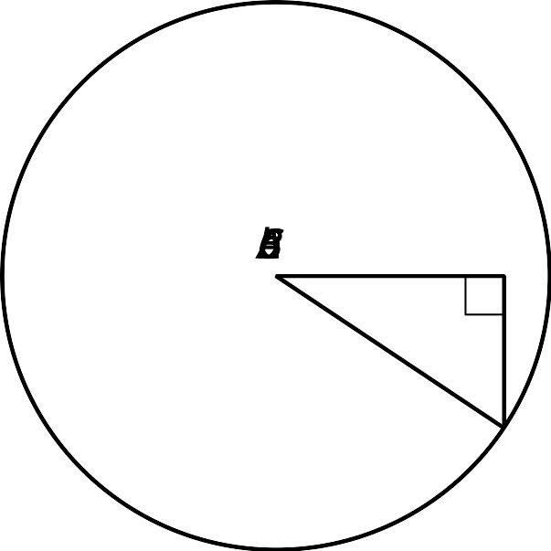

2.2: Recalling Right Triangle Trigonometry
- Find $\text{cos}(A)$, $\text{sin}(A)$, and $\text{tan}(A)$ for triangle $ABC$.
- Sketch a triangle $DEF$ where $\text{sin}(D)=\text{cos}(D)$ and $E$ is a right angle. What is the value of $\text{tan}(D)$ for this triangle? Explain how you know.
- If the coordinates of point $I$ are $(9,12)$, what is the value of $\text{cos}(G)$, $\text{sin}(G)$, and $\text{tan}(G)$ for triangle $GHI$? Explain or show your reasoning.

2.3: Shrinking Triangles
- What are $\text{cos}(D)$, $\text{sin}(D)$, and $\text{tan}(D)$? Explain how you know.
- 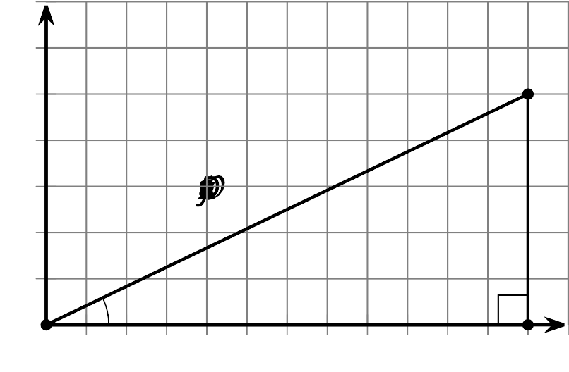
- Here is a triangle similar to triangle $DEF$.
- 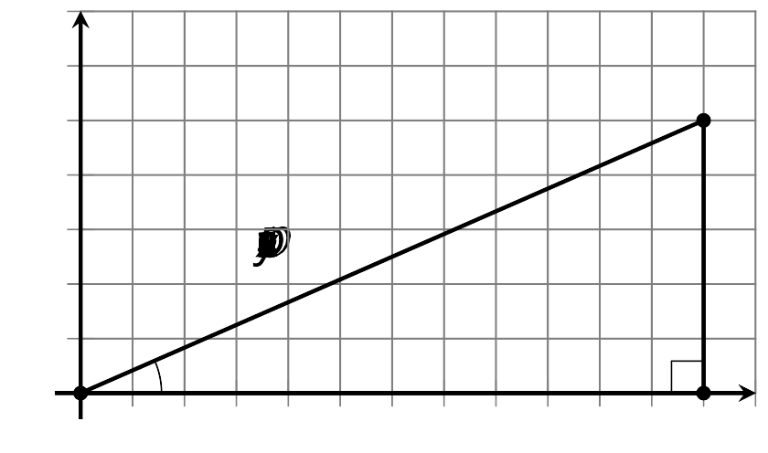
  - What is the scale factor from $△DEF$ to $△D^{′}E^{′}F^{′}$? Explain how you know.
  - What are $\text{cos}(D^{′})$, $\text{sin}(D^{′})$, and $\text{tan}(D^{′})$?
- Here is another triangle similar to triangle $DEF$.
- 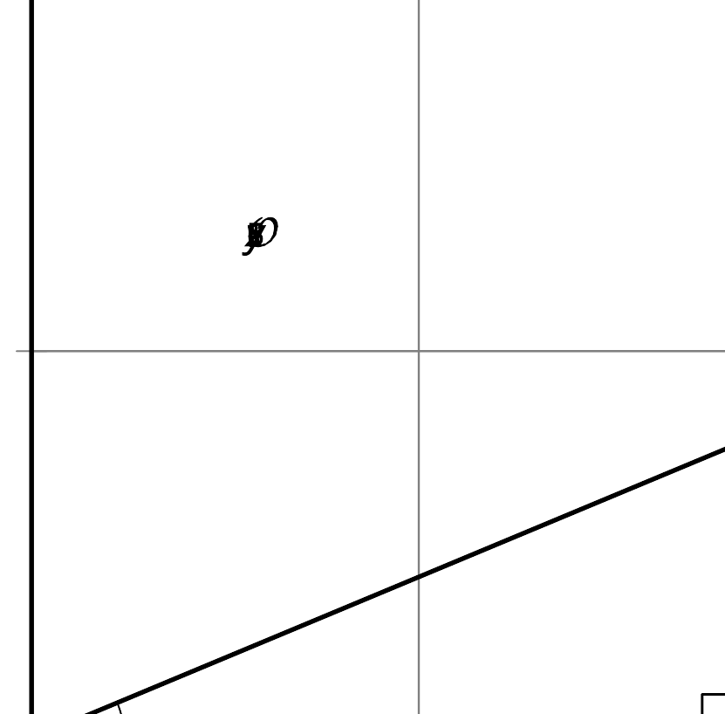
  - Label the triangle $D^{″}E^{″}F^{″}$.
  - What is the scale factor from triangle $DEF$ to triangle $D^{″}E^{″}F^{″}$?
  - What are the coordinates of $F^{″}$? Explain how you know.
  - What are $\text{cos}(D^{″})$, $\text{sin}(D^{″})$, and $\text{tan}(D^{″})$?

Are you ready for more?
Angles $C$ and $C^{′}$ in triangles $ABC$ and $A^{′}B^{′}C^{′}$ are right angles. If $\text{sin}(A)=\text{sin}(A^{′})$, is that sufficient to show that $△ABC$ is similar to $△A^{′}B^{′}C^{′}$? Explain your reasoning.

Lesson 2 Summary
In an earlier course, we studied ratios of side lengths in right triangles.
In this triangle, the cosine of angle $A$ is the ratio of the length of the side adjacent to angle $A$ to the length of the hypotenuse—that is $\text{cos}(A)=\frac{4}{5}$. The sine of angle $A$ is the ratio of the length of the side opposite angle $A$ to the length of the hypotenuse—that is $\text{sin}(A)=\frac{3}{5}$. The tangent of angle $A$ is the ratio of the length of the side opposite angle $A$ to the length of the side adjacent to angle $A$—that is $\text{tan}(A)=\frac{3}{4}$.
Now consider triangle $A^{′}B^{′}C^{′}$, which is similar to triangle $ABC$ with a hypotenuse of length 1 unit. Here is a picture of triangle $A^{′}B^{′}C^{′}$ on a coordinate grid:
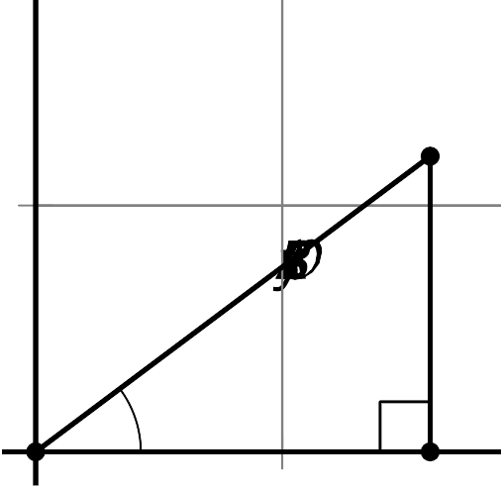
Since the two triangles are similar, angle $A$ and $A^{′}$ are congruent. So how do the values of cosine, sine, and tangent of these angles compare to the angles in triangle $ABC$? It turns out that since all three values are ratios of side lengths, $\text{cos}(A)=\text{cos}(A^{′})$, $\text{sin}(A)=\text{sin}(A^{′})$, and $\text{tan}(A)=\text{tan}(A^{′})$.
Notice that the coordinates of $B^{′}$ are $\left(\frac{4}{5},\frac{3}{5}\right)$ because segment $A^{′}C^{′}$ has length $\frac{4}{5}$ and segment $B^{′}C^{′}$ has length $\frac{3}{5}$. In other words, the coordinates of $B^{′}$ are $(\text{cos}(A^{′}),\text{sin}(A^{′}))$.
© CC BY 2019 by Illustrative Mathematics®

