Unit 4 Lesson 3: Revisiting Proportional Relationships

1 Recipe Ratios (Warm up)

Student Task Statement
A recipe calls for $\frac{1}{2}$ cup sugar and 1 cup flour. Complete the table to show how much sugar and flour to use in different numbers of batches of the recipe.
sugar (cups) | flour (cups)
$\frac{1}{2}$ | 1
$\frac{3}{4}$
 | $1\frac{3}{4}$
1
 | $2\frac{1}{2}$

2 The Price of Rope

Images for Launch
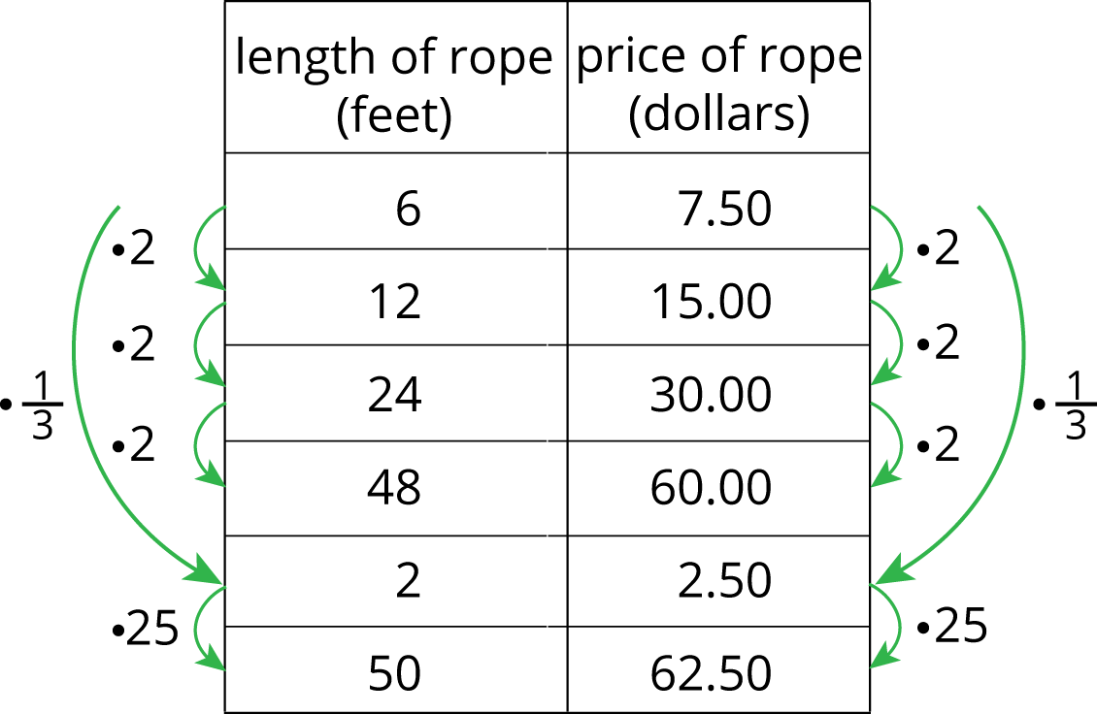

Student Task Statement
Two students are solving the same problem: At a hardware store, they can cut a length of rope off of a big roll, so you can buy any length you like. The cost for 6 feet of rope is $7.50. How much would you pay for 50 feet of rope, at this rate?
- Kiran knows he can solve the problem this way.
- 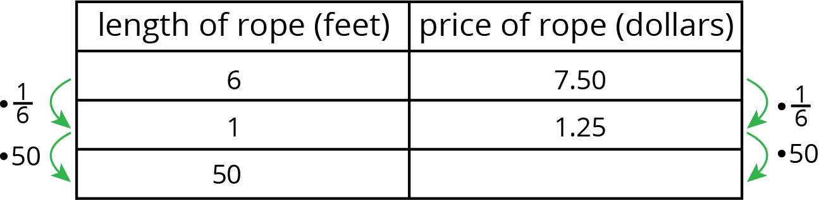
- What would be Kiran's answer?
- Kiran wants to know if there is a more efficient way of solving the problem. Priya says she can solve the problem with only 2 rows in the table.
- length of rope (feet) | - price of rope (dollars)
- 6 | - 7.50
- 50
- What do you think Priya's method is?

Activity Synthesis
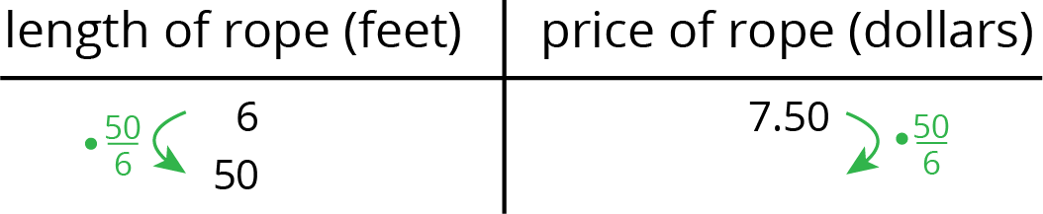
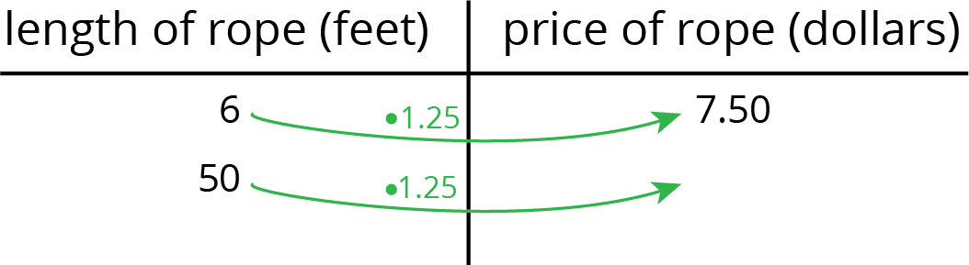

3 Swimming, Manufacturing, and Painting

Student Task Statement
- Tyler swims at a constant speed, 5 meters every 4 seconds. How long does it take him to swim 114 meters?
- distance (meters) | - time (seconds)
- 5 | - 4
- 114
- A factory produces 3 bottles of sparkling water for every 8 bottles of plain water. How many bottles of sparkling water does the company produce when it produces 600 bottles of plain water?
- number of bottles  of sparkling water | - number of bottles  of plain water
- A certain shade of light blue paint is made by mixing $1\frac{1}{2}$ quarts of blue paint with 5 quarts of white paint. How much white paint would you need to mix with 4 quarts of blue paint?

- For each of the previous three situations, write an equation to represent the proportional relationship.

4 Finishing the Race and More Orange Juice (Optional)

Student Task Statement
- Lin runs $2\frac{3}{4}$ miles in $\frac{2}{5}$ of an hour. Tyler runs $8\frac{2}{3}$ miles in $\frac{4}{3}$ of an hour. How long does it take each of them to run 10 miles at that rate?
- Priya mixes $2\frac{1}{2}$ cups of water with $\frac{1}{3}$ cup of orange juice concentrate. Diego mixes $1\frac{2}{3}$ cups of water with $\frac{1}{4}$ cup orange juice concentrate. How much concentrate should each of them mix with 100 cups of water to make juice that tastes the same as their original recipe? Explain or show your reasoning.
© CC BY Open Up Resources. Adaptations CC BY IM.

