Unit 8 Lesson 15: Infinite Decimal Expansions

1 Searching for Digits (Warm up)

Student Task Statement
The first 3 digits after the decimal for the decimal expansion of $\frac{3}{7}$ have been calculated. Find the next 4 digits.
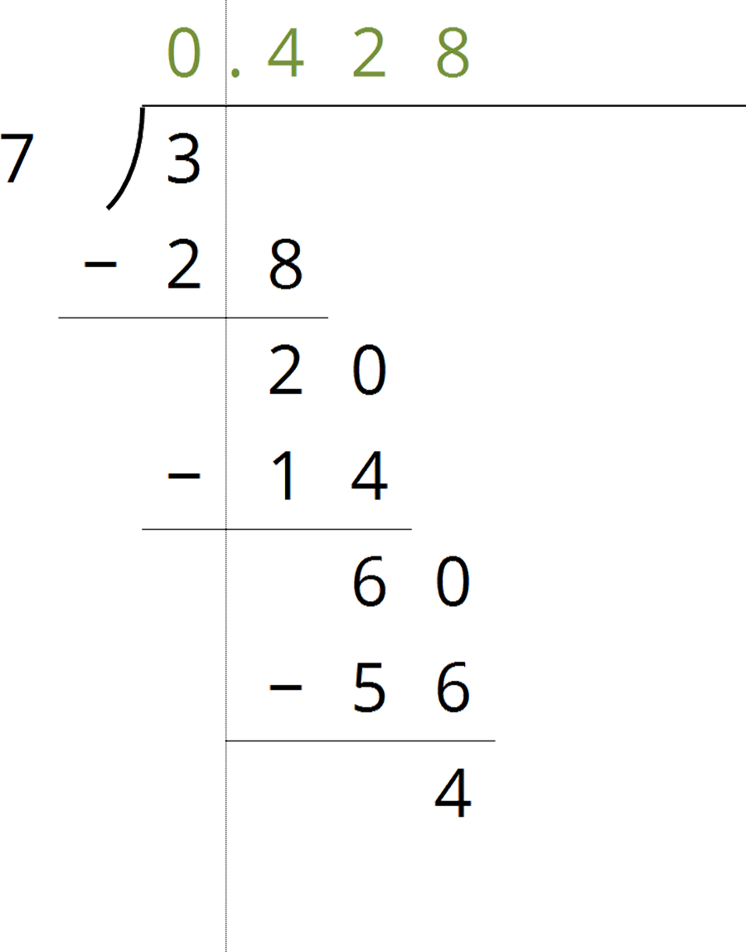

2 Some Numbers Are Rational

Student Task Statement
Your teacher will give your group a set of cards. Each card will have a calculations side and an explanation side.
- The cards show Noah’s work calculating the fraction representation of $0.4\overset{¯}{85}$. Arrange these in order to see how he figured out that $0.4\overset{¯}{85}=\frac{481}{990}$ without needing a calculator.
- Use Noah’s method to calculate the fraction representation of:
  - $0.1\overset{¯}{86}$
  - $0.7\overset{¯}{88}$

3 Some Numbers Are Not Rational

Student Task Statement

  - Why is $\sqrt{2}$ between 1 and 2 on the number line?
  - Why is $\sqrt{2}$ between 1.4 and 1.5 on the number line?
  - How can you figure out an approximation for $\sqrt{2}$ accurate to 3 decimal places?
  - Label all of the tick marks. Plot $\sqrt{2}$ on all three number lines. Make sure to add arrows from the second to the third number lines.
  - 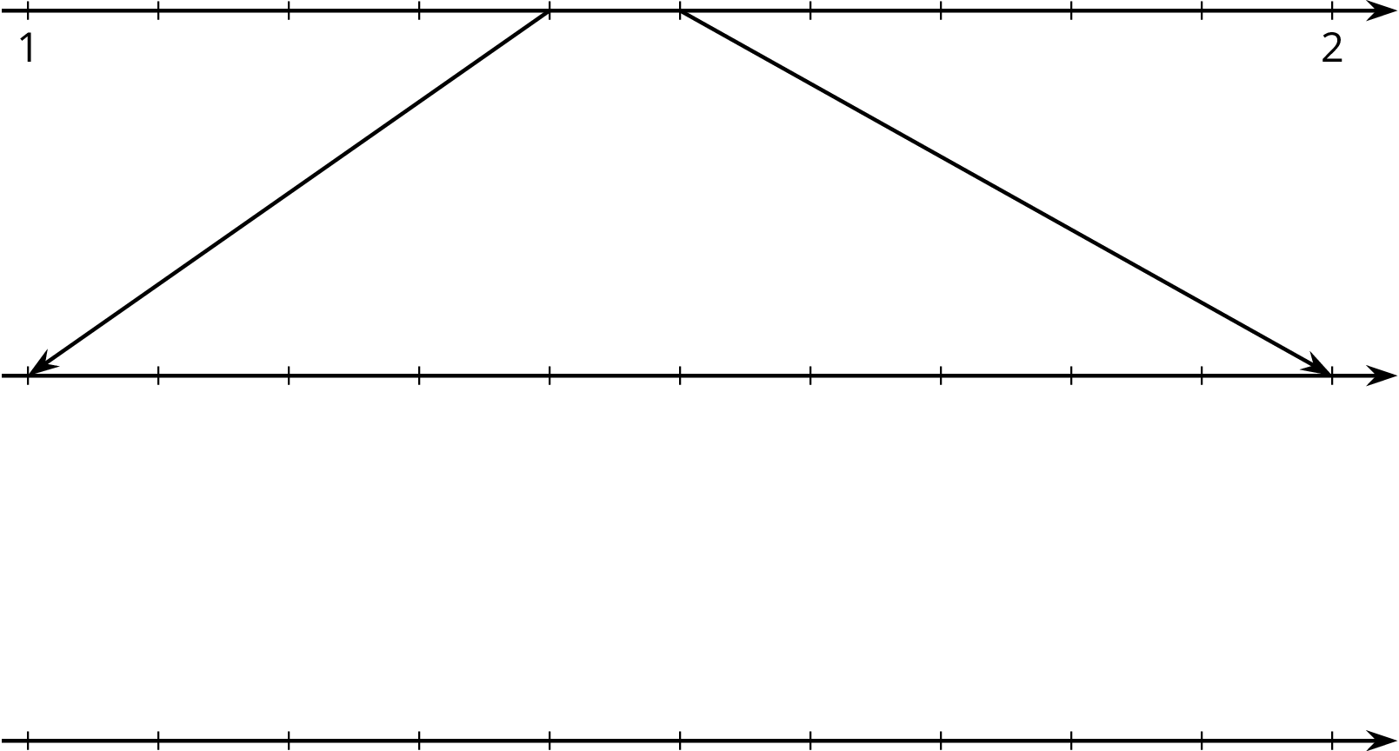

  - Elena notices a beaker in science class says it has a diameter of 9 cm and measures its circumference to be 28.3 cm. What value do you get for $π$ using these values and the equation for circumference, $C=2πr$?
  - Diego learned that one of the space shuttle fuel tanks had a diameter of 840 cm and a circumference of 2,639 cm. What value do you get for $π$ using these values and the equation for circumference, $C=2πr$?
  - Label all of the tick marks on the number lines. Use a calculator to get a very accurate approximation of $π$ and plot that number on all three number lines.
  - 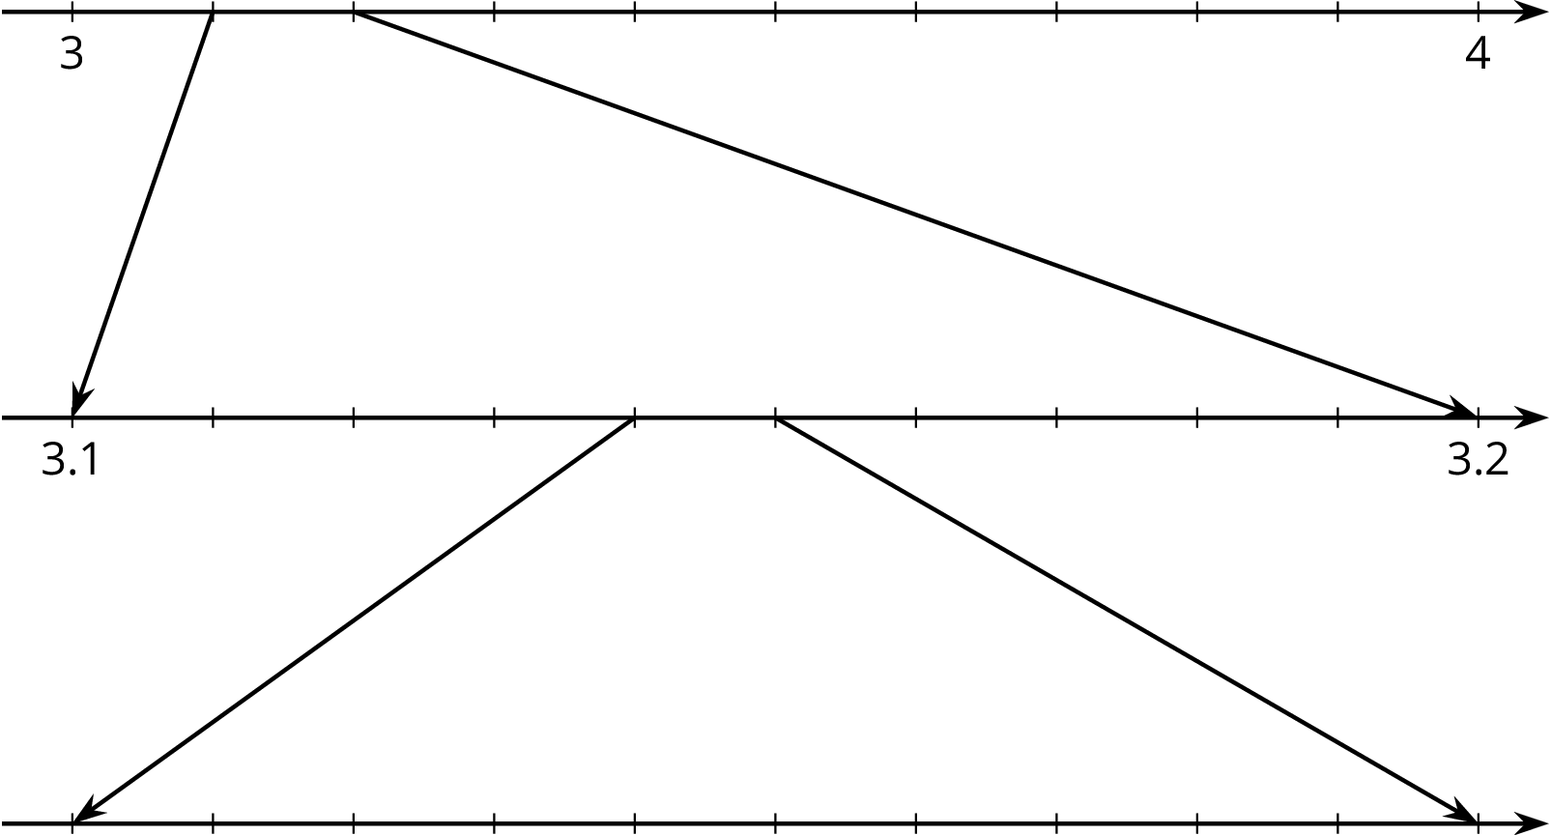

  - How can you explain the differences between these calculations of $π$?
© CC BY Open Up Resources. Adaptations CC BY IM.

