Unit 7 Lesson 8: Triangles with 3 Common Measures

1 3 Sides; 3 Angles (Warm up)

Student Task Statement
Examine each set of triangles. What do you notice? What is the same about the triangles in the set? What is different?
Set 1:
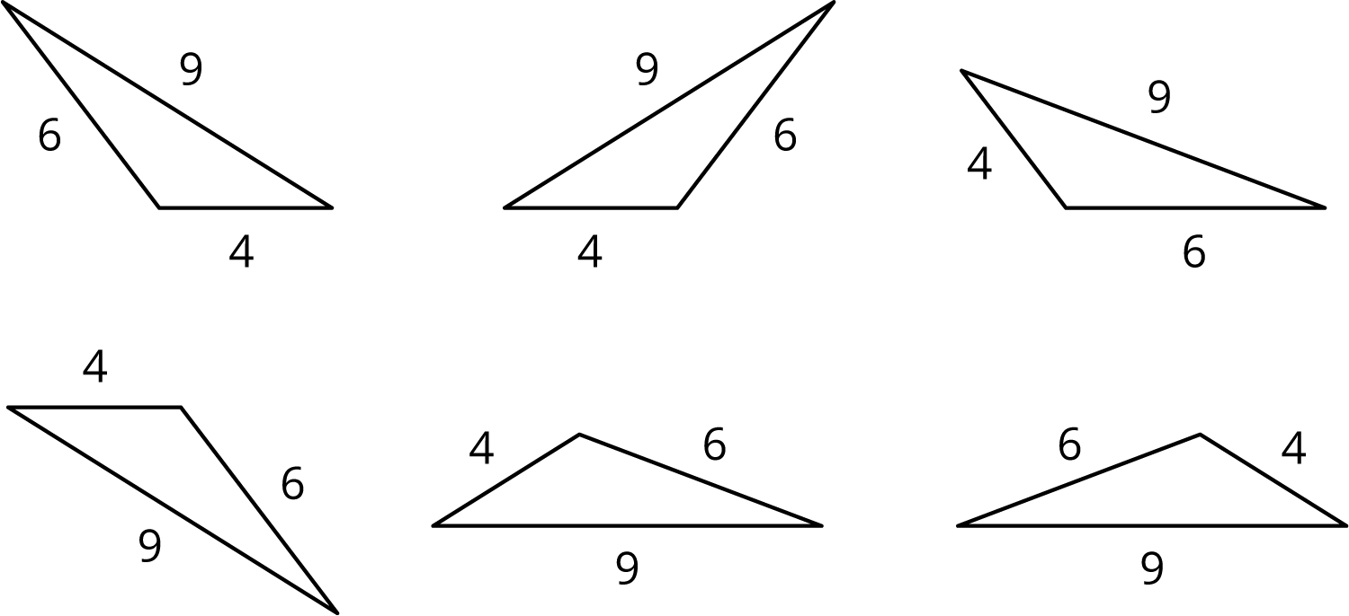
Set 2:
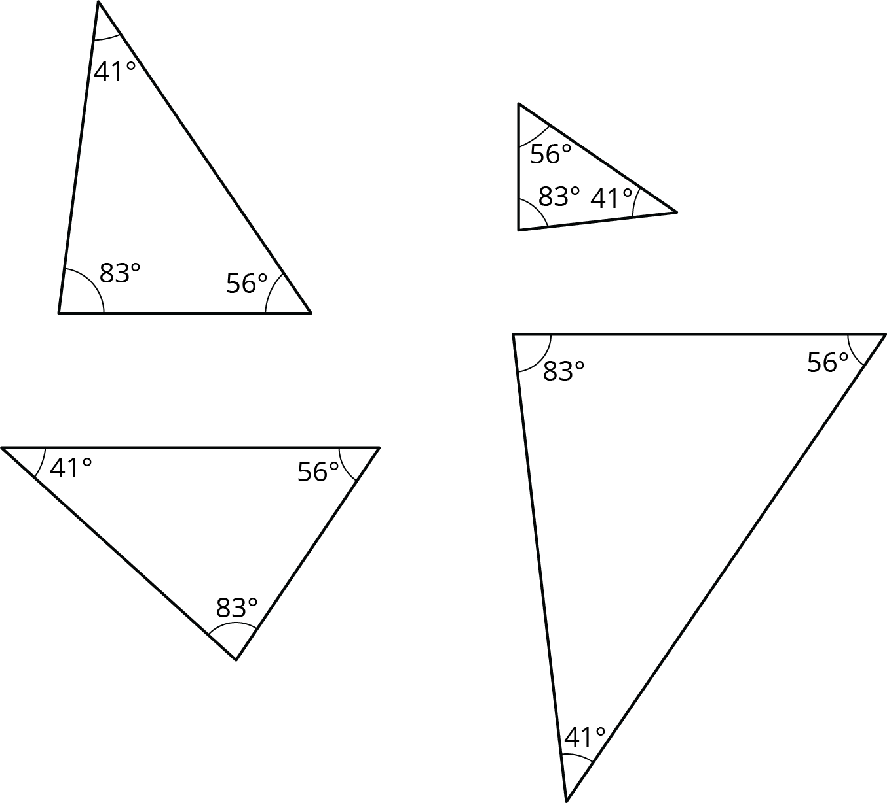

2 2 Sides and 1 Angle

Student Task Statement
Examine this set of triangles.
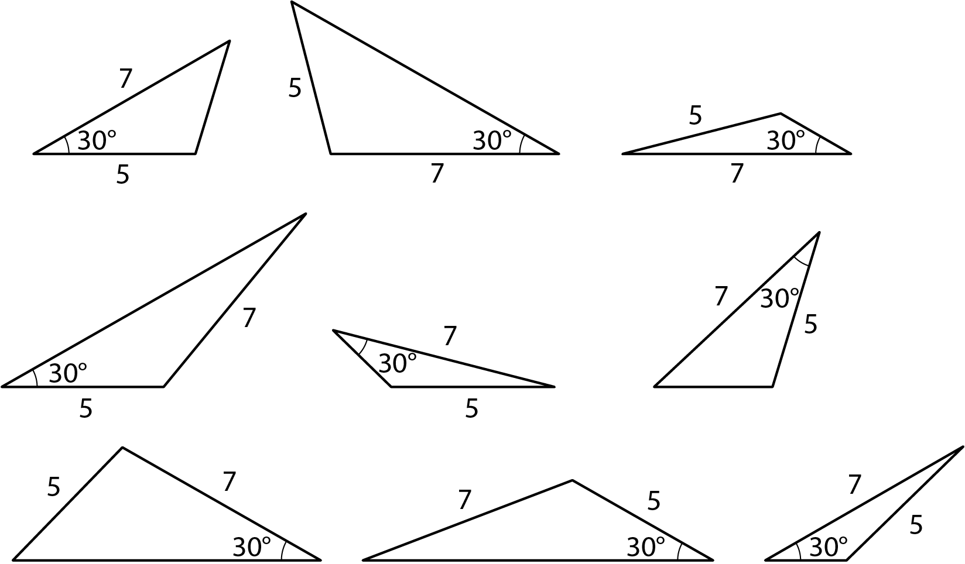
- What is the same about the triangles in the set? What is different?
- How many different triangles are there? Explain or show your reasoning.

3 2 Angles and 1 Side

Student Task Statement
Examine this set of triangles.
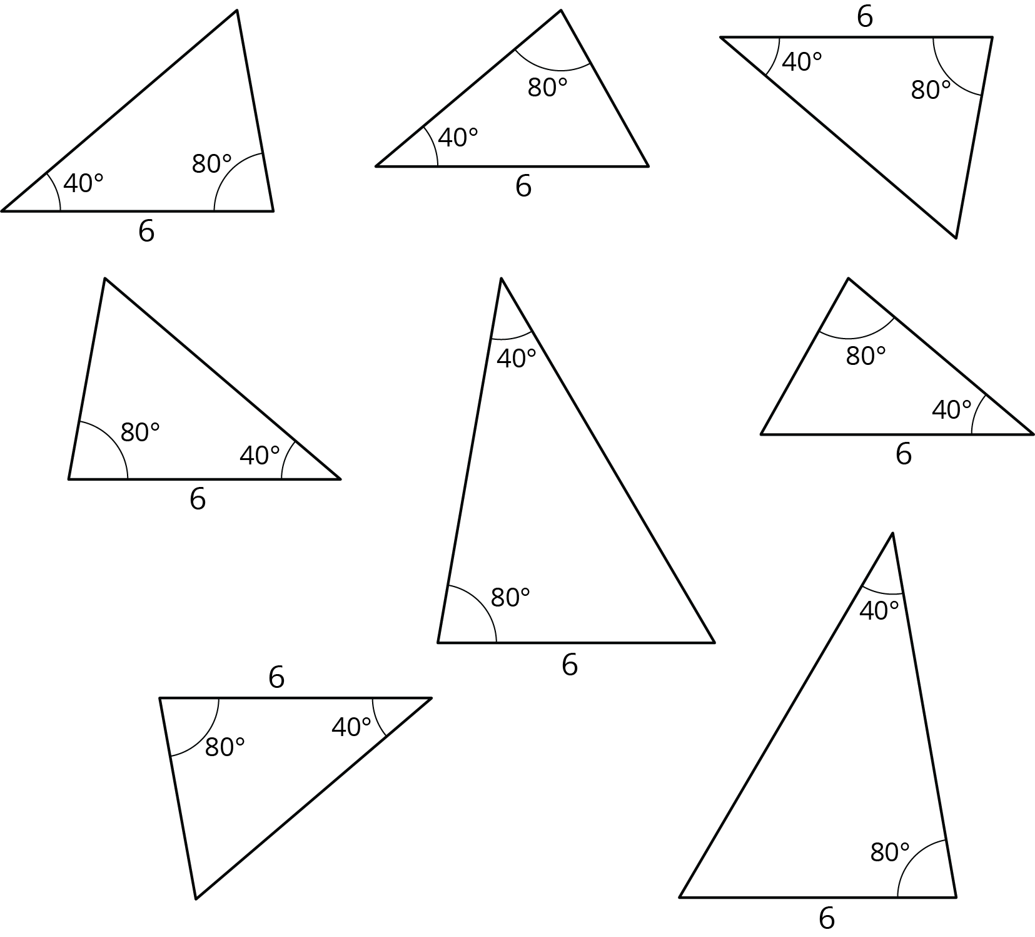
- What is the same about the triangles in the set? What is different?
- How many different triangles are there? Explain or show your reasoning.
© CC BY Open Up Resources. Adaptations CC BY IM.

