Lesson 1: Comparemos, contemos hacia adelante y contemos hacia atrás

Standards Alignments
Addressing | 2.NBT.A.2, 2.NBT.B.7, 2.NBT.B.8
Building Towards | 2.NBT.B.7

Teacher-facing Learning Goals
- Add and subtract within 1,000 using number relationships.

Student-facing Learning Goals
- Comparemos números y sumemos o restemos.

Lesson Purpose
The purpose of this lesson is for students to add or subtract within 1,000 using number relationships.
In a previous unit, students compared three-digit numbers using a number line and considered how close they were to one another and their distance from zero. In this lesson, students compare numbers and use the number line to consider ways to find the difference between 2 three-digit numbers. When locating numbers on the number line, students recognize that when the numbers are relatively close, they can simply count on or count back to determine the difference between the two numbers.
In the second activity, students analyze number lines and counting sequences that increase or decrease by 10 or 100. Using these number relationships, students label number lines by counting on or back by 10 or 100. The work of this activity helps prepare students to use and make sense of computation methods based on counting or adding on by place in upcoming lessons.

Access for:

Students with Disabilities
- Engagement (Activity 1)

English Learners
- MLR8 (Activity 2)

Instructional Routines
Number Talk (Warm-up)

Lesson Timeline
Warm-up | 10 min
Activity 1 | 20 min
Activity 2 | 15 min
Lesson Synthesis | 10 min
Cool-down | 5 min

Teacher Reflection Question
In previous lessons, students located and compared numbers on the number line. How did the number line help them make sense of subtraction methods based on counting on by place? How could you use number lines to help students make their thinking visible for others?

Cool-down
(to be completed at the end of the lesson) 5min
Resta y cuenta

Standards Alignments
Addressing | 2.NBT.A.2, 2.NBT.B.7, 2.NBT.B.8

Student-facing Task Statement
- Ubica y marca 562 y 559 en la recta numérica.
- Encuentra el valor de $562−559$. Muestra cómo pensaste.
- Completa la lista de números para mostrar que se está contando hacia adelante de 100 en 100.
- 552, __________, __________, 852, 952
- Explica cómo sabes que tu lista muestra que se está contando hacia adelante de 100 en 100 y no de 10 en 10.

Student Responses
- $562−559=3$
- 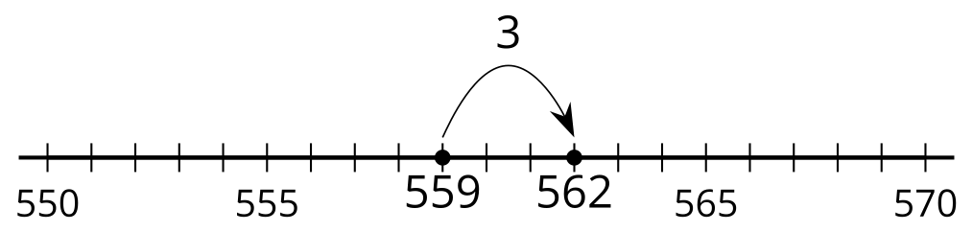
- 552, 652, 752, 852, 952. Sample response: I know it shows counting on by 100 and not 10 because the digit in the hundreds place changes and the digit in the tens place stays the same.

