Lesson 9: La hora al minuto más cercano

Standards Alignments
Addressing | 3.MD.A.1

Teacher-facing Learning Goals
- Tell and write time to the nearest minute.

Student-facing Learning Goals
- Leamos y escribamos la hora al minuto más cercano.

Lesson Purpose
The purpose of this lesson is for students to tell and write time to the nearest minute.
In previous grades, students learned to tell and write time from analog and digital clocks to the nearest five minutes, and to use a.m. and p.m. In this lesson, students build on this work to understand that they can tell time to the nearest minute, using the marks between the numbers that show the 5-minute increments. They also draw hands on a clock to show a given time. As students represent time on the clock and tell time to the minute, they may be off by 1 or 2 minutes. This level of precision is sufficient for the work of this lesson.

Access for:

Students with Disabilities
- Engagement (Activity 1)

English Learners
- MLR8 (Activity 1)

Instructional Routines
Estimation Exploration (Warm-up)

Lesson Timeline
Warm-up | 10 min
Activity 1 | 20 min
Activity 2 | 15 min
Lesson Synthesis | 10 min
Cool-down | 5 min

Teacher Reflection Question
How did students leverage their knowledge of telling time to the nearest 5 minutes from grade 2 while learning to tell time to the nearest minute today?

Cool-down
(to be completed at the end of the lesson) 5min
Tiempos aquellos

Standards Alignments
Addressing | 3.MD.A.1

Student-facing Task Statement
1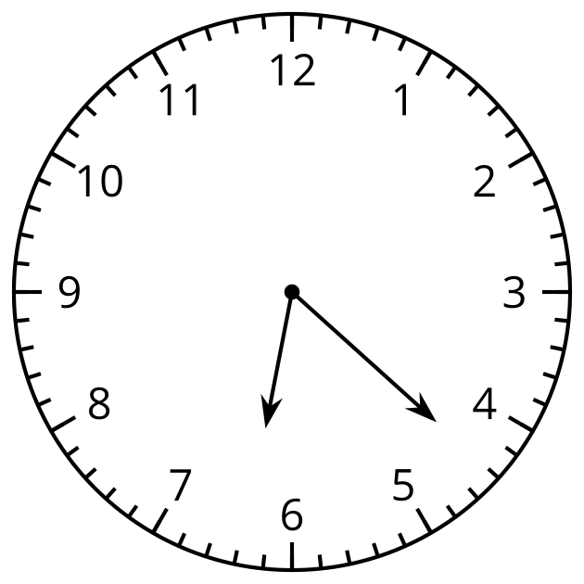
¿Qué hora se muestra? _______________
2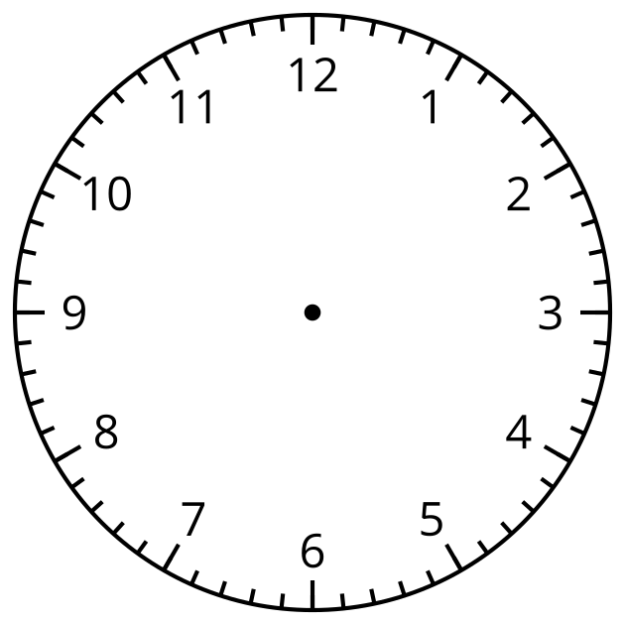
Muestra las 10:13 a.m. en el reloj.

Student Responses
- 6:22
