Unit 6 Lesson 11: Perpendicular Lines in the Plane

1 Revisiting Transformations (Warm up)

Student Task Statement
The image shows quadrilateral $ABCD$.
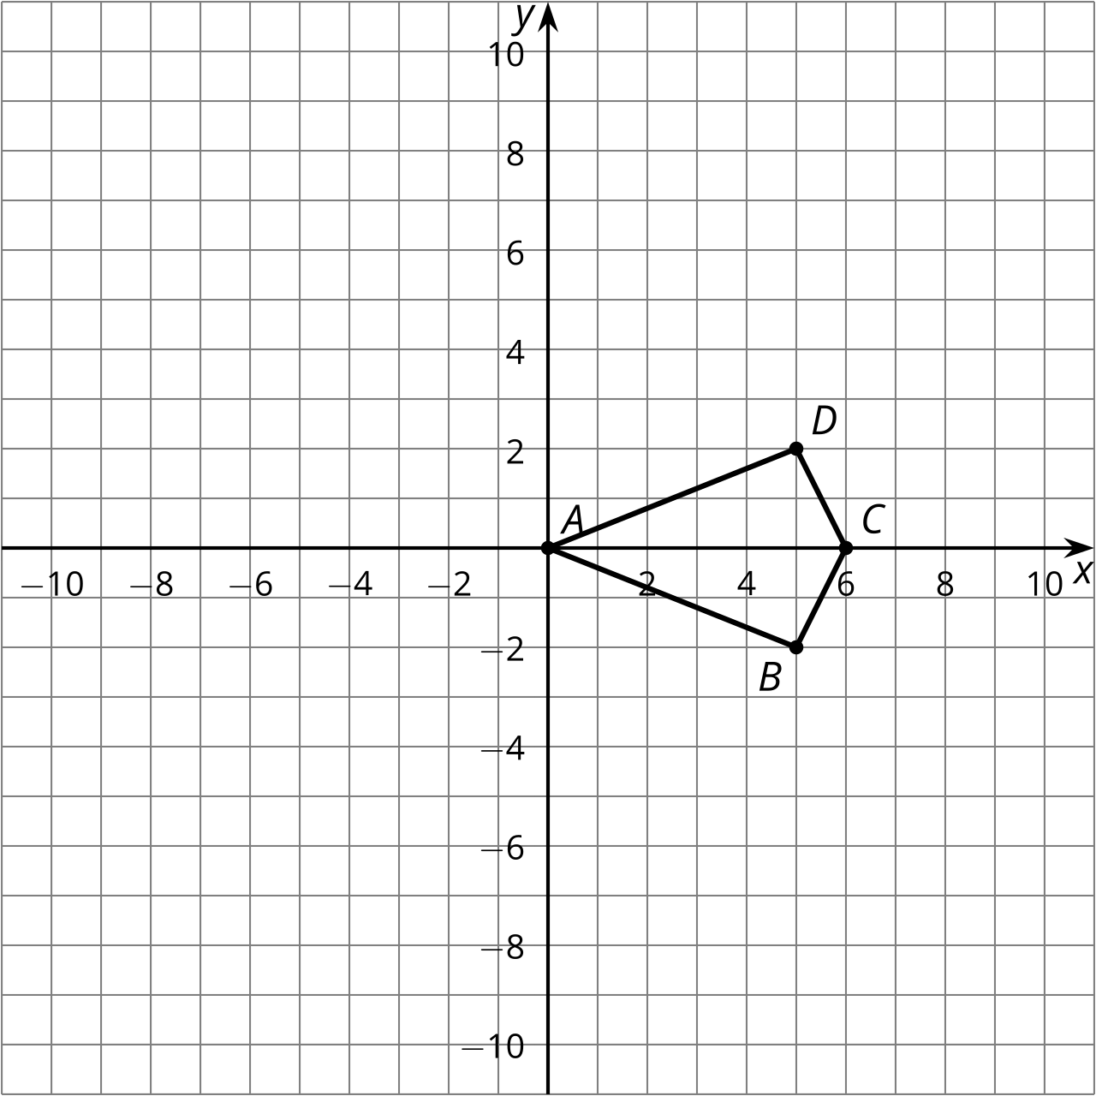
Apply the transformation rule $\left(x,y\right)→\left(\text{-}y,x\right)$ to quadrilateral $ABCD$. What is the effect of the transformation rule?

Activity Synthesis
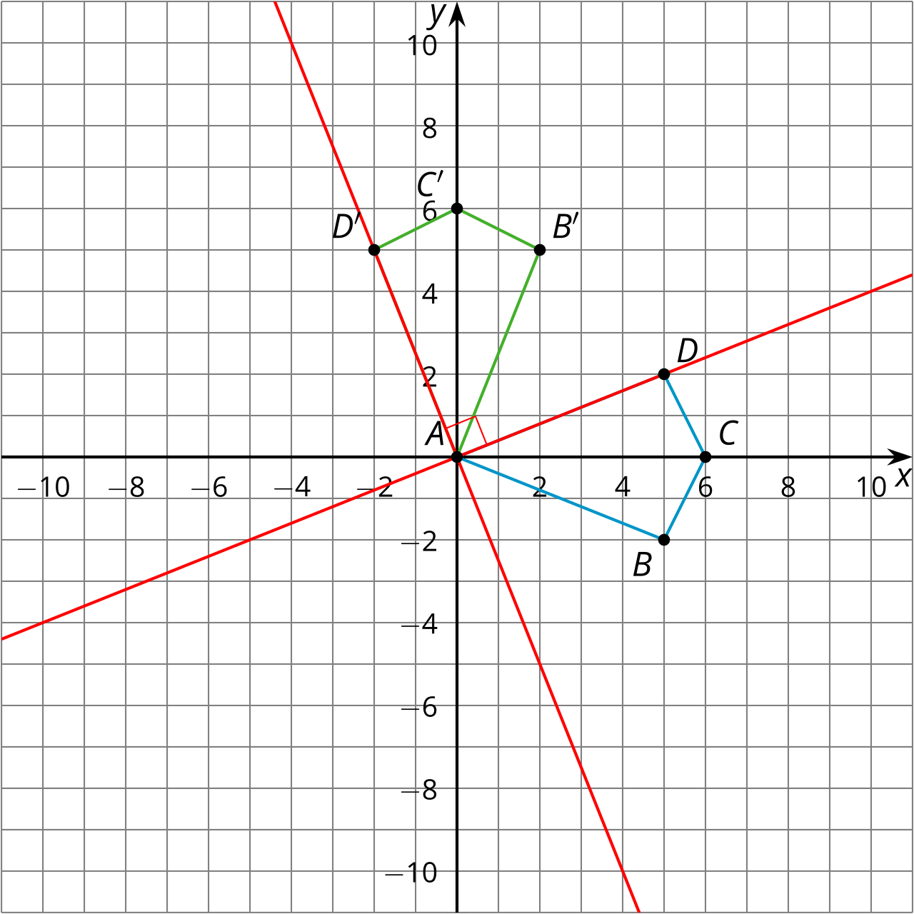

2 Make a Conjecture

Student Task Statement
- Complete the table with the slope of each segment from the warm-up.
 | - original figure slope | - image slope | - product
- $AB$
- $BC$
- $CD$
- $DA$
- The image in the warm-up is a 90-degree rotation of the original figure, so each line in the original figure is perpendicular to the corresponding line in the image. Use your slope calculations to make a conjecture about slopes of perpendicular lines.

3 Prove It

Student Task Statement
Let’s prove our conjecture about slopes of perpendicular lines for the case where the lines pass through the origin.
- Find the slope of a line passing through the point $\left(a,b\right)$ and the origin. Assume the line is not horizontal or vertical.
- Suppose the line is rotated using the transformation rule $\left(x,y\right)→\left(\text{-}y,x\right)$. Find the coordinates of the images of the points $\left(a,b\right)$ and the origin.
- How does the original line relate to the image?
- Find the slope of the image.
- Compare your slopes. What did you just prove?

Activity Synthesis
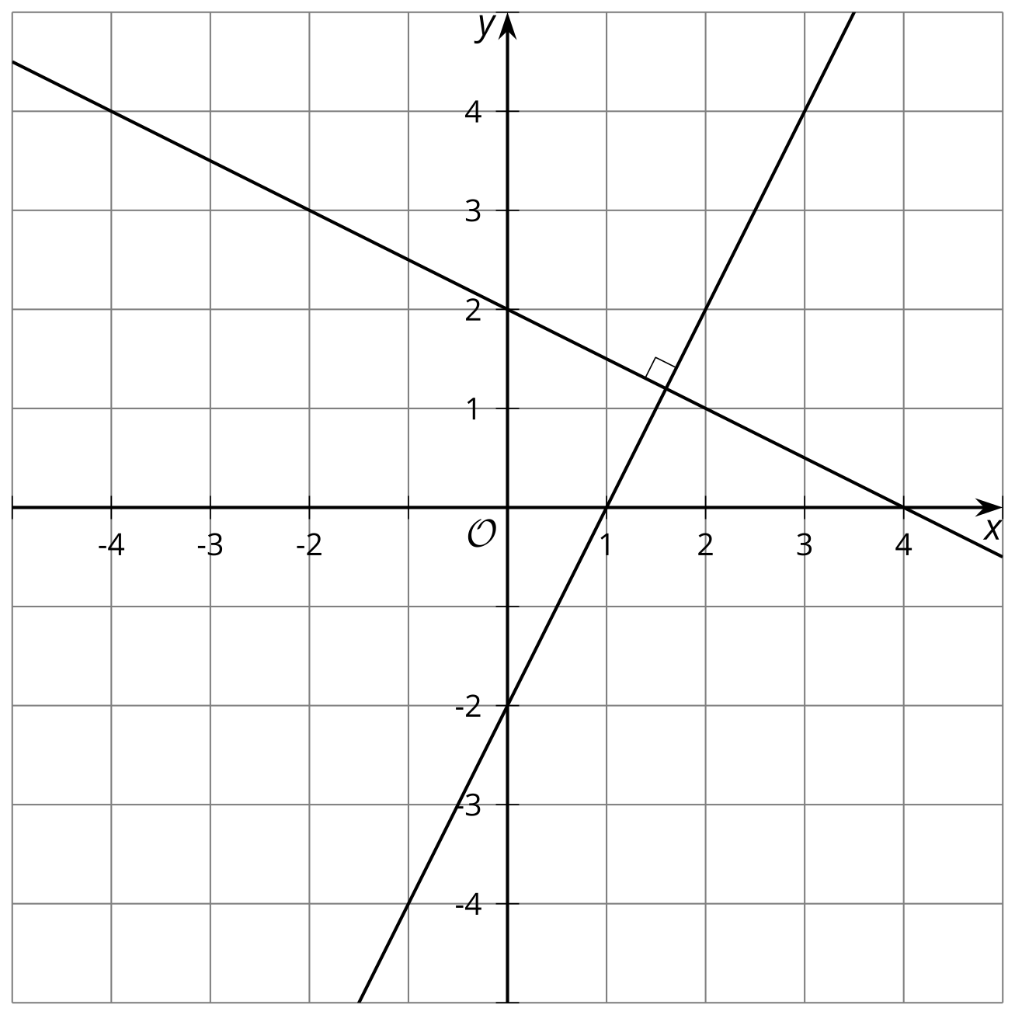

Images for Activity Synthesis
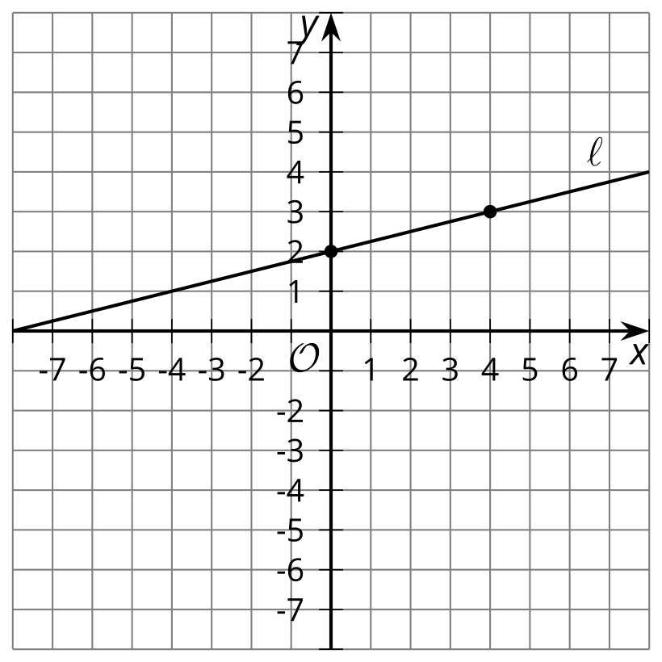
© CC BY 2019 by Illustrative Mathematics®

