Lesson 4: Metric Conversion and Division by Powers of Ten
- Let’s convert units.

Warm-up: True or False: Divide by a Hundred and a Thousand
Decide if each statement is true or false. Be prepared to explain your reasoning.
- $5÷1,​000=0.05$
- $36÷100=0.36$
- $1,​328÷1,​000=1.328$

4.1: Long Jump, Javelin Throw, and Shot Put
athlete | long jump | javelin throw | shot put
Jackie Joyner-Kersee, USA | 727 cm | 4,566 cm | 1,580 cm
Sabine John, Germany | 671 cm | 4,256 cm | 1,623 cm
Anke Behmer, Germany | 678 cm | 4,454 cm | 1,420 cm
- Below are some results Jackie Joyner-Kersee recorded in different events in 1988. Complete the table.
- event | - centimeters | - meters
- long jump | - 727
- javelin throw | - 4,566
- shot put | - 1,580
- Which unit of measure is most helpful when you picture each distance, centimeters or meters? Explain or show your reasoning.
- Why do you think that the distances are measured to the nearest centimeter?
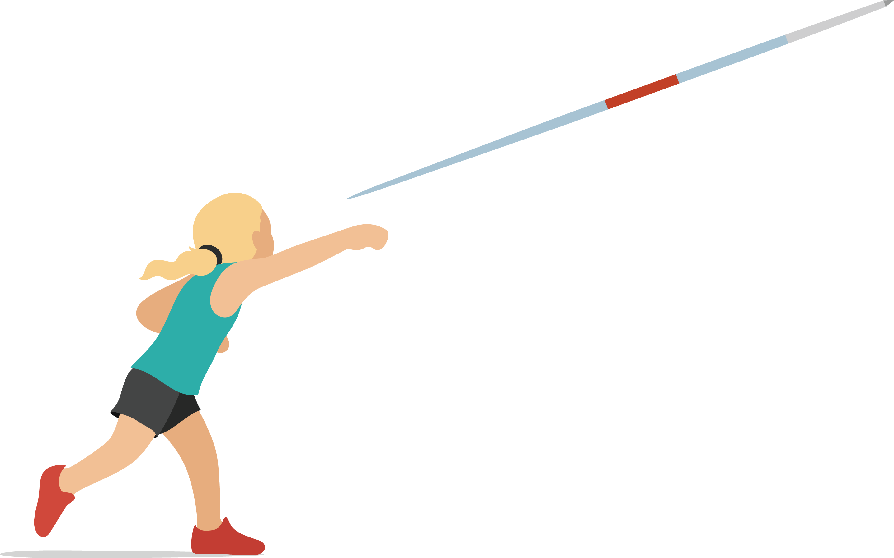

4.2: Hurdles
- The table shows how many meters some students ran during a week. Complete the table to show how many kilometers each student ran.
- student | - distance (meters) | - distance (kilometers)
- Diego | - 9,513
- Clare | - 11,018
- Priya | - 8,210
- Andre | - 10,000
- What patterns do you notice in the table?
- Below is Tyler’s strategy to divide a whole number by 10, 100, or 1,000.
- 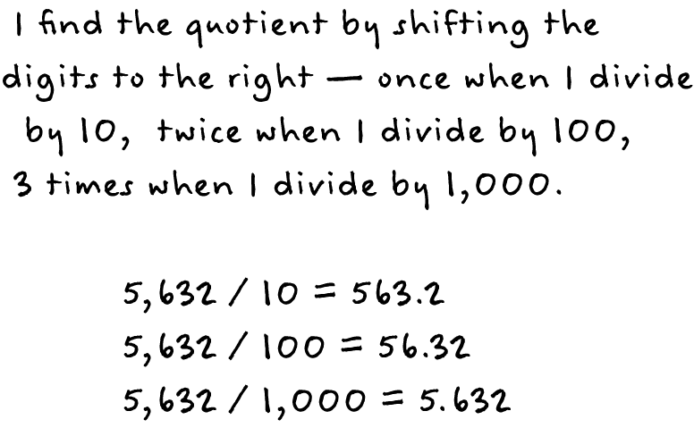
- Describe to your partner what Tyler means.
- (Pause for teacher direction.)
- Why does Tyler’s strategy work? Will Tyler’s strategy always work? Explain or show your reasoning.
© CC BY 2021 Illustrative Mathematics®

