Lesson 8 Practice Problems
- A sequence is defined by $f(0)=\text{-}20,f(n)=f(n−1)−5$ for $n≥1$.
  - Explain why $f(1)=\text{-}20−5$.
  - Explain why $f(3)=\text{-}20−5−5−5$.
  - Complete the expression: $f(10)=\text{-}20−\underset{_}{​}$. Explain your reasoning.
- A sequence is defined by $f(0)=\text{-}4,f(n)=f(n−1)−2$ for $n≥1$. Write a definition for the $n^{\text{th}}$ term of the sequence.
- Here is the recursive definition of a sequence: $f(1)=3,f(n)=2⋅f(n−1)$ for $n≥2$.
  - Find the first 5 terms of the sequence.
  - Graph the value of the term as a function of the term number.
  - Is the sequence arithmetic, geometric, or neither? Explain how you know.
- 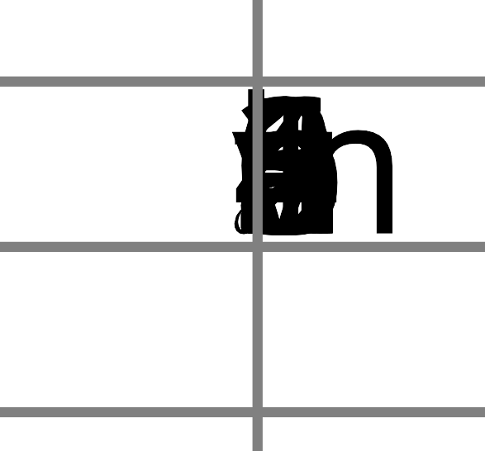
- (From Unit 1, Lesson 7.)
- Here is a graph of sequence $M$. Define $M$ recursively using function notation.
- 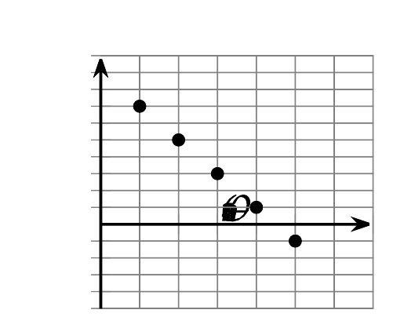
- (From Unit 1, Lesson 6.)
- Write the first five terms of each sequence. Determine whether each sequence is arithmetic, geometric, or neither.
  - $a(1)=5,a(n)=a(n−1)+3$ for $n≥2$.
  - $b(1)=1,b(n)=3⋅b(n−1)$ for $n≥2$.
  - $c(1)=3,c(n)=\text{-}c(n−1)+1$ for $n≥2$.
  - $d(1)=5,d(n)=d(n−1)+n$ for $n≥2$.
- (From Unit 1, Lesson 5.)
- Here is the graph of a sequence:
  - Is this sequence arithmetic or geometric? Explain how you know.
  - List at least the first five terms of the sequence.
  - Write a recursive definition of the sequence.
- 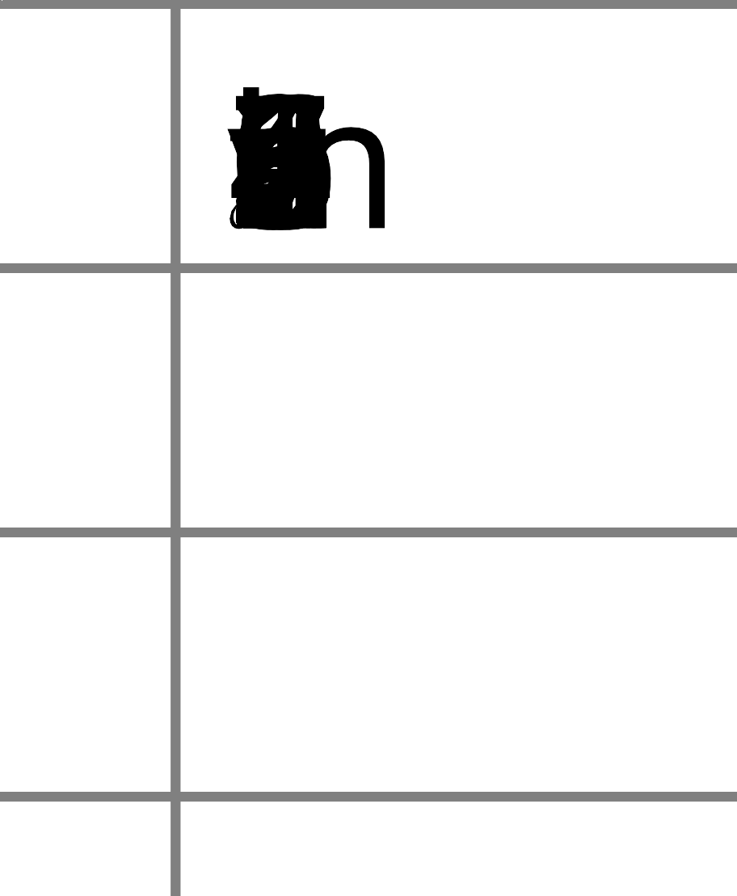
- (From Unit 1, Lesson 7.)
© CC BY 2019 by Illustrative Mathematics®

