Lesson 19: End Behavior of Rational Functions
- Let’s explore the end behavior of rational functions.

19.1: Different Divisions, Revisited
Complete all three representations of the polynomial division following the forms of the integer division.
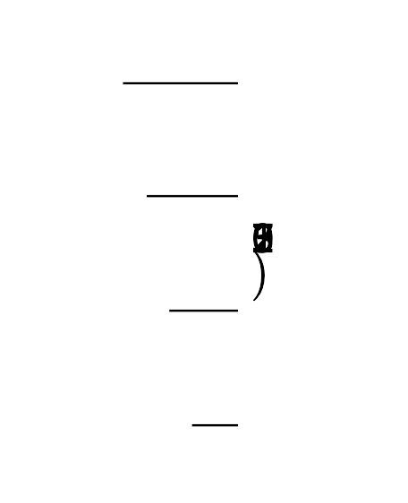
2x2+7x+55x+12x3+7x2+7x+5
$2775=11(252)+3$
$2x^{3}+7x^{2}+7x+5=$
$\frac{2775}{11}=252+\frac{3}{11}$
$\frac{2x^{3}+7x^{2}+7x+5}{x+1}=$

19.2: Combined Fuel Economy
In 2000, the Environmental Protection Agency (EPA) reported a combined fuel efficiency for cars that assumes 55% city driving and 45% highway driving. The expression for the combined fuel efficiency of a car that gets $x$ mpg in the city and $h$ mpg on the highway can be written as $\frac{100xh}{55x+45h}$.
- Several conventional cars have a fuel economy for highway driving that is about 10 mpg higher than for city driving. That is, $h=x+10$. Write a function $f$ that represents the combined fuel efficiency for cars like these in terms of $x$.
- Rewrite $f$ in the form $q(x)+\frac{r(x)}{b(x)}$ where $q(x)$, $r(x)$, and $b(x)$ are polynomials.

19.3: Exploring End Behavior
function | degree  of num. | degree  of den. | rewritten in the form of  $q(x)+\frac{r(x)}{b(x)}$ | end behavior
$g(x)=\text{-}\frac{5}{x+2}$
$h(x)=\frac{7x−5}{x+2}$
$j(x)=\frac{3x^{2}+7x−5}{x+2}$
$k(x)=\frac{2x^{3}+3x^{2}+7x−5}{x+2}$
$m(x)=\frac{x+2}{2x^{3}+3x^{2}+7x−5}$
- Complete the table to explore the end behavior for rational functions.
- What do you notice about the end behavior of different types of rational functions?

Are you ready for more?
- Graph $y=j(x)$ and the line it approaches.
- Under what conditions would the end behavior of the graph of a rational function approach a line that is not horizontal?
- Create a rational function that approaches the line $y=2x−3$ as $x$ gets larger and larger in either the positive or negative direction.

Lesson 19 Summary
In earlier lessons, we saw rational functions whose end behavior could be described by a horizontal asymptote. For example, we can rewrite functions like $d(x)=\frac{x+4}{x}$ as $d(x)=1+\frac{4}{x}$ to see more clearly that as $x$ gets larger and larger in either the positive or negative direction, the value of $\frac{4}{x}$ gets closer and closer to 0, which means the value of $d(x)$ gets closer to 1. We can use similar thinking to understand rational functions that do not have horizontal asymptotes.
For example, consider $f(x)=\frac{x^{2}+4x+5}{x−3}$. Using division, the expression can be rewritten as $f(x)=x+7+\frac{26}{x−3}$. As $x$ gets larger and larger in either the positive or negative direction, the value of the term $\frac{26}{x−3}$ gets closer and closer to 0, which means the value of $d(x)$ gets closer to the value of $x+7$. This means that the end behavior of $f$ can be described by the line $y=x+7$. Here is a graph of $y=f(x)$, the line $y=x+7$, and the vertical asymptote of the function at $x=3$:
© CC BY 2019 by Illustrative Mathematics®

