Unit 3 Lesson 2: Represent Unit Fraction Multiplication

WU Which One Doesn’t Belong: Diagrams (Warm up)

Student Task Statement
Which one doesn’t belong?
A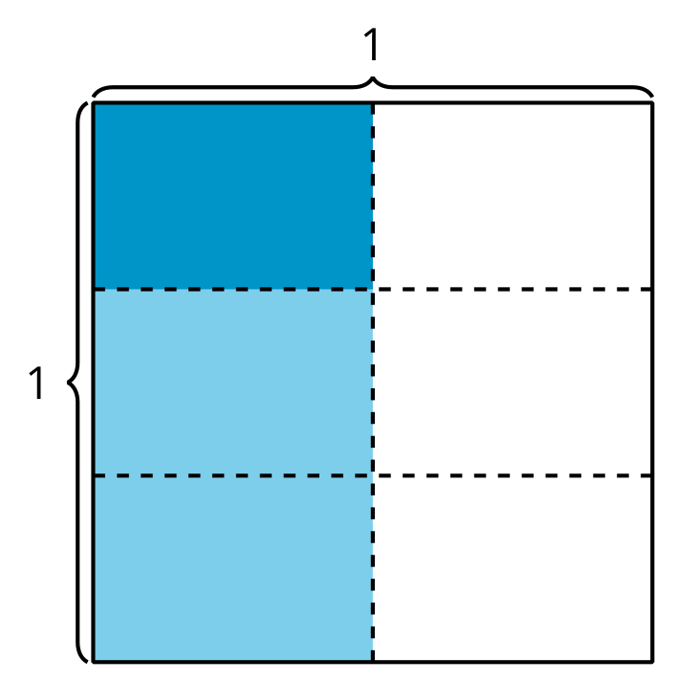
B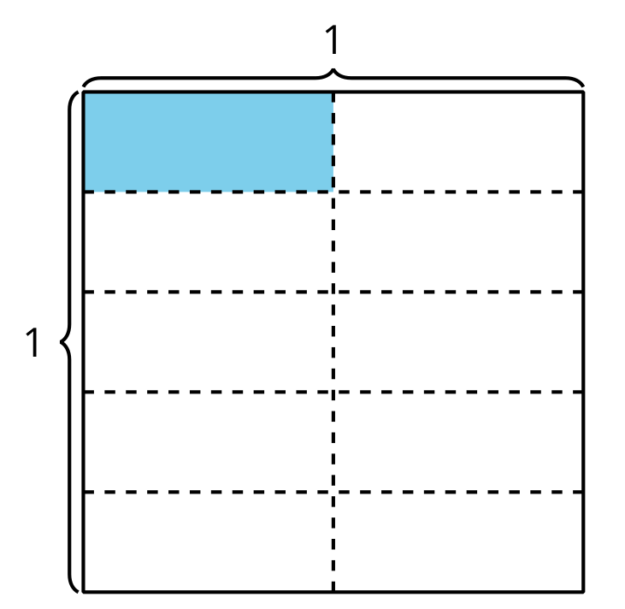
C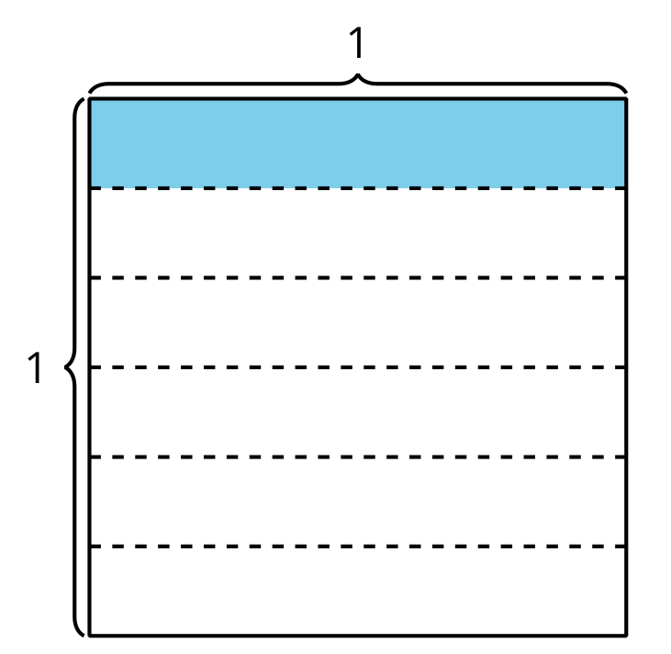
D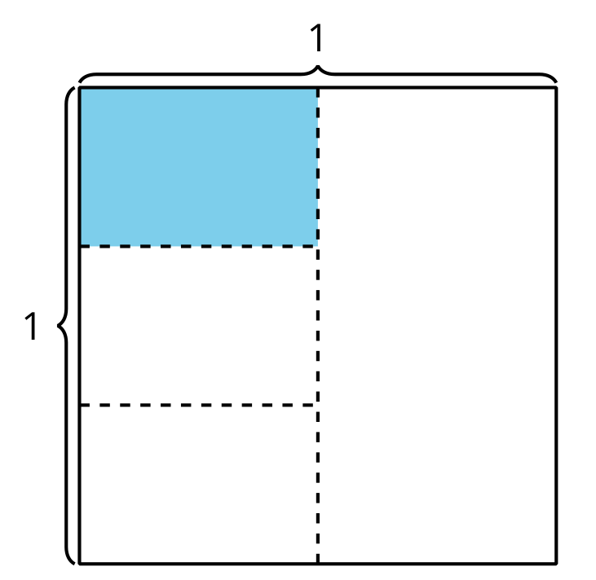

1 Interpret Diagrams

Student Task Statement
- Show $\frac{1}{3}$ of the square.
Shade $\frac{1}{4}$ of $\frac{1}{3}$ of the square.
How much of the whole square is shaded?
- Show $\frac{1}{4}$ of the square.
Shade $\frac{1}{3}$ of $\frac{1}{4}$ of the square.
How much of the whole square is shaded?
- How are the diagrams the same and how are they different?

2 Write an Expression

Student Task Statement
Priya shaded part of a square.
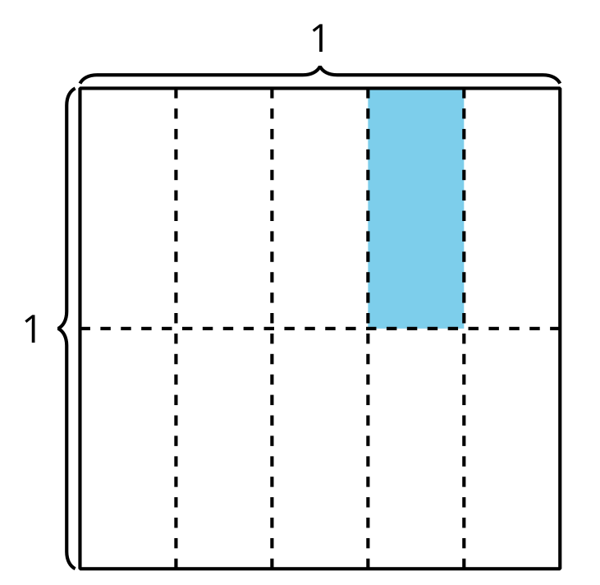
- Explain or show how the expression $\frac{1}{5}×\frac{1}{2}$ represents the area of the shaded piece.
- Explain or show how the expression $\frac{1}{2}×\frac{1}{5}$ represents the area of the shaded piece.
- Write a multiplication expression to represent the area of the shaded piece. Be prepared to explain your reasoning.
- 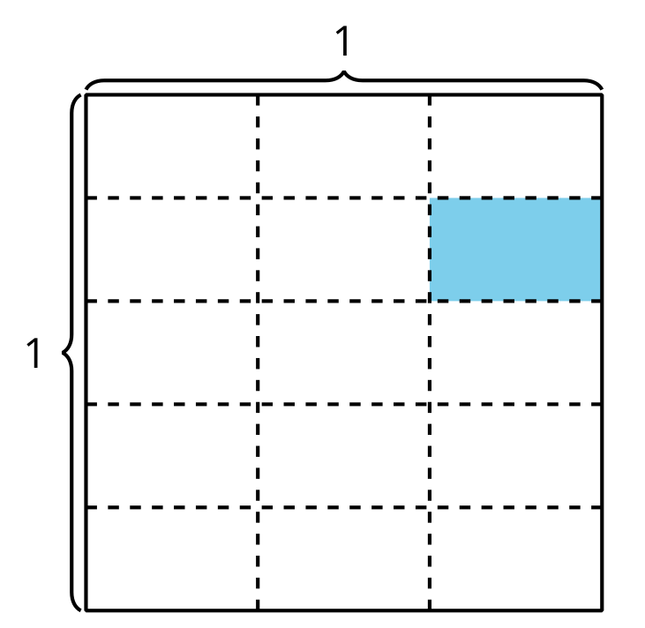
- How much of the whole square is shaded?
© CC BY 2021 Illustrative Mathematics®

