Unit 5 Lesson 11: How Did You Do That?

WU True or False: Add to a Two-digit Number (Warm up)

Student Task Statement
Decide if each statement is true or false. Be prepared to explain your reasoning.
- $24+3=54$
- $42+5=47$
- $42+30=45$

1 How Much Litter?

Student Task Statement
Mai and her classmates volunteer to clean up the local park.
They pick up 37 plastic bottles and 25 paper wrappers.
How many pieces of litter did they pick up all together?
Jada, Kiran, and Tyler find the value of $37+25$ to find out how many pieces of litter Mai's class picked up.
$37+25$
Jada’s way:
$30+20=50$
$7+5=12$
$50+12=62$
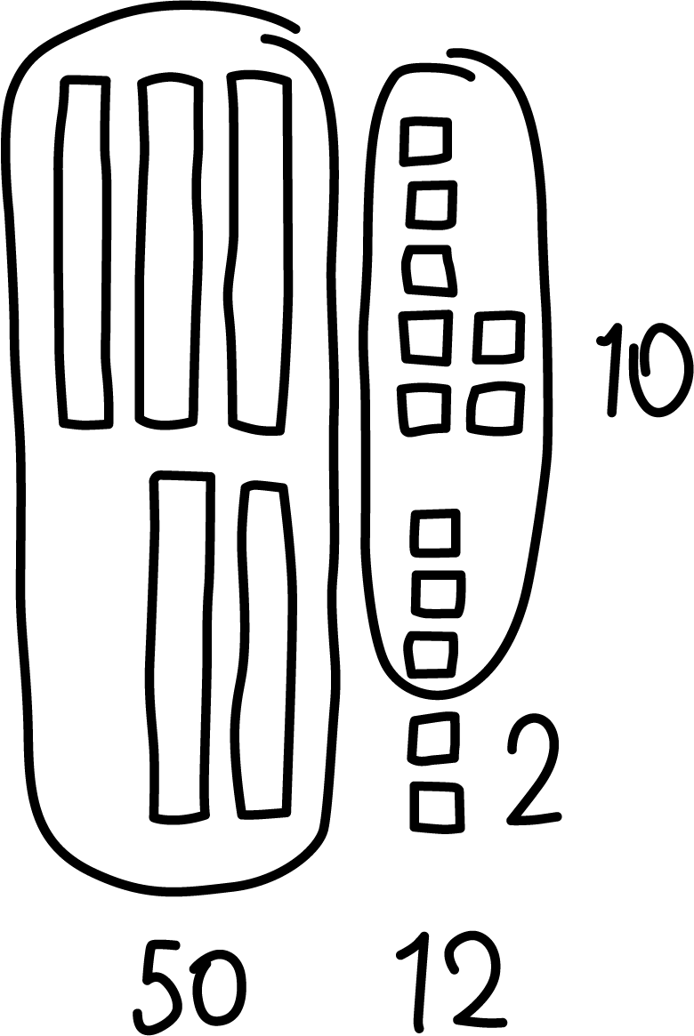
Kiran’s way:
$37+3+2=42$
$42+20=62$
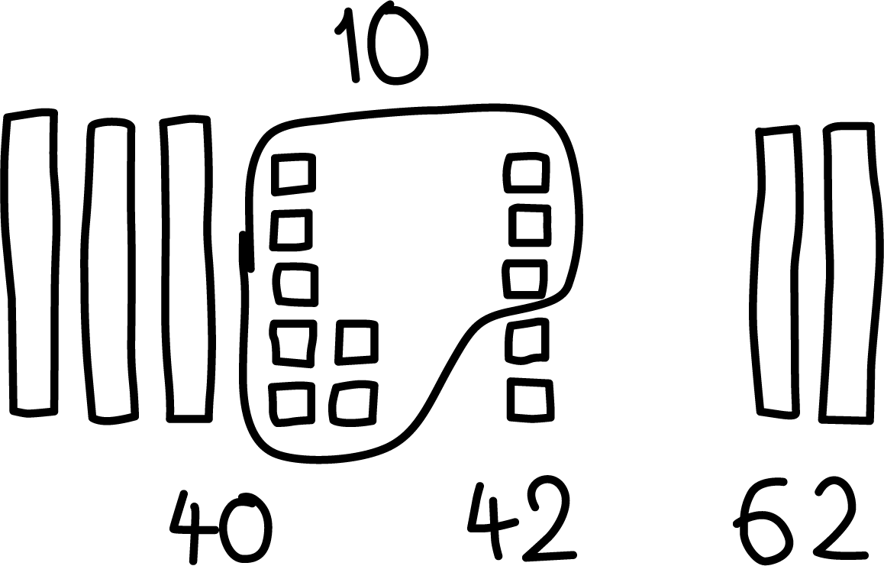
Tyler’s way:
$37+20=57$
$57+3+2=62$

2 It's Your Turn to Add

Student Task Statement
Find the value of $23+68$.
Show your thinking using drawings, numbers, or words.
If you have time: Think about a math story this expression could represent.
Share your stories with a partner.
© CC BY 2021 Illustrative Mathematics®

