Unit 1 Lesson 9: Interpret Bar Graphs

WU Notice and Wonder: Favorite Pets (Warm up)

Student Task Statement
What do you notice? What do you wonder?
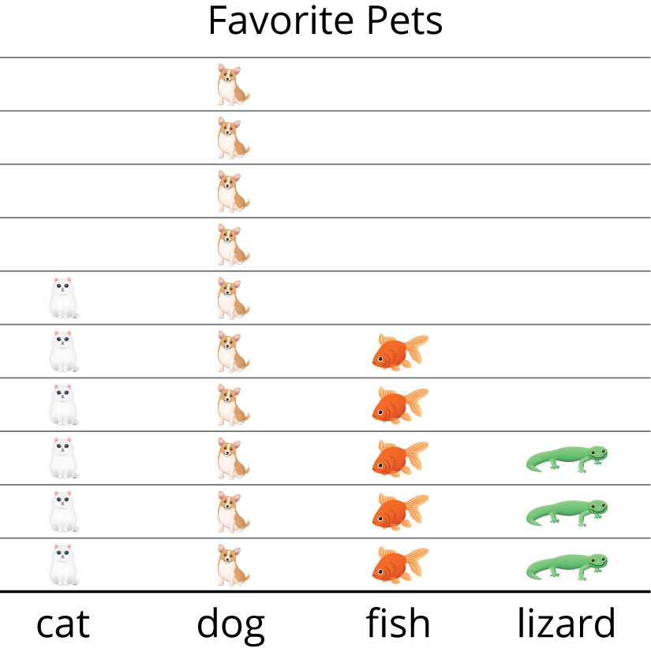
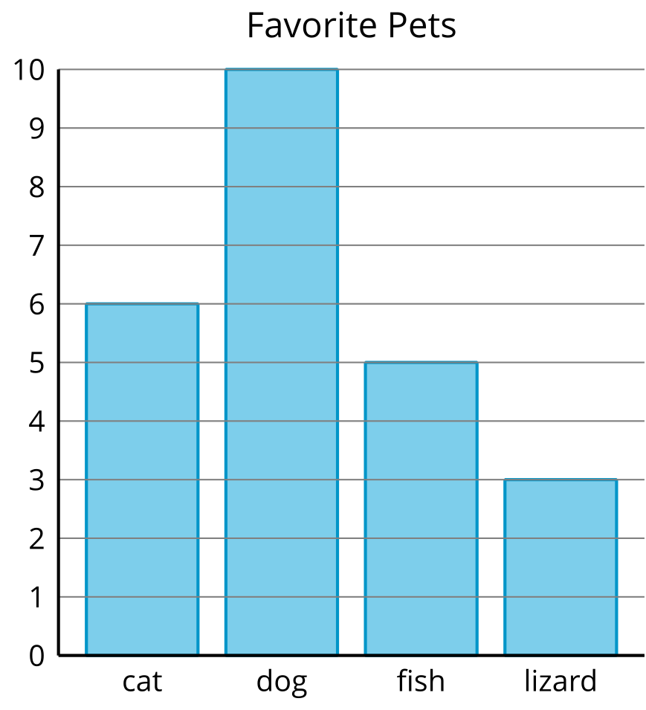

1 Field Trip Choices

Student Task Statement
Groups of students in different classes were asked, “Where would you like to go for our field trip?” Their responses are shown in the bar graphs below.
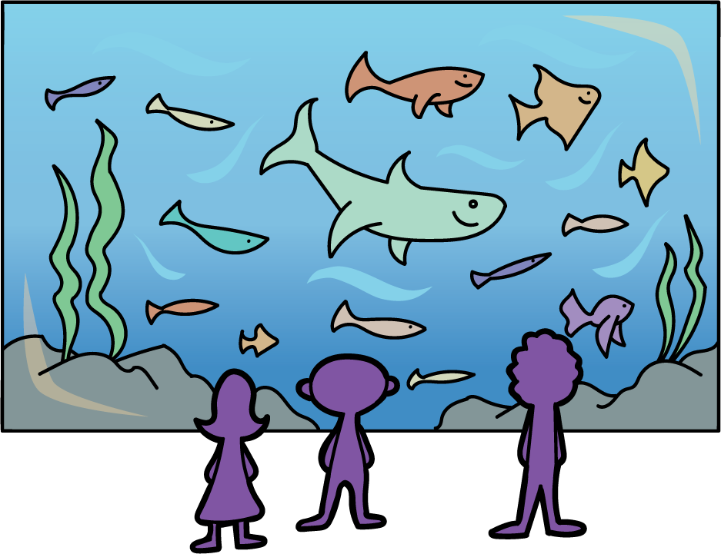
Write as many statements as you can to show what can be learned about the students’ field trip choices from the bar graph.
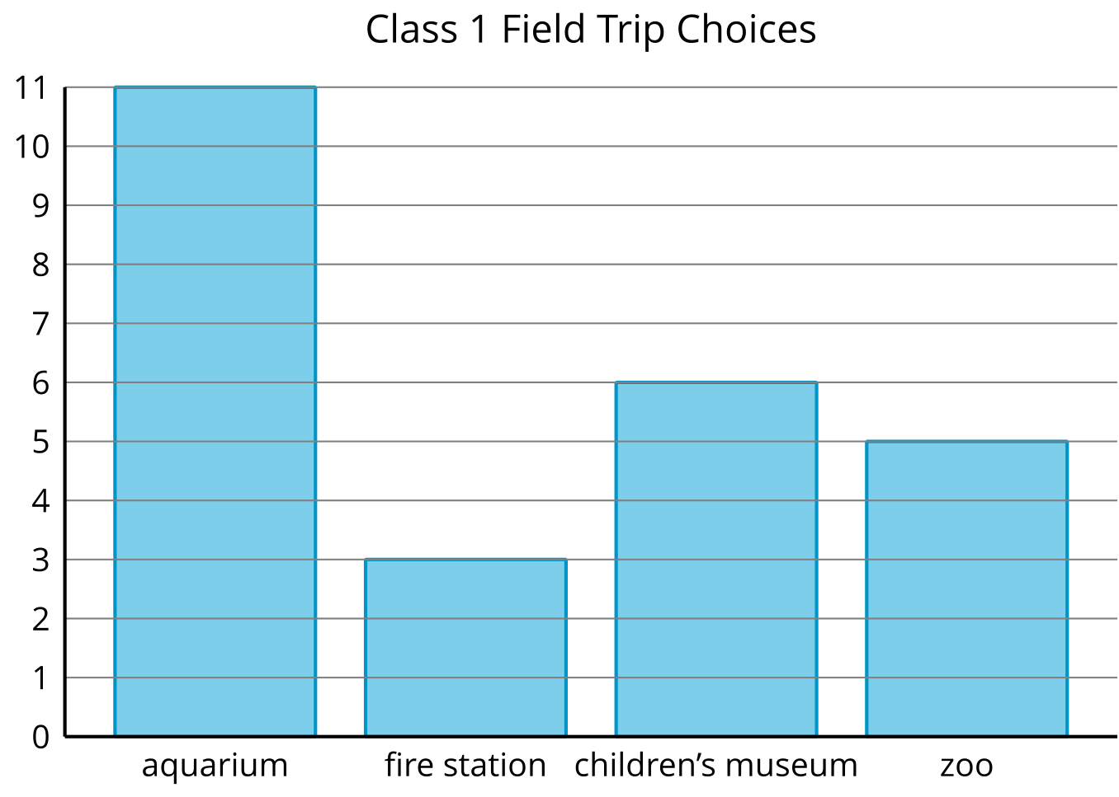
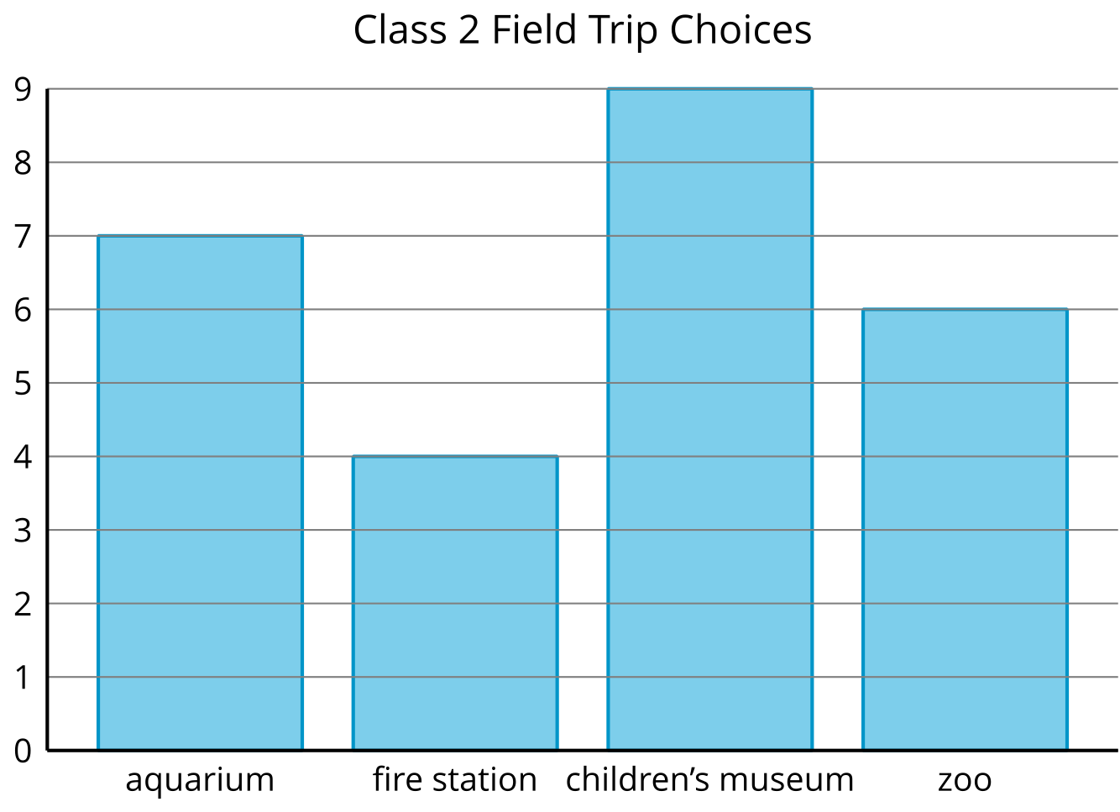
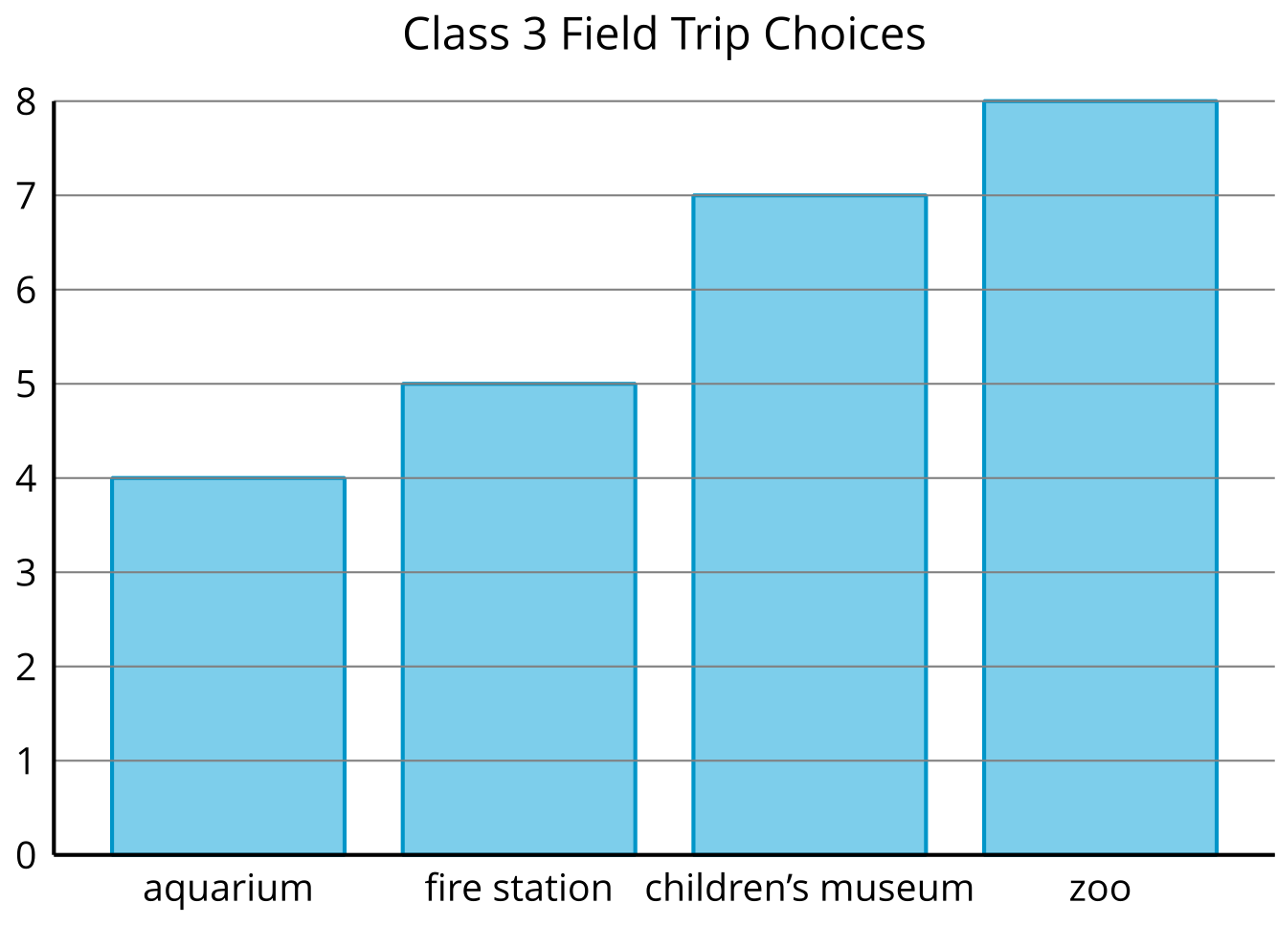

2 Our Favorite Seasons

Student Task Statement
A group of students were asked, “What is your favorite season?” Their responses are shown in the bar graph.
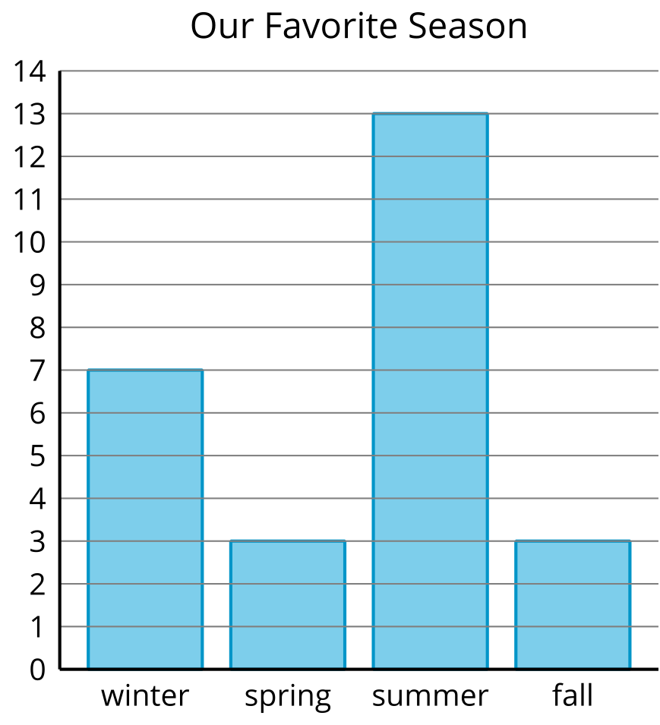
Answer the questions using the graph.
- How many students voted for summer?
- What is the total number of students who voted for fall or spring?
- Which two seasons have a total of 10 votes?
- How many students voted?
© CC BY 2021 Illustrative Mathematics®

