Lesson 7: Graph and Answer
- Let’s represent our data on scaled bar graphs and answer questions about the data.

Warm-up: Notice and Wonder: Graph
What do you notice? What do you wonder?
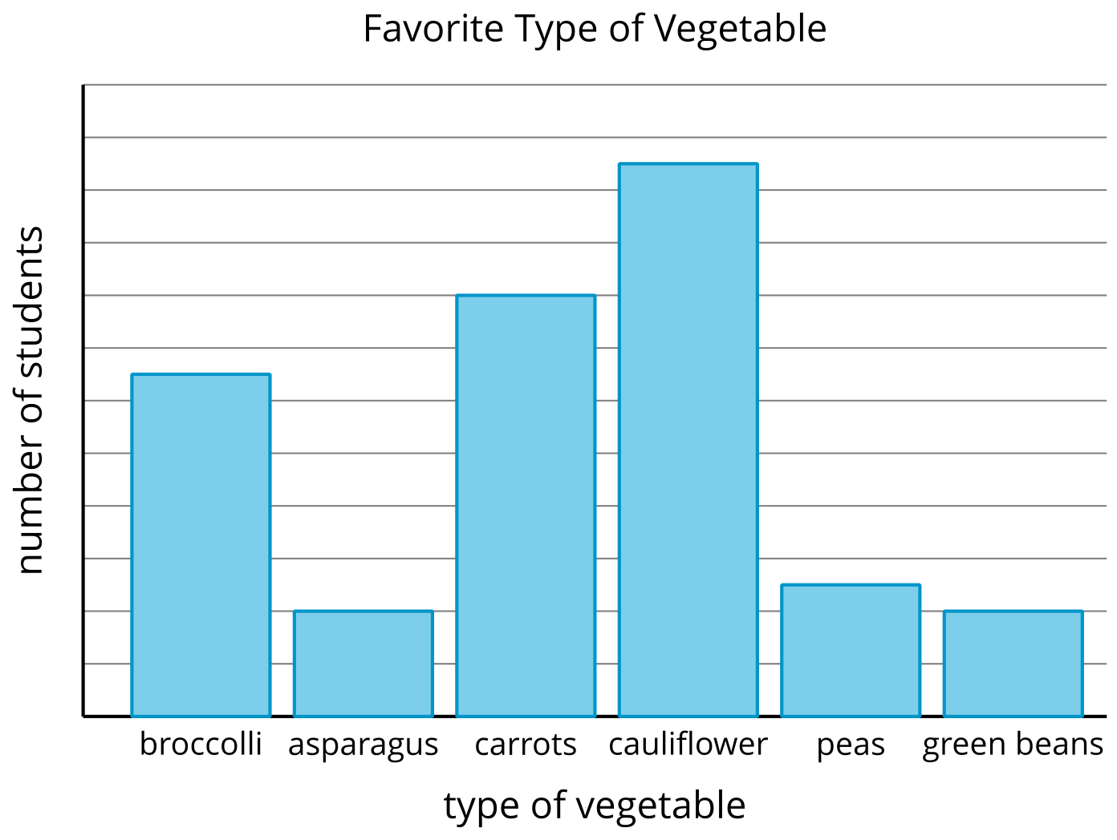

7.1: Draw a Scaled Bar Graph
Work with your group to create a bar graph that represents your survey data. When drawing your bar graph, think about:
- what each unit on the graph represents
- how tall the bar will be for the most popular category and for the least popular category
- the title and labels to use

7.2: Ask and Answer Questions
- Write questions that could be answered with your bar graph by completing these sentences.
  - How many more students liked ___________________________
  - than ___________________________ ?
  - How many fewer students liked ___________________________than
  - ___________________________ ?
  - How many more students liked ___________________________or
  - ___________________________ than ___________________________ ?
- Use your partner’s graph to answer their questions. Show or explain your reasoning.
- The answers to the questions from ___________________________ ’s graph:
© CC BY 2021 Illustrative Mathematics®

