Lesson 4: Symmetry in Figures (Part 1)
- Let’s describe symmetry in two-dimensional figures.

Warm-up: Notice and Wonder: Seeing Double
What do you notice? What do you wonder?
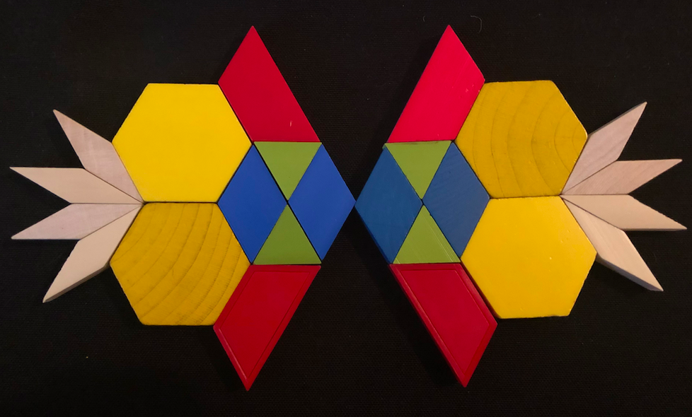

4.1: Perfect Matches
- Lin has pieces of paper in different shapes. She folds each piece of paper once, creating two smaller parts.
- She then sorts the pieces into two categories based on the folding lines.
- 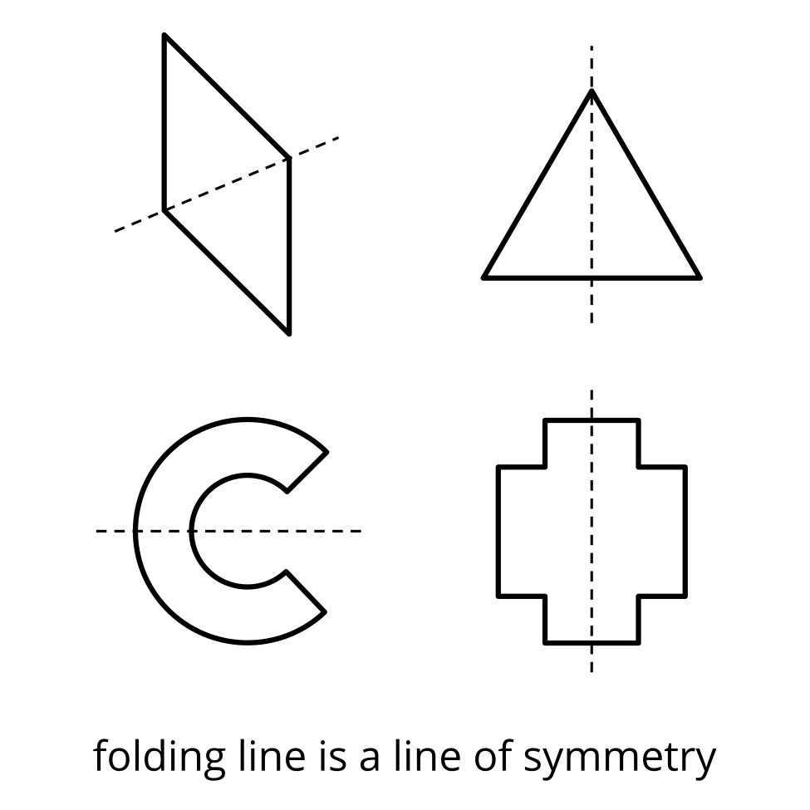
- 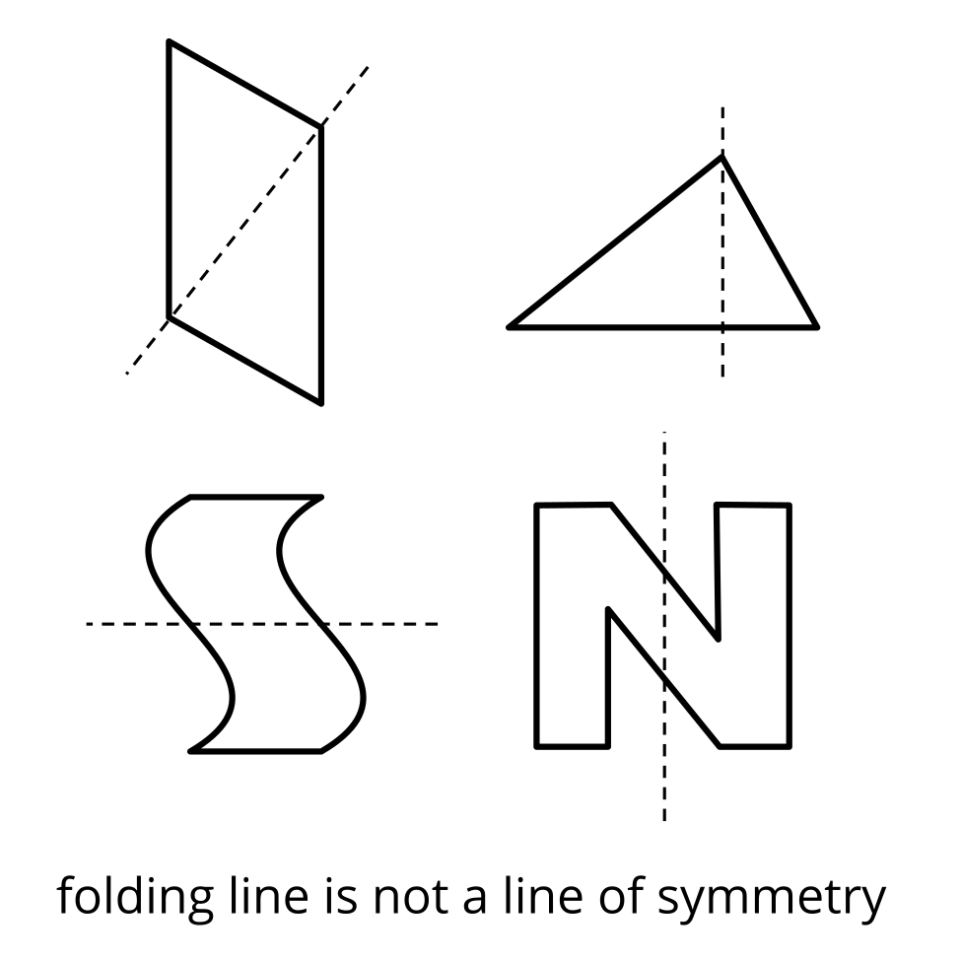
- Study the figures in each category. What do you think a line of symmetry means?
- Complete this sentence:
- A line of symmetry is . . .
- Do the following figures have a line of symmetry? If so, draw the line. If not, explain how you know.
- 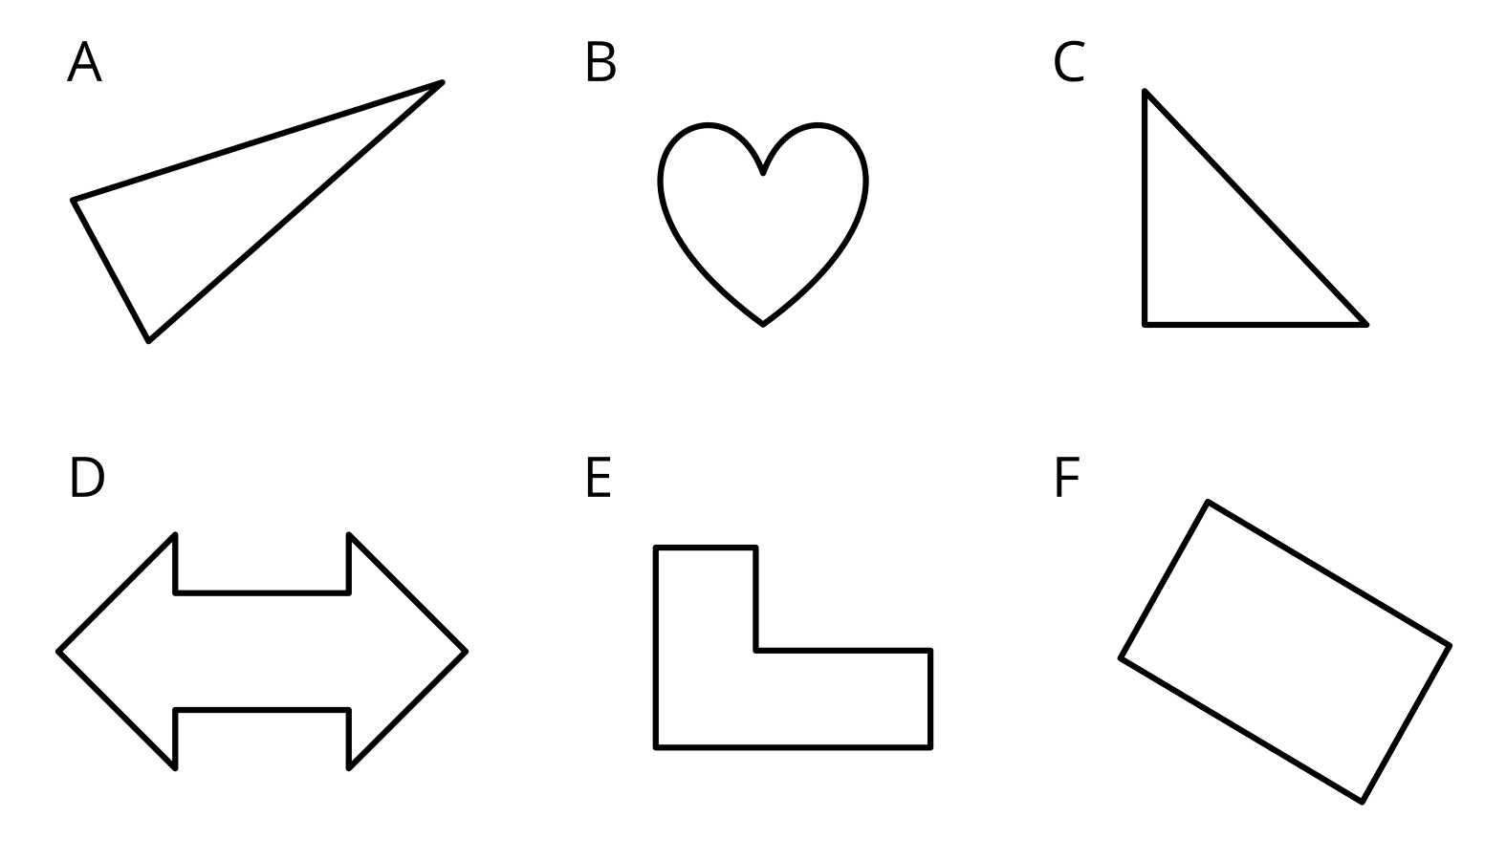
- Are there any figures with more than one line of symmetry? If you think so, draw all the lines of symmetry.

4.2: In Search of Symmetry
Your teacher will give your group a set of cards.
- Sort the figures on the cards by the number of lines of symmetry they have.
- 0 lines of symmetry | - 1 line of symmetry | - 2 lines of symmetry | - 3 lines of symmetry
- Find another group that has the same set of cards. Compare how you sorted the figures. Did you agree with how their figures are sorted? If not, discuss any disagreement.

4.3: Just Keep Folding
Priya is folding paper of different shapes along their lines of symmetry. She keeps folding each one until the folded shape has no more lines of symmetry.
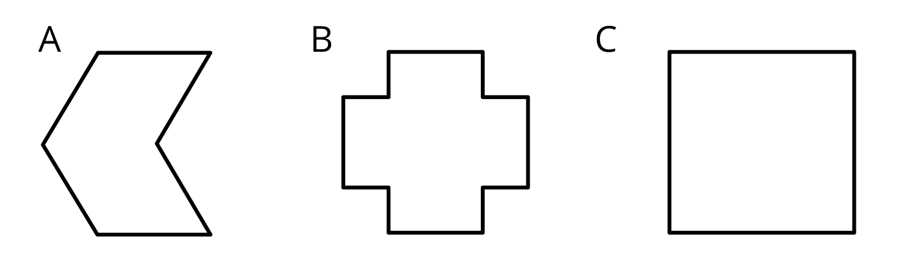
- How many times can she fold each shape before she can no longer continue?
- What do you notice about each folded shape when it can no longer be folded?
© CC BY 2021 Illustrative Mathematics®

