## Unit 6 Lesson 18: The Volume and Dimensions of a Cylinder

### 1 A Circle's Dimensions (Warm up)

#### Student Task Statement

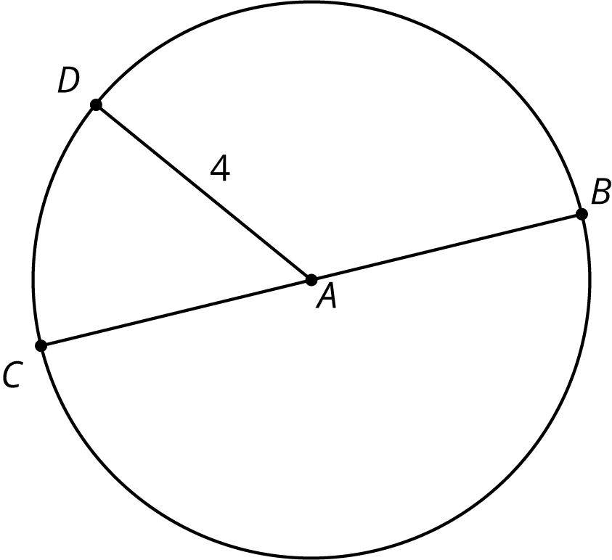

Here is a circle. Points , , , and are drawn, as well as Segments and .

1. What is the area of the circle, in square units? Select all that apply.
   1. approximately 25
   2. approximately 50
2. If the area of a circle is square units, what is its radius? Explain your reasoning.

### 2 Circular Volumes

#### Student Task Statement

What is the volume of each figure, in cubic units? Even if you aren’t sure, make a reasonable guess.

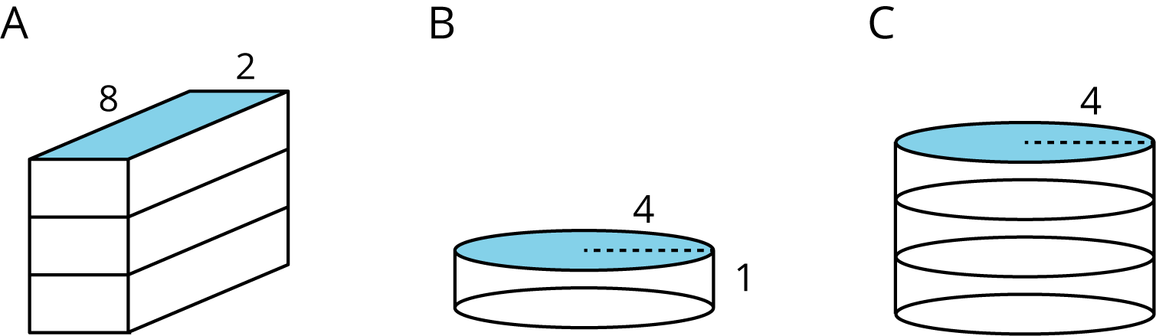

1. Figure A: A rectangular prism whose base has an area of 16 square units and whose height is 3 units.
2. Figure B: A cylinder whose base has an area of 16 square units and whose height is 1 unit.
3. Figure C: A cylinder whose base has an area of 16 square units and whose height is 3 units.

### 3 What’s the Dimension?

#### Student Task Statement

The volume of a cylinder with radius is given by the formula .

1. The volume of this cylinder with radius 5 units is cubic units. This statement is true:

* 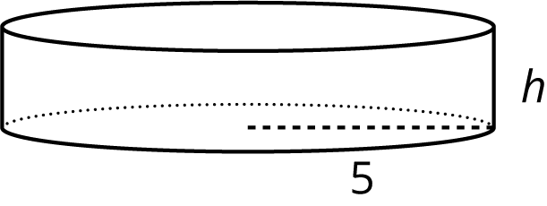
* What does the height of this cylinder have to be? Explain how you know.

1. The volume of this cylinder with height 4 units is cubic units. This statement is true:

* 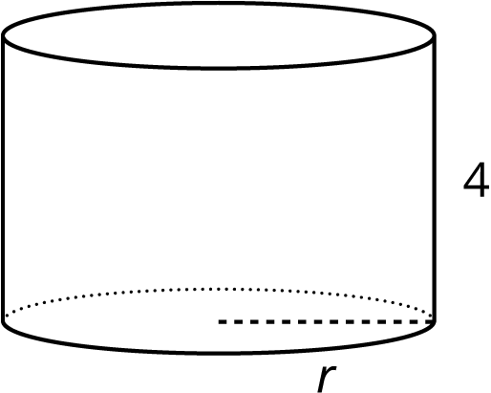
* What does the radius of this cylinder have to be? Explain how you know.

### 4 Cylinders with Unknown Dimensions

#### Student Task Statement

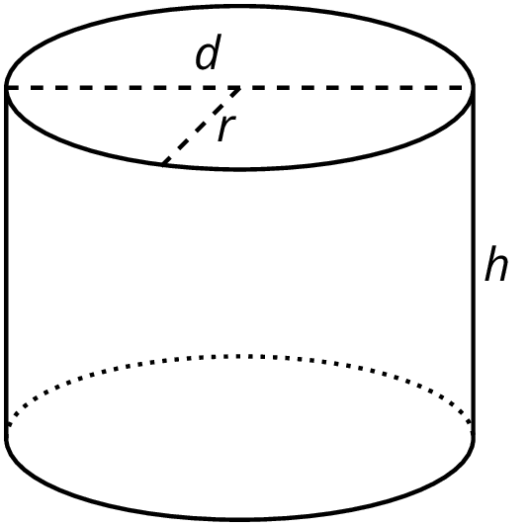

Each row of the table has information about a particular cylinder. Complete the table with the missing dimensions.

|  |  |  |  |  |
| --- | --- | --- | --- | --- |
| diameter (units) | radius (units) | area of the base (square units) | height (units) | volume (cubic units) |
|  | 3 |  | 5 |  |
| 12 |  |  |  |  |
|  |  |  | 11 |  |
| 8 |  |  |  |  |
|  |  |  | 100 |  |
|  | 10 |  |  |  |
| 20 |  |  |  | 314 |
|  |  |  |  |  |



© CC BY Open Up Resources. Adaptations CC BY IM.